Brandy, Dakota, Nicholas

- How to make evidence-based decisions regarding instructional improvement, including changes in practice, by analyzing, evaluating, and using various types of data to engage staff in advancing instructional effectiveness.

“Data-based decision-making for school improvement: Research insights and gaps”
Steps: https://www.tandfonline.com/doi/full/10.1080/00131881.2019.1625716
- Collect Data- Use data to determine the cause of a problem, before taking improvement actions. Questions: How can the collected data be analyzed and interpreted? What do the data mean in relation to the goal? [DATA: ‘big data’, assessments, surveys, observations & discussions (formal, informal, and schematic), community/local/place-based data, and educational research evidence.]
- Goal Setting- therefore, is placed at the top of the model. A key task for school leaders is to make sure that school improvement goals are collectively developed, and that there is dialogue about these goals with all stakeholders. {Three blocks of goals: accountability goals, school development goals, and instructional goals}
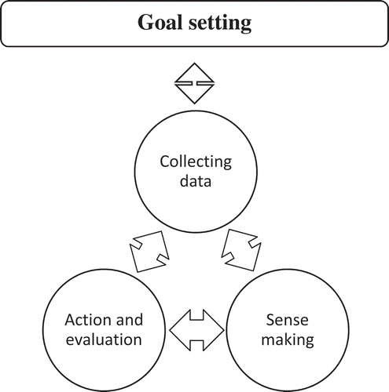
- Sense-making- can lead to the implementation of concrete improvement actions, the outcomes of which subsequently need to be evaluated, based on data, to determine whether the previously set goals were achieved.
- Students are crucial stakeholders in the process of data use, and they can use data to actively steer and improve their own learning, by themselves, with their peers, and with their teachers. And provide different stakeholders with practical examples of the data & goals

Hoy & Miskel
Step 1: Recognize and Define the Problem or Issue
Step 2: Analyze the Difficulties in Existing Situation
Step 3: Establish Criteria for a Satisfactory Outcome
Step 4: Develop an Action Plan or Strategy
Step 5: Initiate and evaluate your plan of action

