Amanda Burns
Angelica Gamon
Brittany Holsinger

Chapter 9 Discrimination in Employment

“The Act prohibits discrimination based on race, color, religion, sex or national origin. Sex includes pregnancy, childbirth or related medical conditions. It makes it illegal for employers to discriminate in relation to hiring, discharging, compensating, or providing the terms, conditions, and privileges of employment.”

Equal Protection Provisions of the Fourteenth Amendment and Employment Discrimination (Page 223)
- Due process of law includes four aspects: procedural, substantive, Vagueness Test, and the Presumption Test.
- These tests are applied by the courts.
- Laws involving Substantive due process (ensures that a valid reason exists before an individual is deprived of life, liberty, or property and that the means used to achieve this objective are reasonable p. 345) are held to higher standards.

Due Process Standards and Employment Discrimination (Page 224)
- Three-level balancing test to determine procedural and process:
- Test applied to determine if a person is entitled to a hearing before action is taken.
- Test can be used to determine if pre- or post-deprivation is necessary.
- Test used to determine the standard and level of proof needed to deprive an individual.

- Vagueness Test is used in cases that involve termination of tenured teachers, teachers under contract, or administrators require notice and reasons for termination as well as an opportunity for the affected employee to respond to the charges.

- Equal protection clause is crucial in employment discrimintation.
- Each person treated equally under the Fourteenth Amendment.
- Discrimination cases: initial claim starts with the plantiff to demonstrate and prove the law was irrational.
- Then, claim shifts to the employer to demonstrate that a reason exists for enforcement of the policy/law.
- Lastly, the court will determine and balance if the plaintiff's claim/reason exists against the employer to take action.

Title VII: Discrimination (Page 224)

- One of the most extensive federal employment laws, the Civil Rights Act of 1964 Title VII, this provides:
- It shall be an unlawful employment practice for any employer
- To fail or refuse to hire or discharge any individual or otherwise to discriminate against any individual with respect to his compensation, terms and conditions or privileges of employment, because of such individuals race, color, religion, sex or national origin:
- To limit, segregate or classify his employees or applicants for employment in any way which would deprive or tend to deprive any individual of employment opportunities or otherwise adversely affect his status as an employee, because of such individual’s race, color, religion, sex or national origin.
b. It shall be an unlawful employment practice for an employment agency to fail or refuse to refer for employment, or otherwise to discriminate against any individual, because of his race, color, religion, sex or national origin, or to classify or refer for employment any individual on the basis of his race color, religion, sex or national origin.

- The original statue (1964), covered employers and labor unions and did not apply to discriminatory employment practices in educational institutions until 1972, when the law was amended.
- Title VII was amended by the Civil RIghts Act of 1991. This provides compensation damages, punitive damages, and jury trial in cases involving discrimination.
- A complaint with the Equal Employment Opportunity Commission (EEOC) must be filed within 180 days following the alleged unlawful employment practice or within 300 days if the individual has filed a claim with a local or state civil rights agency. Failure to meet these time limits results in a loss of legal standing to challenge the alleged act.
- A plaintiff must demonstrate that the employer’s reasons for the challenged employment decision are false and that the actual reason is discrimination. This is difficult to prove because in very few instances do plaintiffs have objective evidence or proof of discrimination. The accused typically denies the charges that are brought against them.

Case Study:
Tammy, a female, tenured teacher in a rural conservative district, was stopped by the local police and charged with driving under the influence. She explained to the officer that she had just left a Christmas party given by her principal and that she had consumed only a few glasses of wine. She was also aware that some of her male colleagues had been stopped in the past but not charged. Nevertheless, she was still charged. As her arrest becomes public, there is pressure from the school board for her to resign.

Discussion Questions
- Can the board force Tammy to resign? Why or why not?
- Is the infraction serious enough to warrant dismissal? Why or why not?
- What about the male colleagues who were not charged for similar offenses?
- What rights does Tammy have as a teacher in this situation?
- What factors would the court consider in ruling on her case?
- What conclusion do you think the court would reach in this situation?

Retaliation (Page 226)
- Title VII prohibits retaliation against an individual who filed a discrimination charge, who participated in a discrimination hearing, or who opposed discrimination.
- Action is taken to discourage or prevent an individual from opposing a discriminatory practice and may be manifested by termination, demotions, or refusal to employ.

Schools and Transgender Teacher (Page 227)
- Teachers may exercise freedom of choice even in the context of sexual transformation.
- Senate passed the Employment Non-Discrimination Act of 2013 that effectively prohibits discrimination on the basis of sexual orientation or gender identity.

Title IX( (Page 229)
- Administered by the Office for Civil Rights (OCR) of the Department of Education.
- This is similar to the provisions in the EEOC’s guidelines found in Title VII.
- Title IX, like Title VII, makes a provision for sexual distinctions in employment where sex is a bona fide ocupational qualification.
- Title IX violations may result in a loss of federal funds.
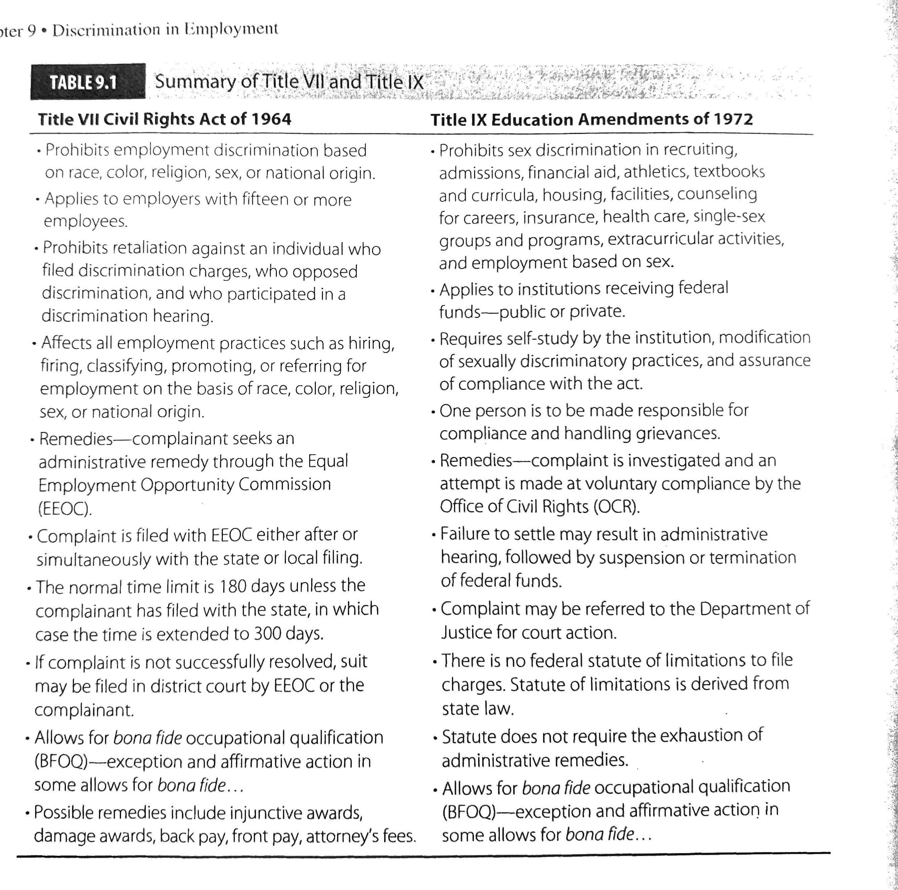

The Rehabilitation Act of 1973 and the Americans With Disabilities Act of 1990 (Page 230)
- American’s with Disabilities Act (ADA) and Individuals with Disabilities Education Act (IDEA)- “protects individuals with disabilities against discrimination and ensures equal access and equal opportunity.”

- Section 504 of the Rehabilitation Act of 1973- “prohibits discrimination against any otherwise qualified person who has a disability with respect to emeployment, training, compensation, promotion, fringe benefits, and terms and conditions of employment.
  - Section 504 covers all people who are disabled and receives federal financial assistance.
  - Supreme Court upheld the court of appeals ruling by stating “that a person with a contagious disease may be considered handicapped under Section 504 of the statute.” (Example: AIDS, Tuberculosis) Page 232-233

- ADA protects not only students with disabilities, but any person who has a physical or mental impairment that limits one or more major life activities, has a record of impairment, or is regarded by others as having such an impairment.
  - DOES NOT apply to impairments that are temporary and minor (duration of six months or less).

GENERAL RULES:
- Cannot make any pre-employment inquiry or require a pre-employment medical examination to determine if an applicant is disabled or to determine the severity.
- Cannot use any employment criterion/test that has the effect of eliminating the qualified disabled person.
- School districts must make reasonable accommodations for people with known disabilities, including job applicants and/or employees.

Pregnancy and Public School Employment (Page 239)
Pregnancy Discrimination Act of 1978 (amendment to Title VII)
- Ensure that pregnant employees are treated in the same manner as other employees with respect to the ability to perform their duties.
- Act covers pregnancy, childbirth, and related medical conditions.
- Women cannot be dismissed, denied a job, or denied a promotion due to pregnancy.
- Women must be able to take sick leave as other employees do for medical reasons.
- Pregnancy must be treated as a temporary disability - giving the female same provisions of disability benefits, sick leave, and insurance coverage as any other employee that has a temporary disability.

Sexual Harassment (Page 241)

- Sexual harassment is prohibited by Title VII and Title IX.
- Harassment is considered to be a form of sex discrimination. This can be displayed in different forms, from verbal statements and gestures to overt behavior.
- Victims, as well as the harasser, can be male or female, not necessarily of the opposite sex.
- The victim is not always the person harassed but can be anyone affected by the offensive conduct.
- Verbal harassment includes but is not limited to, inquiring of a sexual nature, sexual comments about their personal anatomy or clothing, requesting dates and not accepting the answer “no.”
- Nonverbal harassment includes prolonged staring, giving personal gifts without cause, blowing kisses or licking their lips, making various sexual gestures with their hand, or posting sexually suggestive cartoons or pictures.
- It is difficult to claim sexual harassment if the accused party is not aware that their behavior is unwelcomed.

