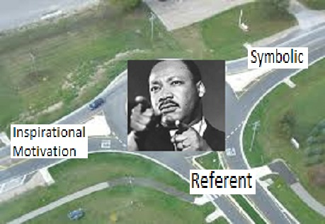
Martin Luther King Jr.
“I HAVE A DREAM”
Referent Power- An administrator’s ability to influence behavior based on subordinate's liking and identification with the administrator. Based on your likability, respect, personality, but you have to establish a respect, trust and loyalty among your colleagues to establish this type of power.
Inspirational Motivation- when a person’s vision, message and referent power reaches to the core of another person to the point that the feel inspired and intrinsically motivated to make a change.
Symbolic- The administrator in this perceptual lens is leader that bring excitement they are charismatic about what they are wanting to do. This can help to motivate their staff to get on board and be a part of the change. This person has a vision and uses different methods to get people to buy in.
One word that comes to my mind in this intersection, is servant leader
Servant leader is one who is willing to put the interest of other above his/her own.
1 Kings 12:7- and they said to him, “If you will be a servant to this people today and serve them, and speak good words to them when you answer them, then they will be your servant forever.
Referent power, inspirational motivation, and symbolism intersect in so many different ways. The first two words that came to my mind when looking at these different intersections were leadership and servant. People want to see their leader as a person who is excited about the change, but also as a person who is willing to get their hands dirty and lead the change. After establishing a sense of respect and trust through referent power the leader can then begin to use inspirational motivation and symbolism to spur their subordinates on to a desire to be a part of the change that is going to be taking place.

