Warner Burke Burke-Litwin theory Organizational Change

Group Members: Amanda, Brittany, Samantha, Angelica
Outline Final Project

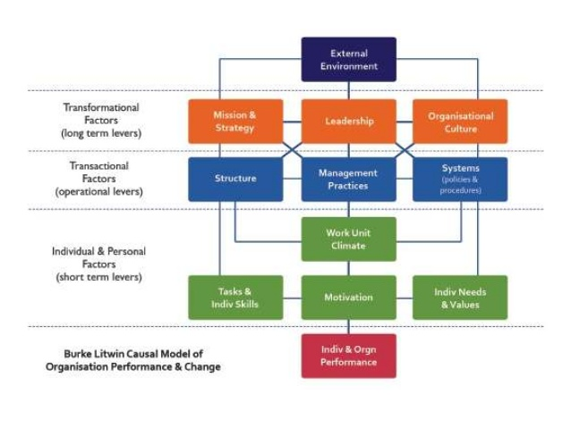

Introduction: Samantha
Warner Burke: He came up with a process to make organizational change a success. It is a process that goes from the top-down. It consists of 12 organizational dimensions. All of these dimensions are linked in some way. In order for change to be successful in any organization, all of the people involved have to be on the same page and following the same procedures. Based on the Burke-Litwin model, the steps do go in a certain order.
This model is an example of an open system because outside factors play an important role in organizational change.

Transformational Change- Leadership is more about motivation of the employees, environment of collaboration, team building, over all culture
Transactional Change- Routines, Procedures, management, achievement of set goals

Activity: Group activity determining which dimensions you think are the most important and the order they go in.

External environment: This is the first step of the process. When you are thinking about the school as the organization, this includes: Factories, markets, economy, legislation, School board and the community. All of the stakeholders involved will make up the external environment. Ex: When a major change is trying to be implemented, the school board and superintendent have to be involved and are a major part of the process.

Angelica
Mission and strategy- This is the purpose of the organization and what the process will be to achieve the goal.
Leadership- The individual(s) in this role are responsible for developing the vision and motivating the rest of the organization in completing or achieving the goal.
Organizational culture- This is the value of the organization. They will be less formal than the “mission and strategy” but will still exist implicitly throughout the organization. This does not happen immediately but over time.
Brittany
Transactional factors (blue blocks) refer to day-to-day operations within the organization. The authors argue these factors are strongly affected by management, rather than leadership. Change in these factors is only likely to lead to lasting change if, in turn, the transformational factors are also affected.
Structure- Changes in strategy can lead to changes in the way the organization is structured. This can impact on relationships, responsibilities and ways of working. Which includes hierarchy or departments.
Management practices-Behaviors and activities of managers usually aligned to carrying out the overall strategy.
Systems-These are the mechanisms put in place to help and support employees. This may be legal systems or reward systems, for example.
Amanda
Work Unit Climate – The team’s working environment. For example, how well team members cooperate, how comfortable individuals feel expressing themselves or how well goals are set and rewarded. (Transformational)
Motivation – The setting of goals to inspire and direct employees. (Transformational)
Task Requirements and Individual Skills/Abilities – Matching the job description with the expertise of an employee. An experienced, high-level employee may still struggle to adopt new technologies, for example.
Individual Needs and Values – Employees will expect certain demands, such as pay, work/life balance, responsibility etc. to be met in their role.
Samantha
Individual and organizational performance: This is the last step of the process for organizational change. This step in the process happens when all of the other dimensions have already been met. Ex: Teachers are implementing a change that their administrators have enforced. They are following through with rules and procedures to make the organizational change a success. This also includes: individual needs, goals, or individual success. Individual needs are not as important as the needs of the organization as a whole.

Conclusion: Based on this model, organizational change can only be a success when all of different factors are meeting the same goals and following the managerial process. The bigger picture has to be seen and the needs of the individual person are not a major factor. The needs and goals of the individual are taken into account but the organization as a whole is the main priority when trying to make affective change happen. Another major factor is the leadership has to be strong and the change does have to happen from the top-down.

