
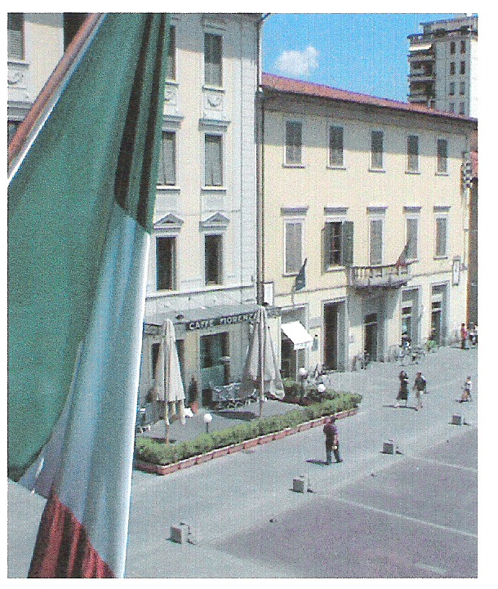 | Disegno Italia  Summer Program 2009  West Virginia University
Who: Students in Art, Art History, Fashion Design, Fashion Merchandising, Graphic Design,
Interior Design, Journalism, Landscape Architecture, Marketing, Photography, Product Design, and Theatre

Where: Two weeks: Il Sillabo, San Giovanni Valdarno, Tuscany, Italy
Two weeks: Nuova Accademia Di Belle Arti Milano (NABA), Milan, Italy

What: Six-semester-credit summer program taught in English. Space is contingent upon availability; first come, first served

When: Departure June 27, 2009, check-in date in Tuscany, June 28, 2009. Classes held June 28, 2009 – July 24, 2009. Check-out date in Milan, July 26, 2009.

Cost: $6,700.00 – Includes:
- Il Sillabo and NABA tuition and institutional fees
- Lodging
- Health insurance
- Administrative fees
- Orientation breakfast buffet, welcome dinner, cooking lesson dinner, wine/food
tasting at a farm in Chianti
- Weekend in Rome: round-trip train, hotel, guide, most entry fees
- Field trips during two weeks in Tuscany: charter bus or train, most entry fees, guide
- Round trip charter bus: Milan to San Giovanni Valdarno
- Charter bus: Milan apartments to Milan airport

Housing: Apartments: short distance from school, shared occupancy, TV, telephone, equipped kitchen

Expenses
not included:
- Airfare
- Passport
- Food
- Personal expenses
- Bus/metro, some entry fees, some materials/supplies for NABA courses (supplies can be purchased at the NABA Store on campus)

Student
Learning
Outcomes: As a result of this study abroad program, students will:
- Develop an understanding of Italian society and culture.
- Develop “survival” knowledge of Italian language, or speaking/listening skills if they have previous background.
- Develop an understanding of local culture, art, architecture, and history, and the connection to design solutions/opportunities, through field trips in central and northern Italy.
- Develop an understanding of the many cultural and design business resources in Milan as a result of guided and independent field trips.
- Apply Italian design theory and practice to the development and communication of a specific design topic.
- Enhance their understanding of art and design from a global perspective.

Program: Interdisciplinary component: Weeks 1 and 2, taught in Tuscany
This 3-credit-hour semester course will be taken by all students.
- ARHS 225/FDM 293 - Introduction to Italian Culture

Specialized component: Weeks 3 and 4, taught at NABA in Milan
Select your first and second choice from the following 3-credit-hour semester courses.

Design
- ID 293 – Interior Design Studio
- ID 293 – Product Design Studio
Fashion
- FDM 293 – Fashion Accessories Design Studio
- FDM 293 – Fashion Journalism Studio
- FDM 293 – Fashion Merchandising Studio
- FDM 293 – Fashion Photography Studio
- FDM 293 – Fashion Styling Studio
- FDM 293 – Fashion Textiles and Fibres Studio
Graphic Design
- ART 293 – Graphic Art Design for Fashion
- ART 293 – Photography and Moving Image

Program informational packets for this Faculty-Led program are available at http://www.wvu.edu/~intlprog/

For additional information, contact:
WVU Office of International Programs
Attention: Disegno Italia Summer Program
E-mail: OIP@mail.wvu.edu
336 Stansbury Hall/P.O. Box 6214
Morgantown, WV 26506-6214
Phone (304) 293-6955 x 1

