A Public Thesis Defense in Biological Sciences

“The Effects of Elevated Water Conductivity on Larval Eastern Hellbender (Cryptobranchus a. alleganiensis) Survival, Development, Locomotor Performance, and Physiology”

Presented by Sam Mathes
M.S. Student
Ecology and Evolutionary Biology

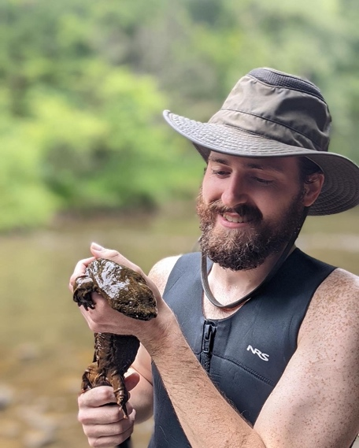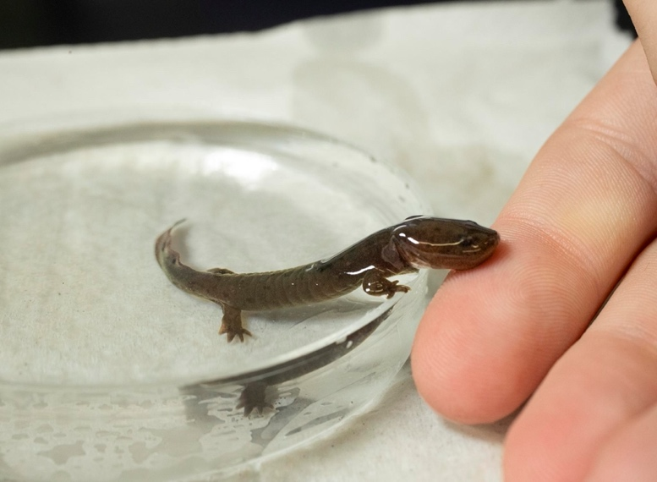

Defense will be held in person and virtually on:
Friday March 29th, 2024
9:00am
Irvine 159
Microsoft Teams Link
Advisors: Dr. Viorel D. Popescu and Dr. Shawn R. Kuchta

