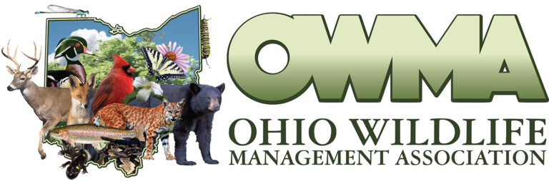Save the Date: 01-20-2023

OWMA Members,

The 63rd Ohio Wildlife Management Conference has been scheduled for January 20th, 2023. We hope you will mark your calendars and plan to join us at the Nationwide & Ohio Farm Bureau 4-H Center, 2201 Fred Taylor Drive, Columbus, OH 43210.

We are excited to announce our keynote speaker is Dr. Stan Gehrt, professor in the School of Environment and Natural Resources at The Ohio State University. The title of Dr. Gehrt’s presentation is “Mammalian Carnivores in a Human Dominated Landscape”.

We have distributed a call for abstracts, and we encourage you to share your research, knowledge, and experience via poster or oral presentation. If you have questions about abstract submission, conference details, or if your organization is interested in hosting an informational table at the 2023 conference, please let us know (contact info below).

Conference registration and a preliminary agenda will be available in the coming weeks. Up-to-date information can be found at the OWMA website: [www.ohiowildlife.org](http://www.ohiowildlife.org)

All the best,

Mark Wiley, President: [mark.wiley@dnr.ohio.gov](mailto:mark.wiley@dnr.ohio.gov)

Christina Slover: [christina.monroeswcd@gmail.com](mailto:christina.monroeswcd@gmail.com)