The Ohio University Department of Biological Sciences invites you to a public dissertation defense:

The behavioral responses to environmental stressors in swordtail fishes

Meredith Fitschen-Brown

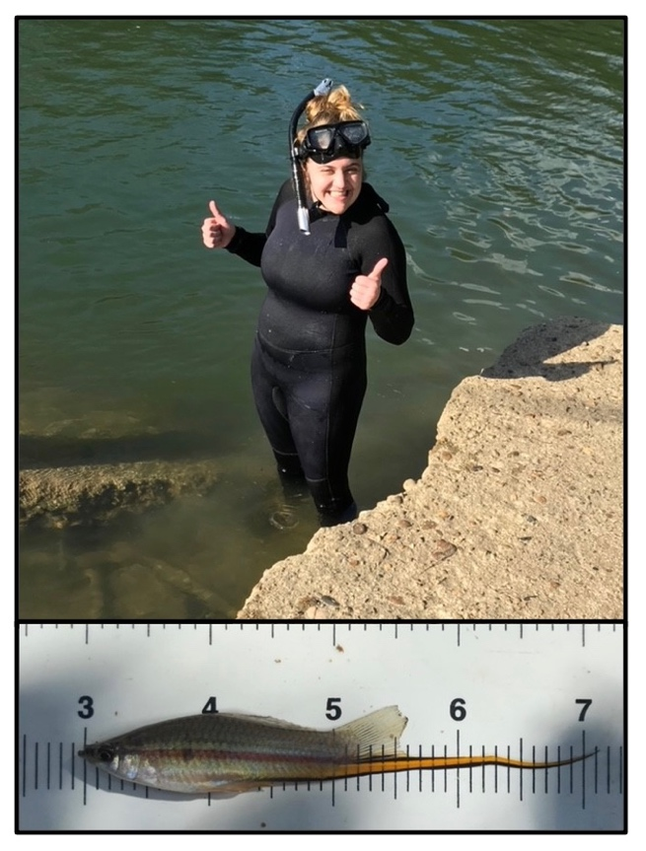

**Wednesday October 12th, 2022**

**2:00 PM EST**

[Click Here For TEAMS Link](https://teams.microsoft.com/l/meetup-join/19%3ameeting_N2Q4NmY4ZWYtODllMi00MjE1LWIyZDYtZmE0MDAzMjNkODk4%40thread.v2/0?context=%7b%22Tid%22%3a%22f3308007-477c-4a70-8889-34611817c55a%22%2c%22Oid%22%3a%22dc084ea5-037e-4fe1-8bf7-df1a0923405b%22%7d)

Advisor: Dr. Molly R. Morris