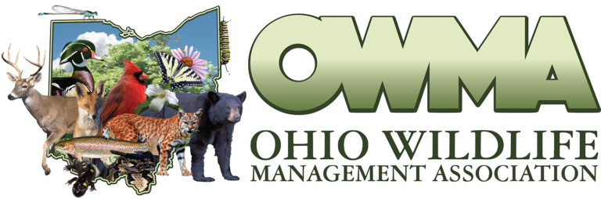Save the Date: 01-21-2022

OWMA Members,

The 62nd Ohio Wildlife Management Conference has been scheduled for January 21st, 2022 and will be held at the Nationwide & Ohio Farm Bureau 4-H Center, 2201 Fred Taylor Drive, Columbus, OH 43210.

We appreciate all who helped make the virtual conference a success last January. We are looking forward to seeing everyone in-person this coming January and expect that you will all be excited to get out and mingle with your colleagues while maintaining safety protocols (see below). While we are still in the planning phase, we have some interesting speakers lined up. We are sending a call for abstracts and posters as well as invitations for hosting informational tables.

If you or someone you know has research or information they are willing to present at the 2022 conference or if your organization is interested in having a space for a table please let us know (contact info below). please reach out to us.

Registration will open in the coming weeks via the OWMA website: [www.ohiowildlife.org](http://www.ohiowildlife.org)

All the best,

Cody Grasser, President: [CGrasser@pheasantsforever.org](mailto:CGrasser@pheasantsforever.org)

Mark Wiley, President Elect: [Mark.Wiley@dnr.ohio.gov](mailto:Mark.Wiley@dnr.ohio.gov)

**The Nationwide & Ohio Farm Bureau 4-H Center has implemented the following Health & Safety Protocols so we can all be safe and enjoy our time together:**

* The space will be sanitized before you arrive.  Hand sanitizer and disinfecting wipes will be in the room.
* Masks are required to be worn by all students, faculty, staff and visitors to all Ohio State campuses and medical facilities regardless of vaccination status.
* If anyone is experiencing COVID-19 symptoms, we ask that they refrain from coming onto campus.
* Accurate records for those present at the meeting will be kept in case someone attending the meeting/event contracts COVID-19 and is needed for contact tracing. Attendance records will be kept for at least 6 months beyond the date of the meeting/event.