Dear Wildlife and Conservation, Marine and Freshwater Biology, Environmental Biology, and Biological Sciences Majors,

Do you want to learn about ongoing research in Conservation, Ecology, Evolution, Systematics, Paleontology, Botany, and Environmental Biology at Ohio University? Are you interested in getting research experience as part of your undergraduate experience? Want to earn an easy two BIOS credits hours learning about ecological and evolutionary research at Ohio University and meet the people doing the work? If yes then consider enrolling in **U**nder**G**raduate **R**esearch **I**mmersion **P**rogram (UGRIP) and taking BIOS 3880, through the Ohio Center for Ecology and Evolutionary Studies (OCEES, [https:/www.ohio.edu/cas/ocees](https://www.ohio.edu/cas/ocees)); it may be perfect for you. UGRIP provides the opportunity for undergraduate with a strong interest in organismal or environmental biology to learn about conservation, ecological, evolutionary, or environmental research at OU.

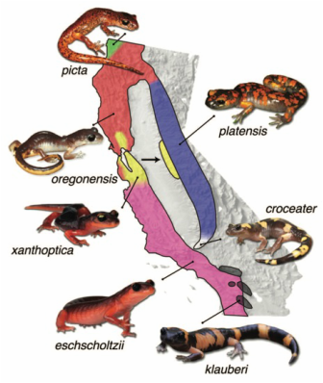UGRIP consists of two components that engage students in research during their time at OU. We offer BIOS 3880 (Undergraduate Research and Inquiry) a 2 cr. hr. class that meets every Wednesday of Spring quarter from 11:50-13:40. You attend our weekly Ecolunch research seminars and then meet with the speaker discussing their talk and research. We hope that the BIOS 3880 experience inspires your interest to become engage in research with OCCES faculty and graduate students. Our goal is to get you involved in a research experience early that can lead to a formative research experiences in your junior/ senior years. UGRIP also supports your research on a competitive basis (LIKE PURF).

The UGRIP experience will reveal the research opportunities at OU and can help you choose and focus your research interests. Students from all participating OCEES departments (Biological Sciences, Environmental and Plant Biology, Geology, Mathematics, Geography, Philosophy) are welcome.

To apply to the UGRIP program.

1. you must be a freshman or have a 3.0 GPA
2. you must apply by 1 December

Download the UGRIP Application form at <https://www.ohio.edu/ugrip-application-form>.

Applicants will be notified by mid-December and should register for BIOS 3880 for Spring Semester, don’t worry there is plenty of space available and you can register late or at the beginning of the semester (when you register for the class a permission slip will automatically be sent for my approval).

Questions or for more information contact Willem Roosenburg - [roosenbu@ohio.edu](mailto:roosenbu@ohio.edu)

](https://catmailohio-my.sharepoint.com/personal/kf573518_ohio_edu/Documents/HSRecapture.xlsx?web=1)

Cheers,

Willem

Willem Roosenburg

Director, OCEES

247 LSB