OU grad Johnson climbs the ODNR ladder
By GRACE WARNER For The Messenger April 16, 2019
https://www.athensmessenger.com/news/ou-grad-johnson-climbs-the-odnr-ladder/article_58634aaa-645d-5be4-a48f-5044a1f09c6a.html_
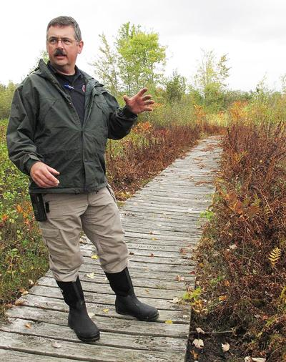
Jeff Johnson, the Ohio Department of Natural Resources chief of natural areas and preserves, is seen at Cranberry Bog State Nature Preserve near Buckeye Lake.

LOGAN — He started from the bottom and now he’s at the top.
Jeff Johnson was recently named chief of the Ohio Department of Natural Resources (ODNR) Division of Natural Areas and Preserves.
Although Johnson has always loved the outdoors and lived on the same farm he grew up on in Fairfield County, he never thought of having a career path like this.
Johnson started his career roughly 25 years ago as a seasonal maintenance worker for the division.
He had just completed his bachelors from Ohio University in zoology and was earning his masters in in evolution behavior and ecology.
“I was just finishing up my graduate work and went to a hike at one of the state nature preserves not too far from where I live,” he recalled. “When the hike was done I asked the manager if he had a job almost jokingly, and he said ‘funny you should say that, I just had an opening come up this week.’”
Johnson served as a naturalist from 1995 to 1997 at Hocking Hills State Park and as manager of the park from 2014 to 2015.
His most recent position was in the division as a natural resources administrator, where he oversaw a lot of the daily field operations and reported directly to the chief for the division of parks and watercraft.
ODNR was among the state agencies experiencing budget woes in the early 2000s. This is when the division of natural areas and preserves merged under the umbrella of parks and watercraft. The division went from 42 full-time employees to now having just nine permanent employees.
However, according to Johnson, the most important goal for he and ODNR director Mary Mertz is to focus on receiving enough funding from the state to get the program back to where it once was.
“That’s my goal is to get us back to where we were in our peak back in the late 1990s,” Johnson said. “We were recognized nationally as a leader in that preservation and conservation movement.”
Since the beginning of the year, Mertz and Johnson have been largely working together on the budget and looking at areas that need funding more than others within the division.
Although Johnson feels the goal is obtainable, that’s not his biggest concern.
“If we get the budget that’s been presented, my biggest concern at this point and time is finding enough qualified staff to fill the positions that we’re going to have to fill in such a short period of time,” added Johnson.
Johnson noted the staff they have right now is “second-to-none,” but said to fill the new positions they’ll be developing is going to take some experience.
“The reason they wanted to bring us back out (from under parks and watercraft) is because really the mission of the divisions are different enough. The types of things we work on really does warrant us working as a single unit to make sure that mission gets promoted the best it can,” stated Johnson.
The Division of Natural Areas and Preserves is responsible for identifying, acquiring and managing lands in Ohio that represent examples of Ohio’s natural landscape types, natural vegetation and geological history.
These sites, dedicated as State Nature Preserves, protect more than 30,000 acres of land that have ecological significance.

