Seminar in Conservation Biology

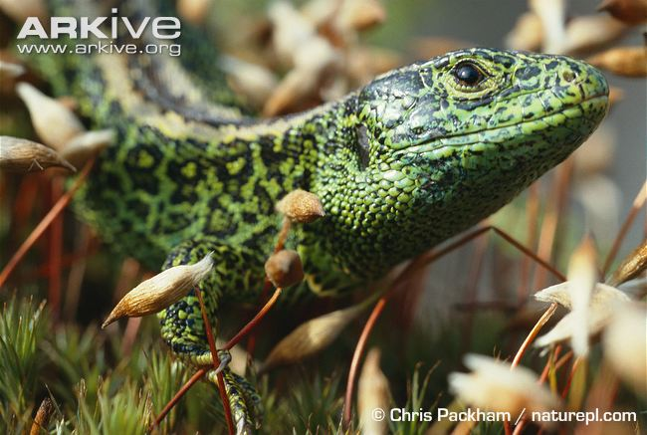
Dispersal, Population Dynamics and Conservation Biology

BIOS 7970
2 Credit Hours
Course # 1890
Organizational Meeting
Thursday 18 January
201 Life Sciences Building
1:00 pm

