PRESS RELEASE: November 25th, 2013

Organization:
Project R.I.S.E. (Realizing Individual Strength through Education)
Akron Public Schools
70 N. Broadway, Room 300
Akron Oh 44308-1911

Contact:

Rachel Breece, Child & Family Development Specialist
(330) 761-2969 / RachelBreece@gmail.com

Debra Manteghi, Program Manager & APS District Homeless Education Liaison
(330) 761-2969 / dmantegh@akron.k12.oh.us
Volunteers from the University of Akron Help Make Harvest Dinner a Success for Families Experiencing Homelessness
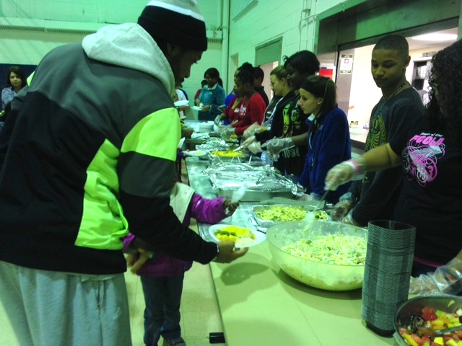
On November 18th, The Salvation Army hosted the sixth Annual Project RISE Parent RISE-ing Harvest Dinner for the students and families in varying homeless situations in the Akron Public School District. The Harvest Dinner gives these families and youth who are experiencing homelessness the opportunity to celebrate this festive time of year with food, fun and friendship. The evening included arts and literacy activities, parent-child activities, Thanksgiving dinner, giveaways, and entertainment.
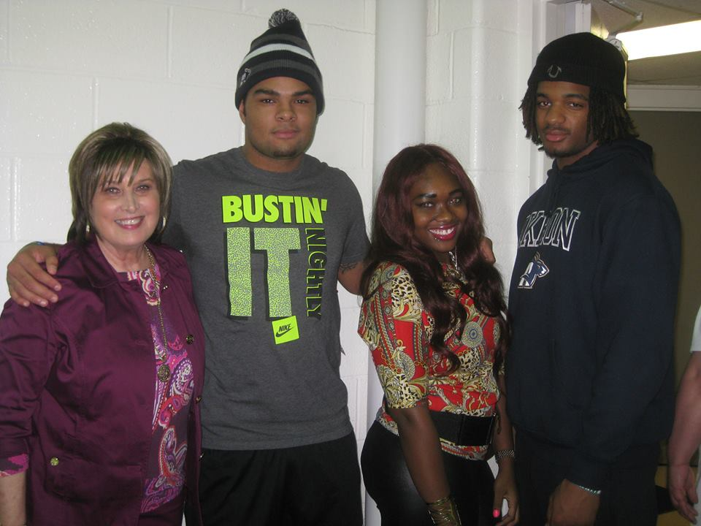
With over 150 people in attendance, without the help of some special volunteers, the event would not have been as successful. Many volunteers were from Debra Manteghi’s Family Homelessness Class from the University of Akron were in attendance at the event. The class spans over two weekends and teaches students about causes and effects of homelessness as well as laws surrounding the issue.
Keith Sconiers from the University of Akron Helps a Younger Student Fill Their Plate.
Several of these volunteers were members of the Zips football team, which delighted the children young and old! The students were able to help set up, clean up and help the young students with their activities.
Earlier in November, the students in the Family Homelessness Class got an in-depth look at Akron’s Project RISE and how the organization helps children and families experiencing homelessness.
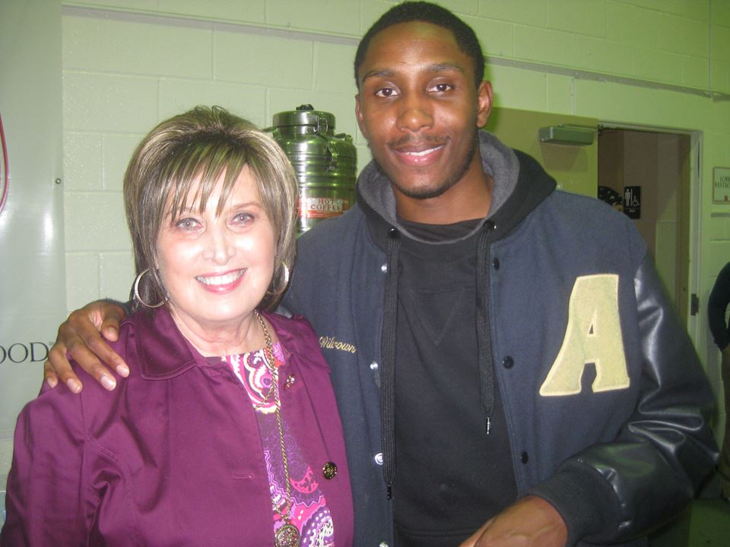
Two representatives from Project RISE made a special visit to the Family Homelessness Class to give the students a better idea of what the program was all about. The representatives presented two important programs facilitated and developed by Project RISE. Rachel Breece gave a presentation on the RISE-ing Families: Reaching New Heights Program at Akron’s Battered Women’s Shelter. Megan Heavrin presented on the Love & Learn Doll Project.
Debra Manteghi with University of Akron Students: DeOntae Moore, Je’Nae Dozier and Jerome Lane.
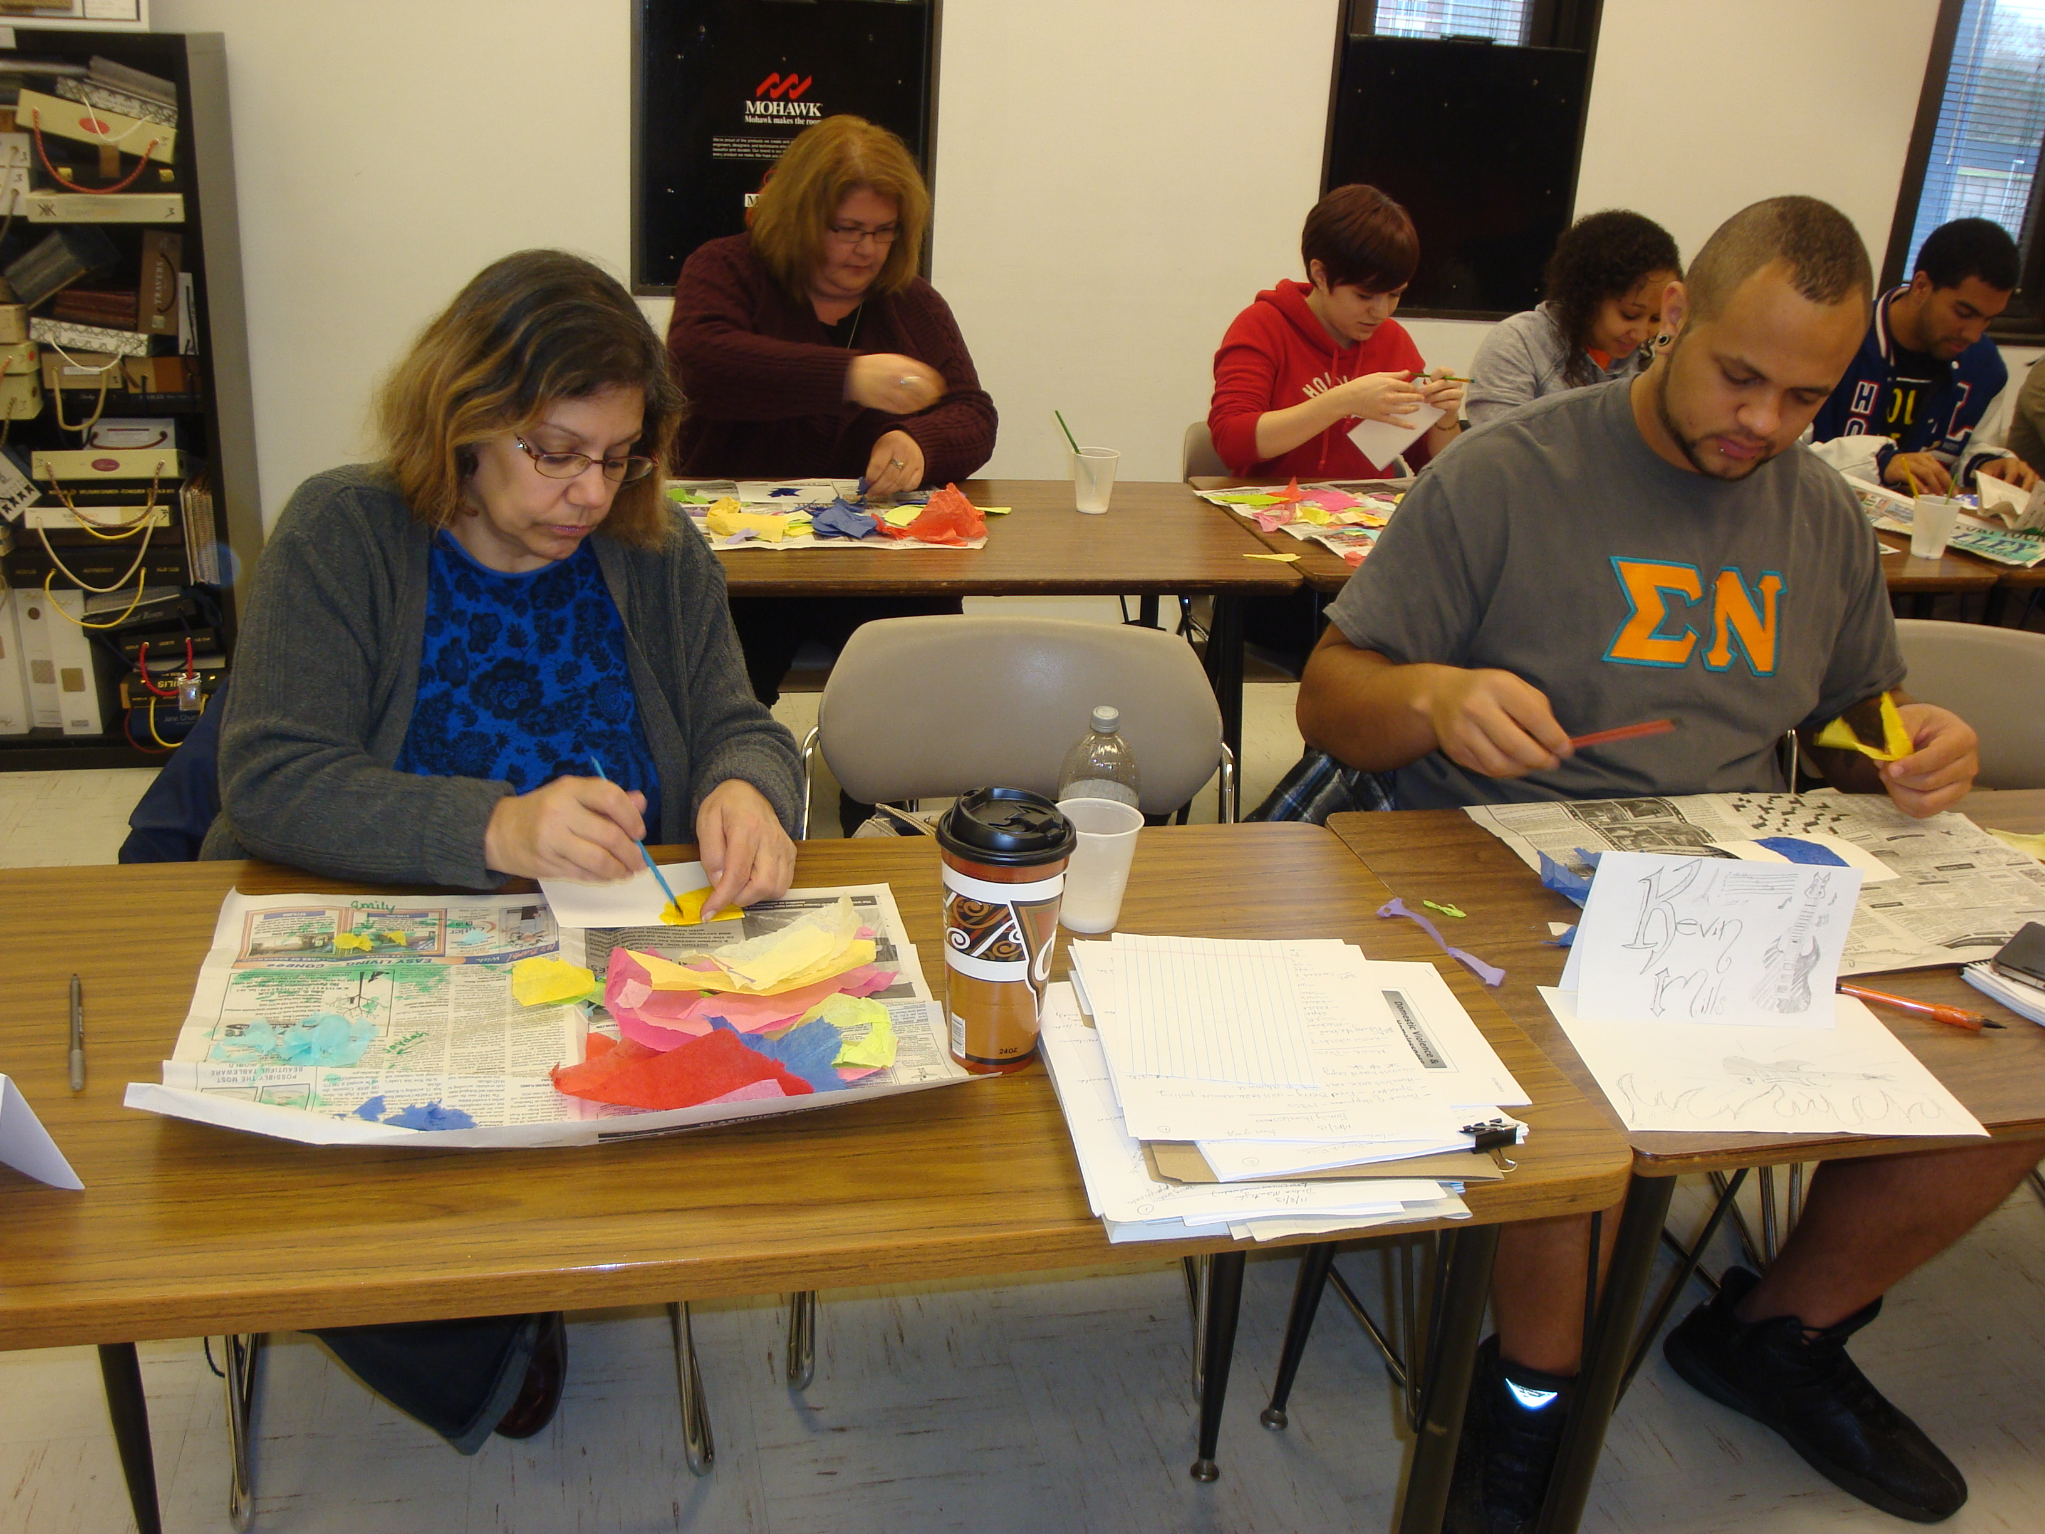
Megan Heavrin is a Child & Family Development Specialist with Project RISE. Her presentation focused on the Love & Learn Doll Project and also included a power point presentation and a group activity. The Love and Learn Doll Project strives to reach out to the children in residence in Akron’s homeless shelters and their parents. The Doll Project provides handmade dolls to young children to help facilitate positive parent-child interaction as well as school readiness skills. Each doll comes with a tote bag, baby doll quilt, story book and educational activity book.
Willie Brown from the University of Akron with Debra Manteghi
at the Harvest Dinner.

The group activity following Ms. Heavrin’s presentation focused on the six early literacy skills. The students got into small groups and brainstormed several activities to promote the early literacy skills. The ideas and discussion generated during this activity will be beneficial to the ongoing development of the Doll Project.

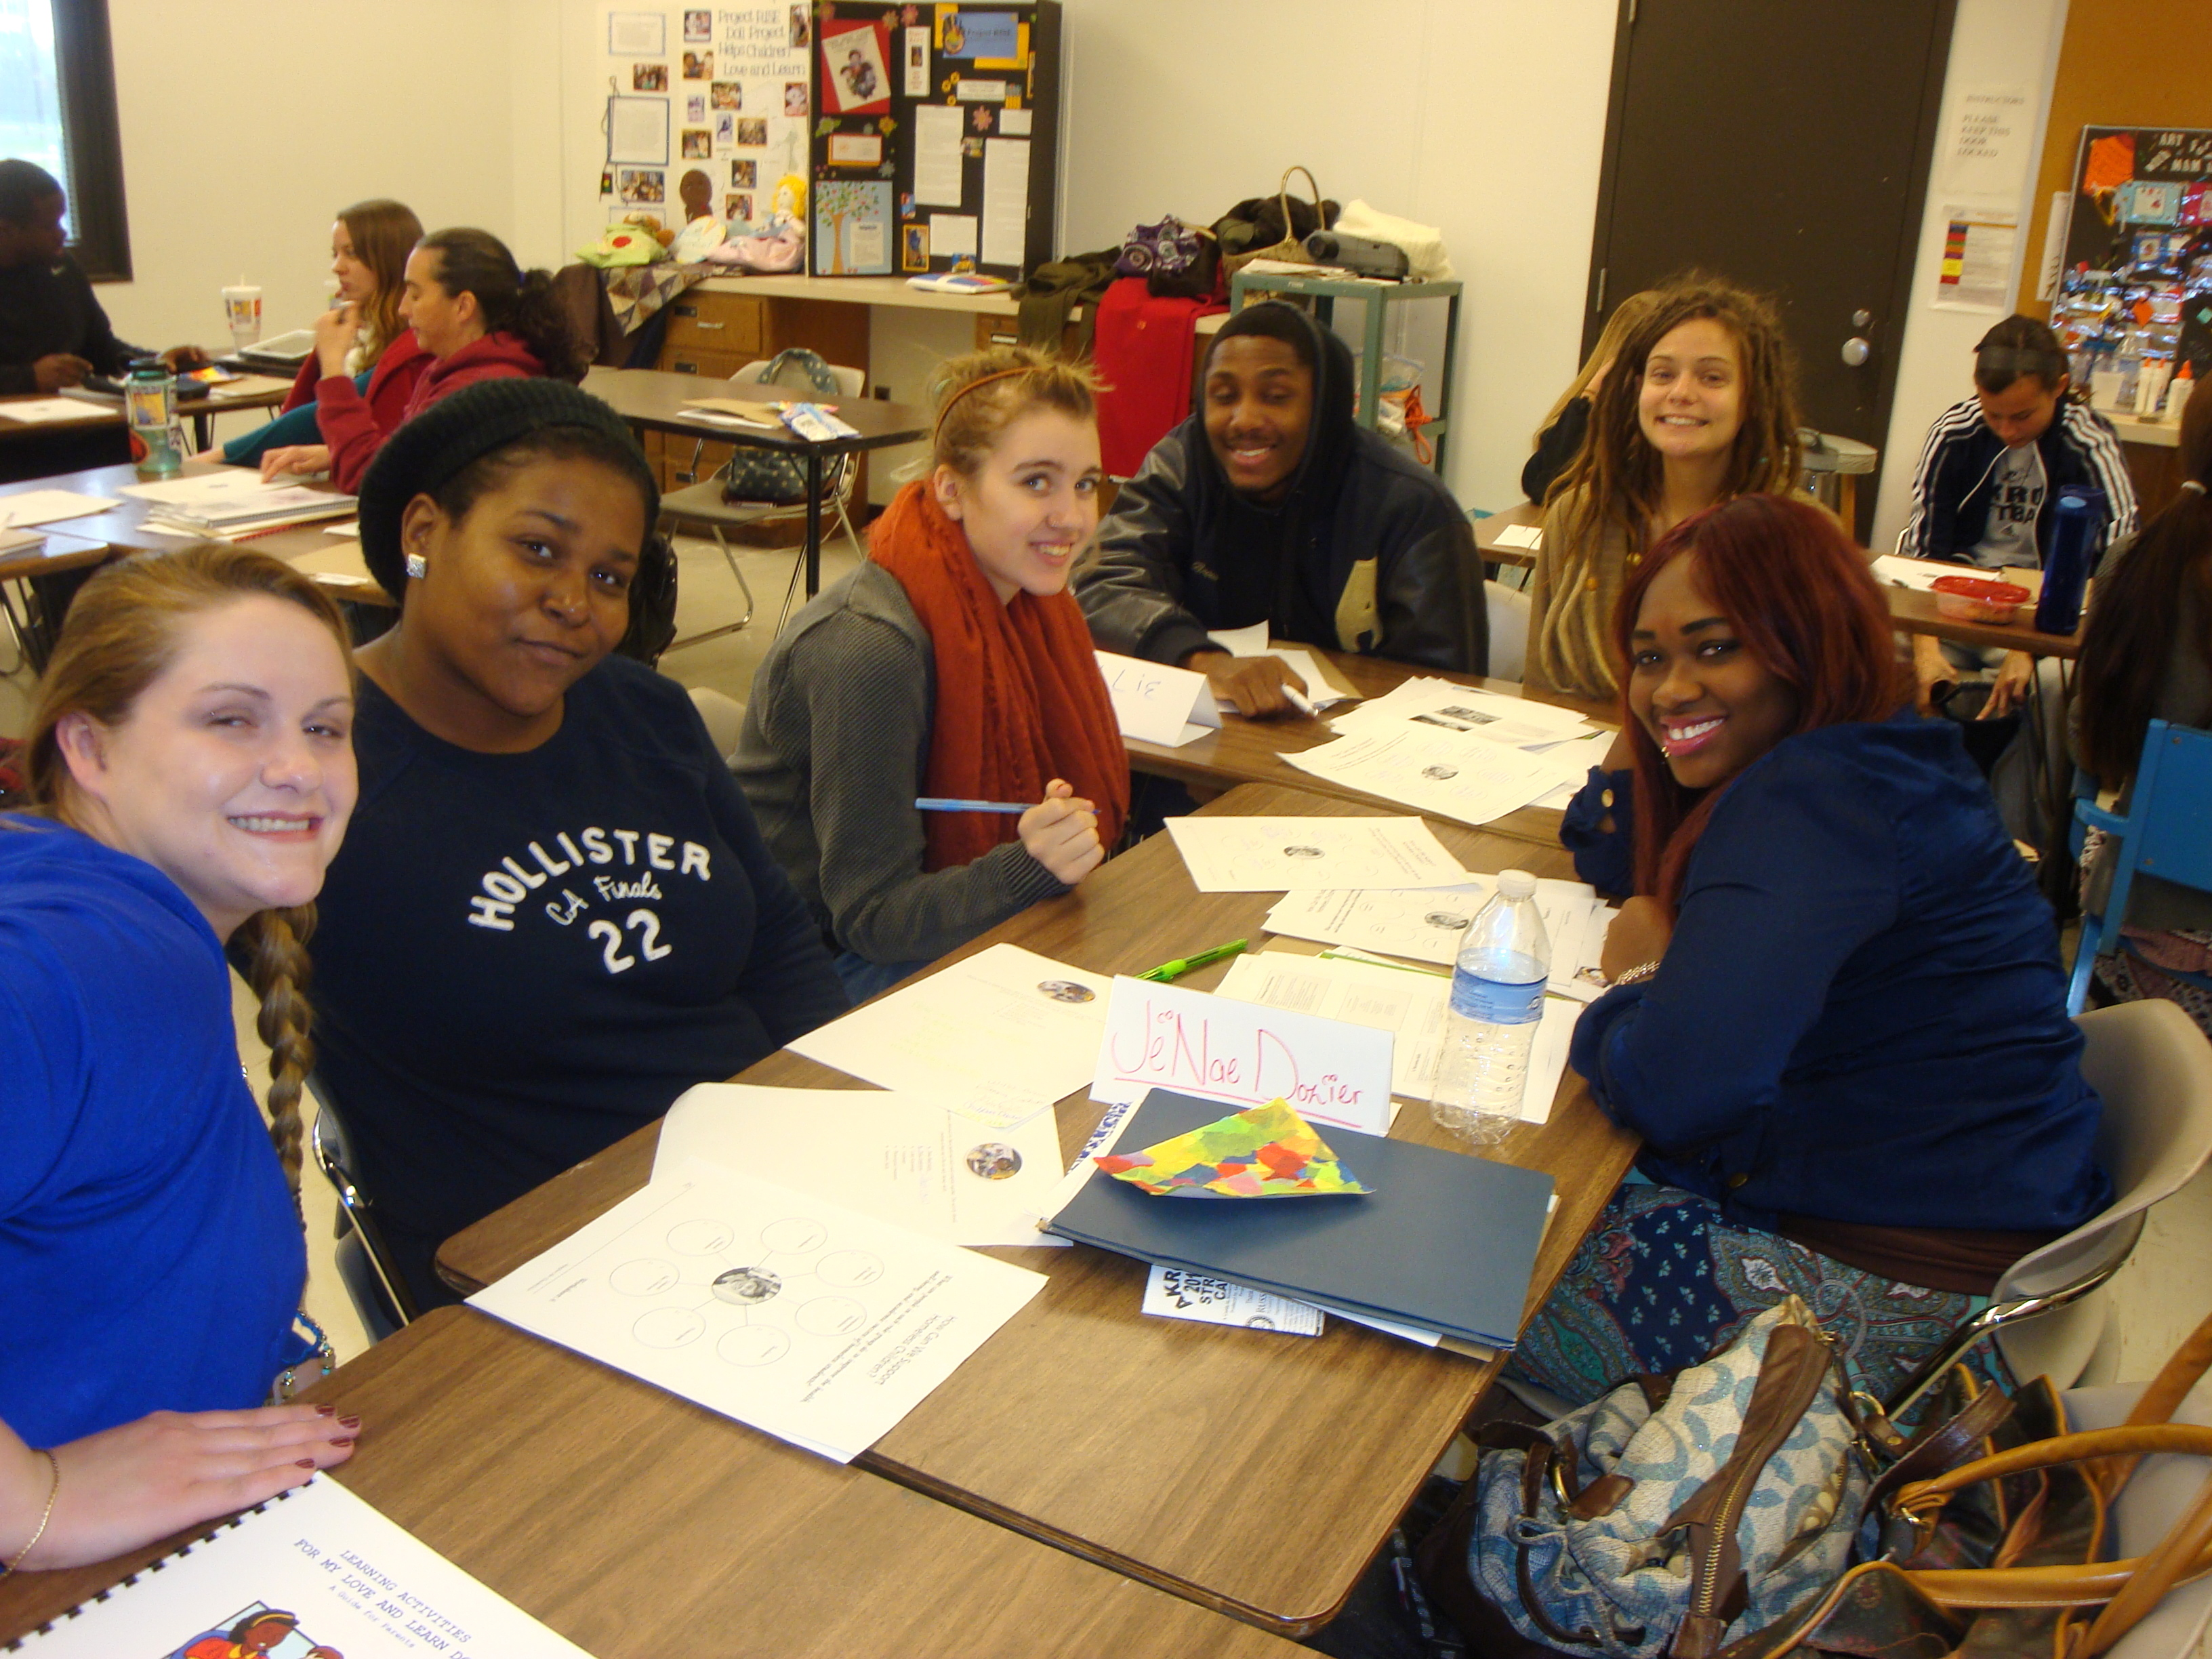
Rachel Breece, who is also a Child & Family Development Specialist for Project RISE, gave a presentation on the RISE-ing Families: Reaching New Heights Program. Ms. Breece aimed to show the session attendees what a vital part Arts & Literacy play in Project RISE. She is able to provide Educational Arts Programming at the local homeless shelters and specifically the Battered Women’s Shelter. The RISE-ing Families Program was held at the Battered Women’s Shelter during the 2012-2013 school year. The program included a parent component and was funded by the Women’s Endowment Fund.
Family Homelessness Class Participants Working on Their Mosaic Projects.

Following the PowerPoint presentation, the students were able to get a hands-on learning experience as Ms. Breece implemented a sample lesson plan with them. The students made Tissue Paper Mosaics using a water and glue mixture, paintbrushes and watercolor paper. In addition to completing the project, the students also learned some background information about Mosaics and saw sample pictures. Ms. Breece aimed for the project to be relaxing, fun, educational and confidence-building, as it is for the students residing in the shelters. The student’s projects turned out beautifully and really demonstrated their unique skill sets and perspectives, much like they do for the students in the shelters.
Family Homelessness Class Students Work on the Love & Learn Doll Project Activity with Megan Heavrin of Project RISE.

Ms. Manteghi is part of the Family & Consumer Sciences Faculty at the University of Akron. Under the Family & Consumer Sciences Department, students can focus on Child Development, Family Development, Fashion Merchandising, Interior Design or Family & Consumer Sciences Teacher Education.

The University of Akron’s Association for Educating Young Children (UAEYC), led by Dr. Susan Witt of the FCS Department, has also been involved with many service projects for Project RISE over the last few years. Some of these projects include: decorating tote bags for kids removed from their homes due to abuse, a teddy bear and t-shirt collection for kids living in shelters, blanket making workshops to give away with the Love & Learn Doll Project, a shoe collection for children in need, making Valentines for hospitalized children, and many more. Project RISE is very grateful for the collaboration of the Family & Consumer Sciences Department for all of the service learners, interns and opportunities to help us in the work we do. For more information about the Family & Consumer Sciences Department, please call Dr. Virginia Gunn at 330-972-7721 or visit the website at: http://www.uakron.edu/fcs/.

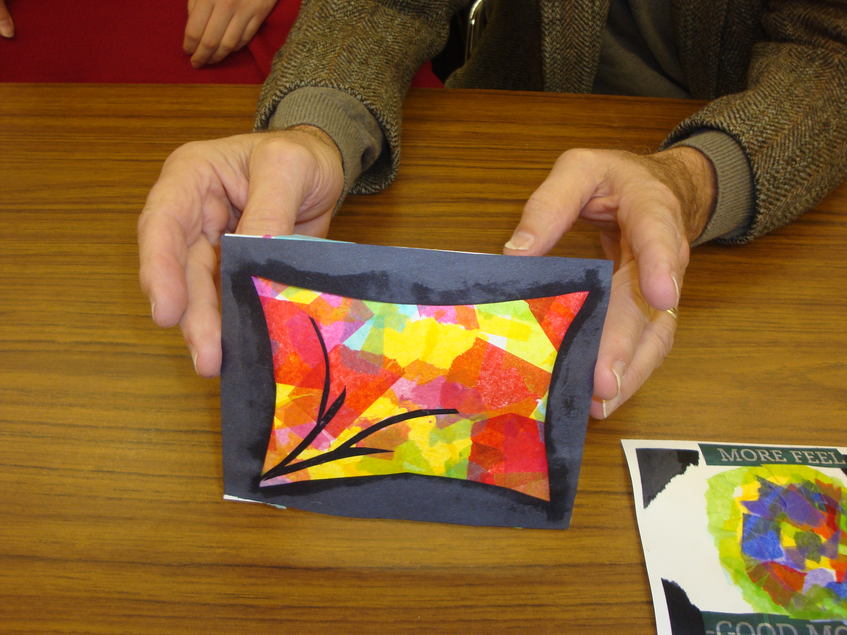
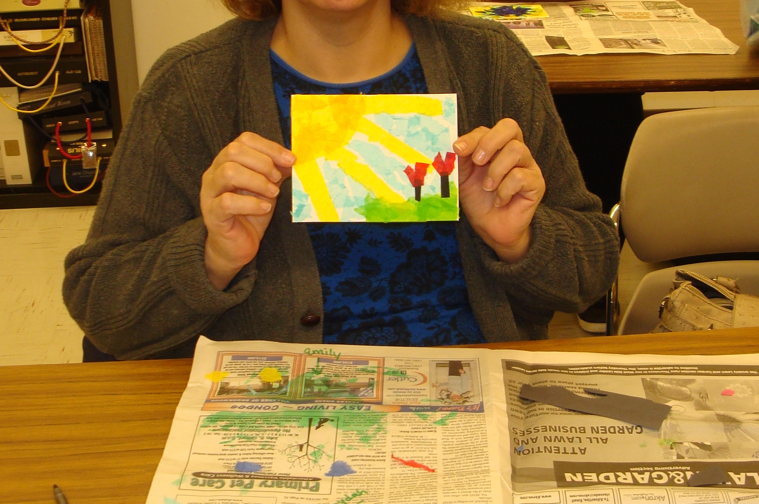
Project RISE is a federally funded program through Ohio Department of Education. This program is a collaborative effort by Akron Public Schools, local shelters and the Akron community to provide supplemental educational services to children and youth experiencing homelessness. During the 2012-2013 school year, Project RISE Identified and served over 1,200 students who were experiencing homelessness. For more information on Project RISE and how you can help, please contact Debra Manteghi at 330-761-2969 or dmantegh@akron.k12.oh.us.
Above & Below: Students Show Off Their Completed Mosaic Project

