PRESS RELEASE: November 25th, 2013

Organization:
Project R.I.S.E. (Realizing Individual Strength through Education)
Akron Public Schools
70 N. Broadway, Room 300
Akron Oh 44308-1911

Contact:

Rachel Breece, Child & Family Development Specialist
(330) 761-2969 / RachelBreece@gmail.com

Debra Manteghi, Program Manager & APS District Homeless Education Liaison
(330) 761-2969 / dmantegh@akron.k12.oh.us

Salvation Army hosts 6th Annual Project RISE Harvest Dinner for Local Families Experiencing Homelessness
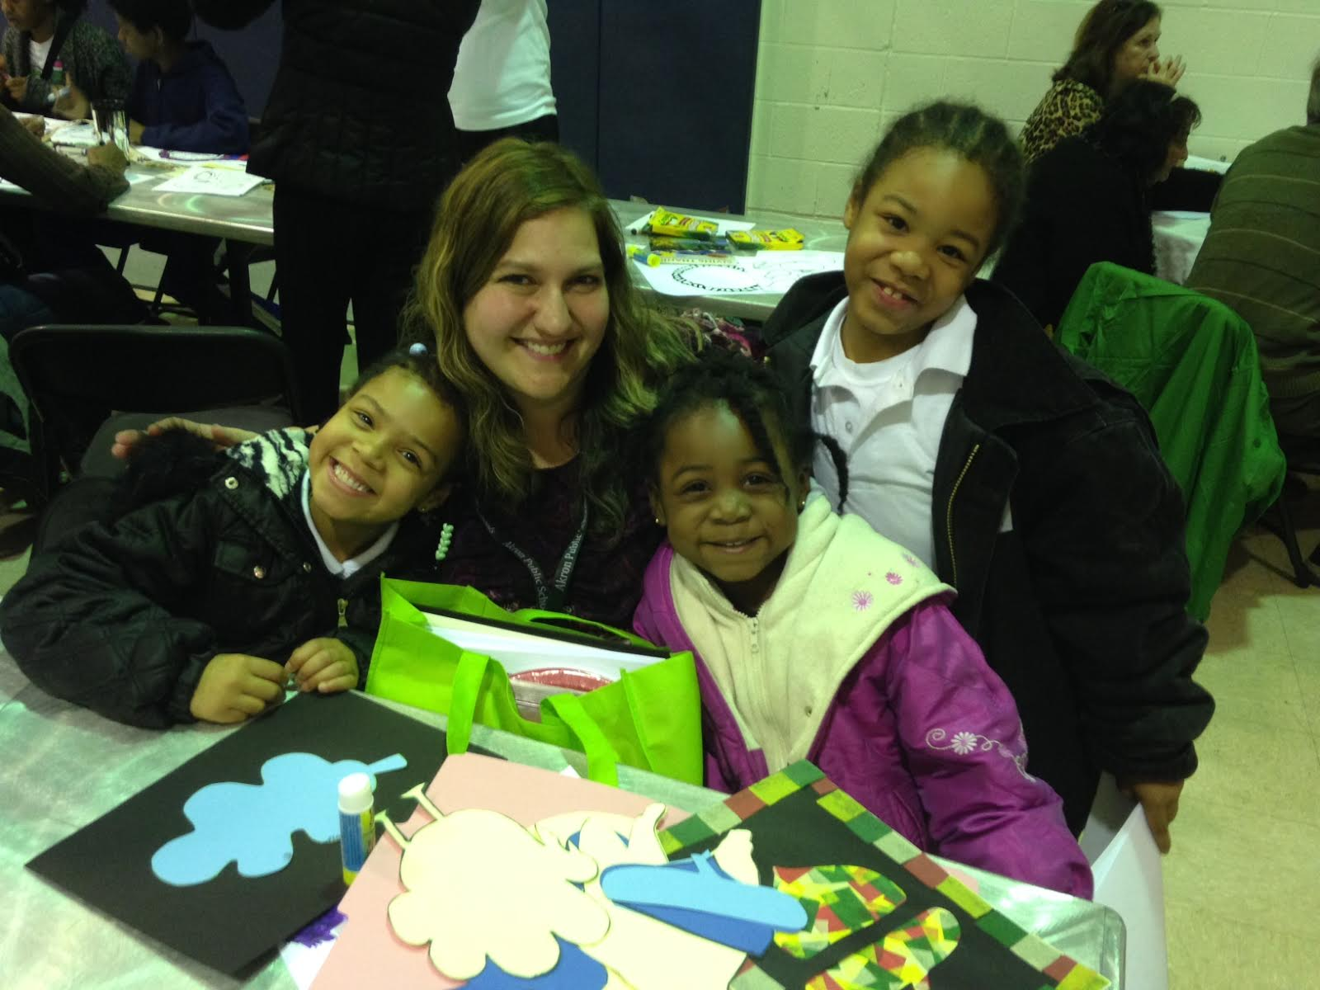
On November 18th, The Salvation Army hosted the sixth Annual Project RISE Parent RISE-ing Harvest Dinner for the students and families in varying homeless situations in the Akron Public School District. The Harvest Dinner gives these families and youth who are experiencing homelessness the opportunity to celebrate this festive time of year with food, fun and friendship. The evening included arts and literacy activities, parent-child activities, Thanksgiving dinner, giveaways, and entertainment.
The dinner was held in the gymnasium of Salvation Army in Akron. The tables were festively decorated with cornucopias and ribbon and the cheery atmosphere was felt as soon as one entered the special event.
Project RISE Staff Member, Nancy Joseph, With a Few of the
Students in Attendance.
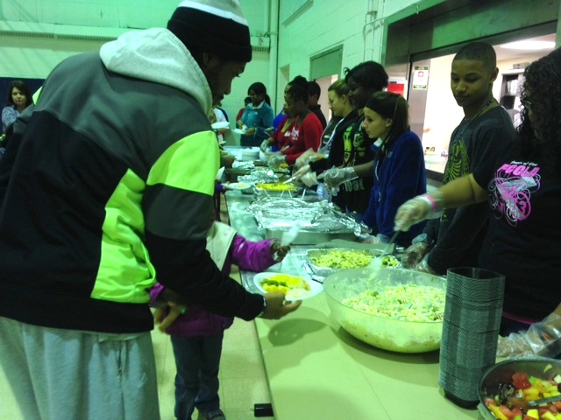
Kenmore High School’s FCCLA (Family Career & Community Leaders of America), led by Family & Consumer Science teacher, Cheryl Marez, brought 12 turkeys and helped set up, serve food and clean up. Students, staff and teachers from Kenmore High School donated enough money to allow the FCCLA to purchase the 12 turkeys.
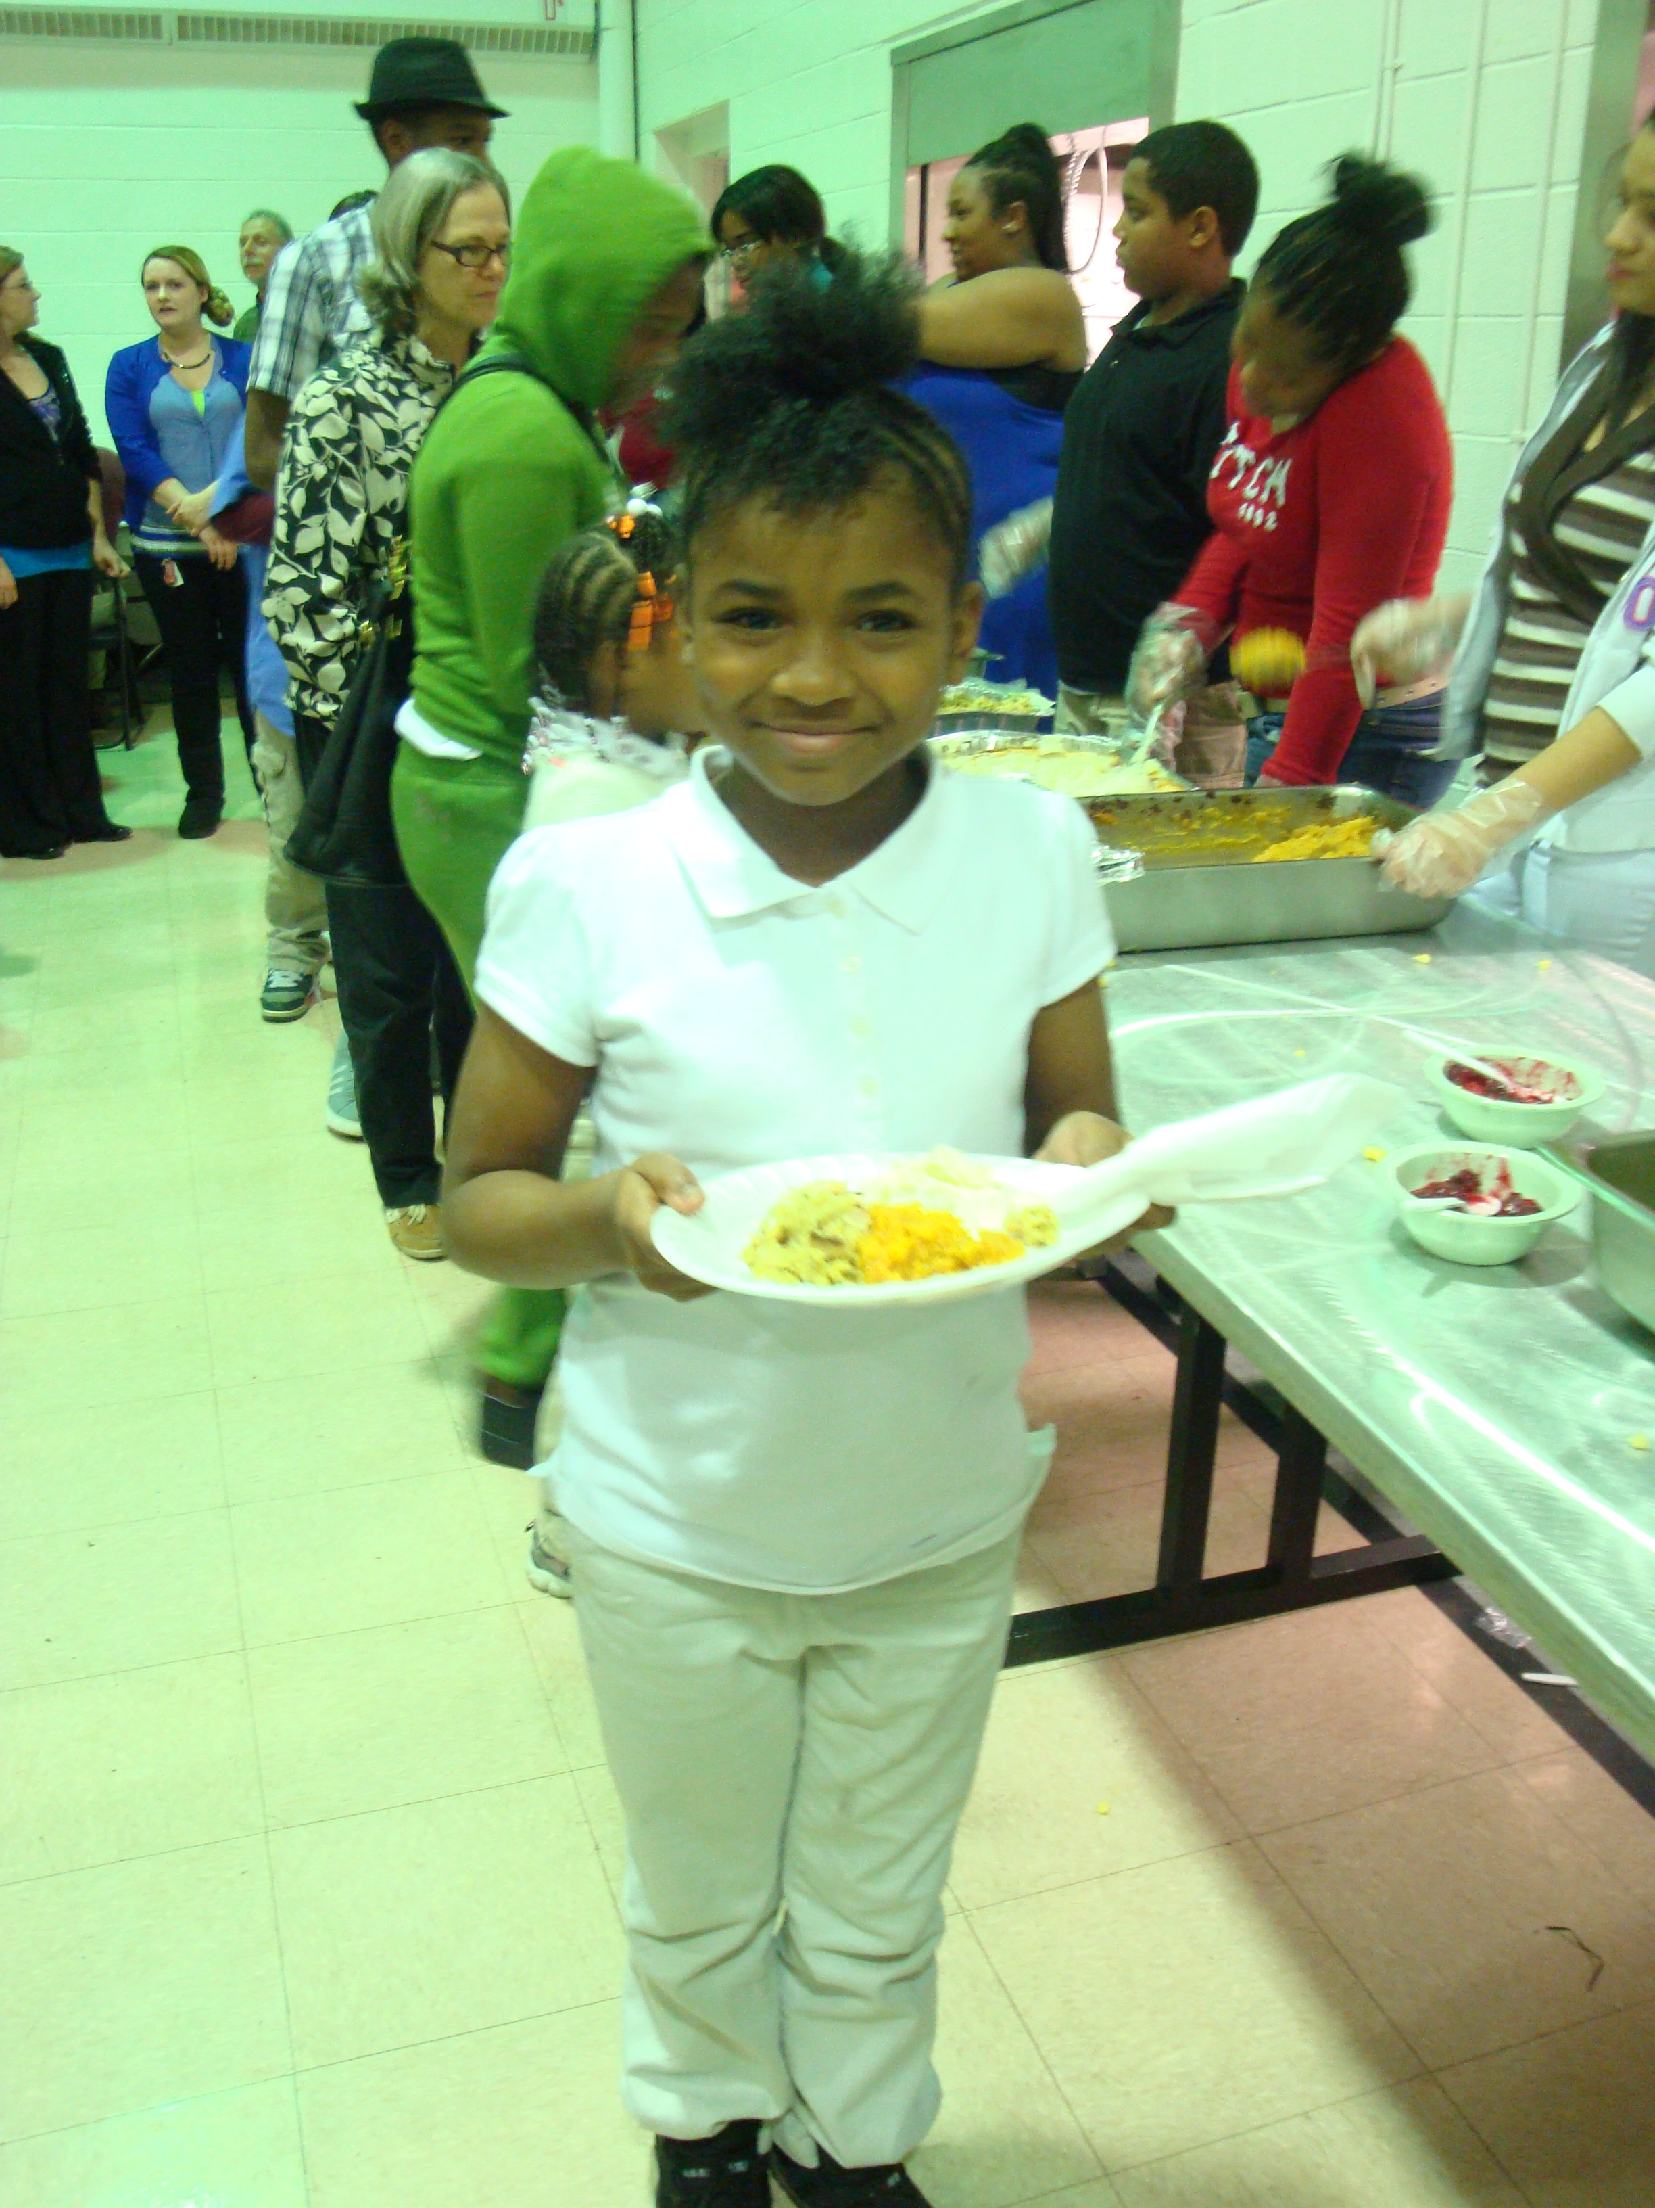
The turkeys were prepared by Mrs. Marez’ foods classes at Kenmore. Students from Susan Huntley’s Hospitality Program at East High School prepared 150 dinner rolls for the dinner. Ms. Huntley and several students also attended the dinner as special guests and volunteers. Karen Vitrano’s 8th grade students from East Middle School donated 2 pans of delicious apple crisp for dessert. Valerie Skelley’s Griff Inn Hospitality Program at Buchtel High School donated 10 pounds of corn and 60 cookies. Other dishes for the event were provided by the Local Shelters in attendance, Project RISE Staff Members and Advisory Council Members. The delicious meal was served to the 150 guests by the students from Kenmore’s FCCLA.
A Volunteer from the University of Akron Helps a Younger Student Get Served.
Several volunteers from the University of Akron were also in attendance. The students were from Debra Manteghi’s Family Homelessness Class at the University. Several of these volunteers were members of the Zips football team, which delighted the children young and old!
Not only did the Harvest Dinner provide a wonderful meal for the students and families, but also engaging activities and the distribution of donations. Before the meal, families worked on a colorful cornucopia activity together. The families had the opportunity to think about what they were thankful for, despite their hardships.
A Student with Her Full Plate.
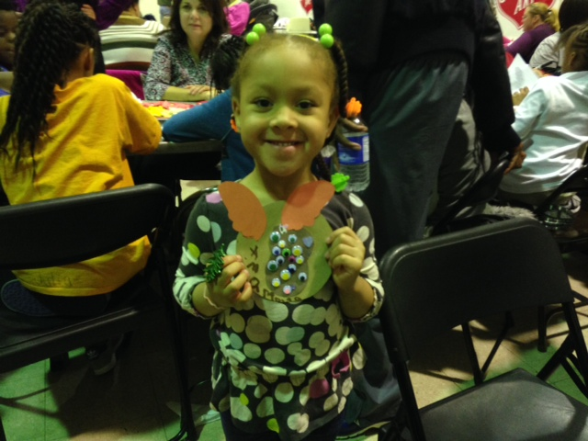
After the meal, students were invited to participate in an interactive Story Time provided by Robin Echols Cooper. Following the Interactive Story Telling, the students split up into several different age groups to do various age-appropriate activities. Activities were provided by Project RISE staff members Cindy Palumbo and Nancy Joseph, Kathy Marten and Robyn Vittek from The Akron-Summit Public Library and Patricia Wicks from Pathworks. Their activities were implemented with help from various Project RISE staff members. The parents had the opportunity to work on a group project with Bridgette Hopson of Mother’s Assisting Mothers. All the students and parents had a chance to be creative and expressive!
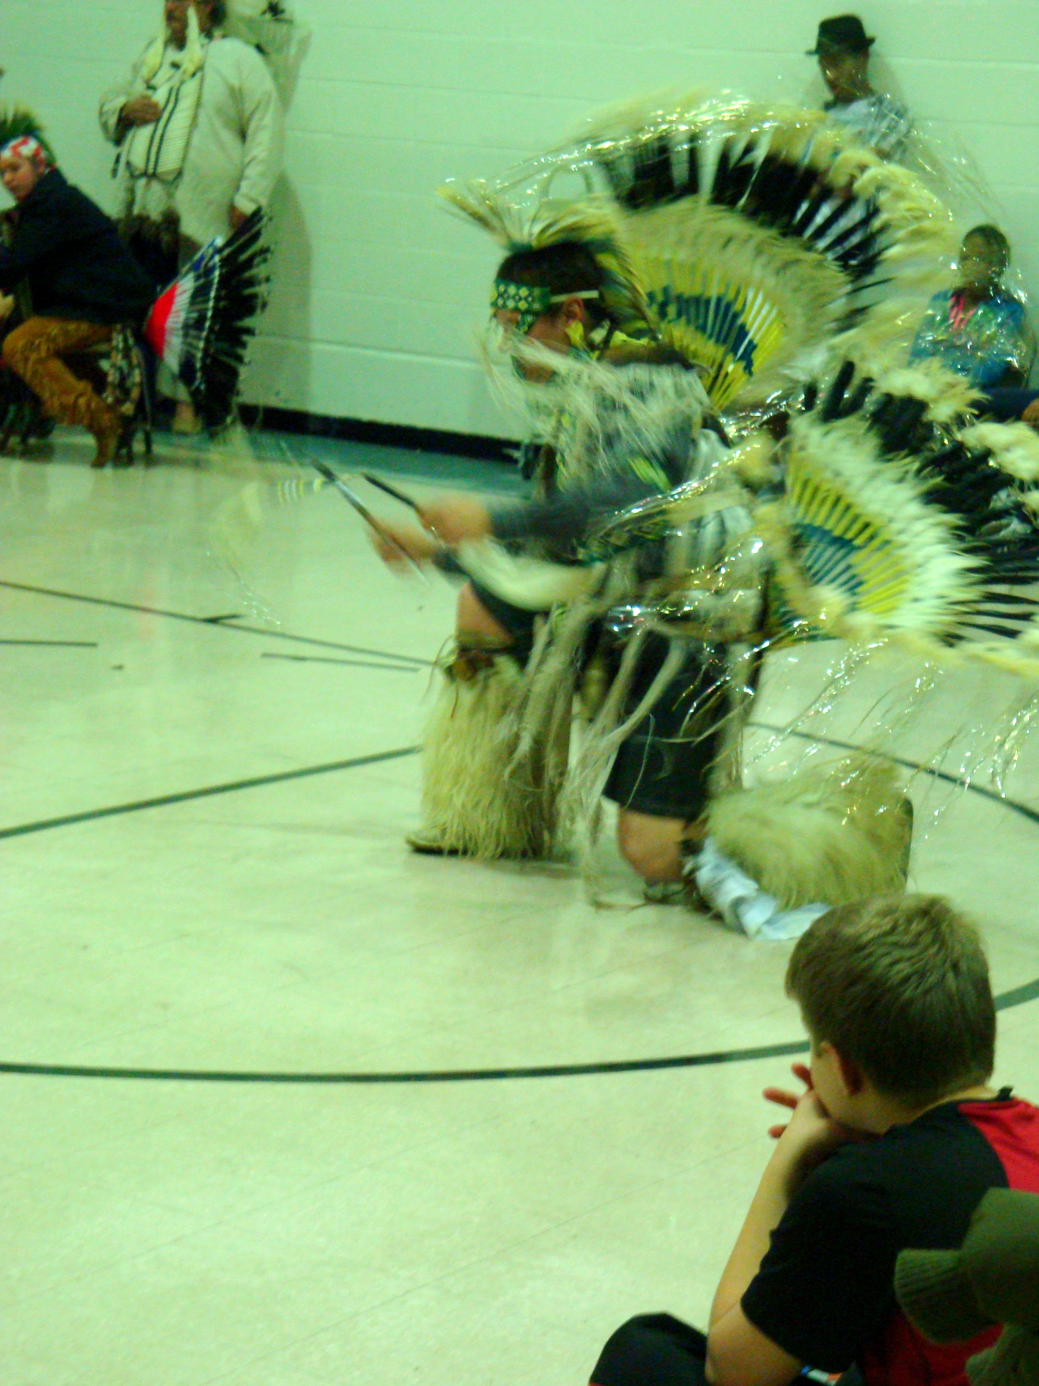
Chuck Bell of First Book also attended the event, giving new books to each student and younger children. After the activities, the students and families had the opportunity to watch traditional Native American dances performed by the Tonweya Dancers of Boy Scout Troop No. 74 from Firestone Park United Methodist Church. The audience was enchanted and captivated by the rousing dances, costumes and drumming. At the end of the performance, audience members were invited to join the dancers which made a special memory for the children and adults as well.
A Student Shows Off Her Completed Art Work.
Before they left, guests were given more donations to take with them. The Akron-Summit County Public Library donated 10 boxes of used books for the students and families to take after the dinner and entertainment. Project RISE also provided several toiletries, paper products and school supplies as giveaways.

Tonweya Dancer dazzles the crowd.
Project RISE would like to thank everyone who contributed to the donations, food and activities. Without the donations and support from Kenmore High School’s FCCLA, the shelters who contributed dishes, contributions from the Project RISE advisory council and the Salvation Army, this event would not have been possible.
One of the Tonweya Dancers Impresses Onlookers During the Dancing Presentation.
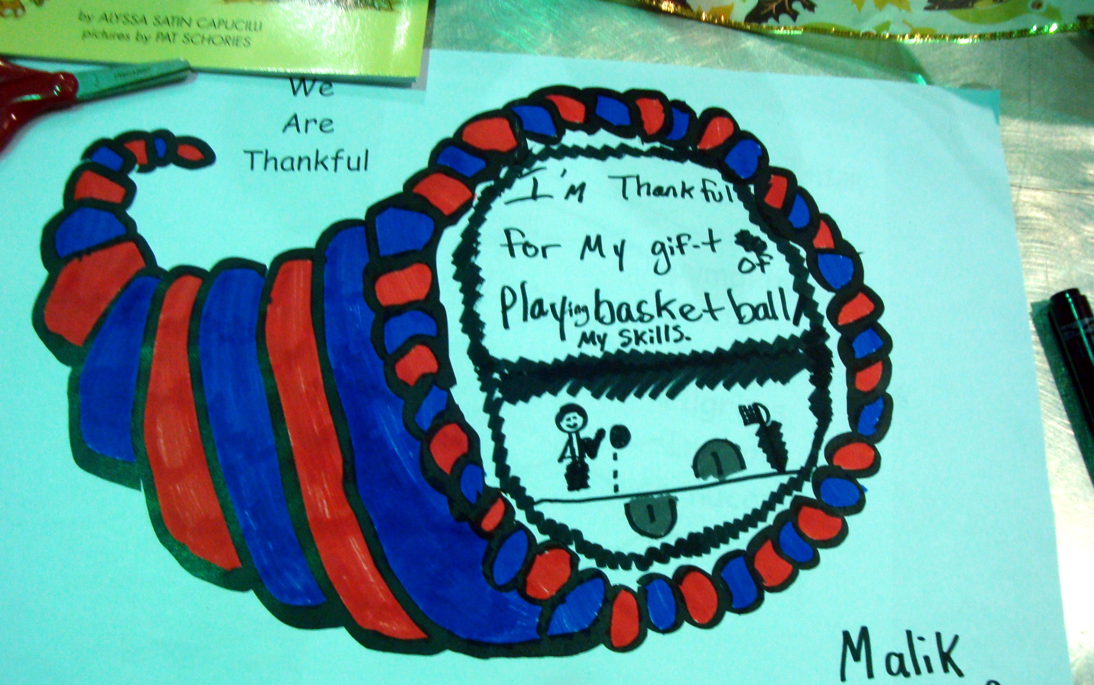
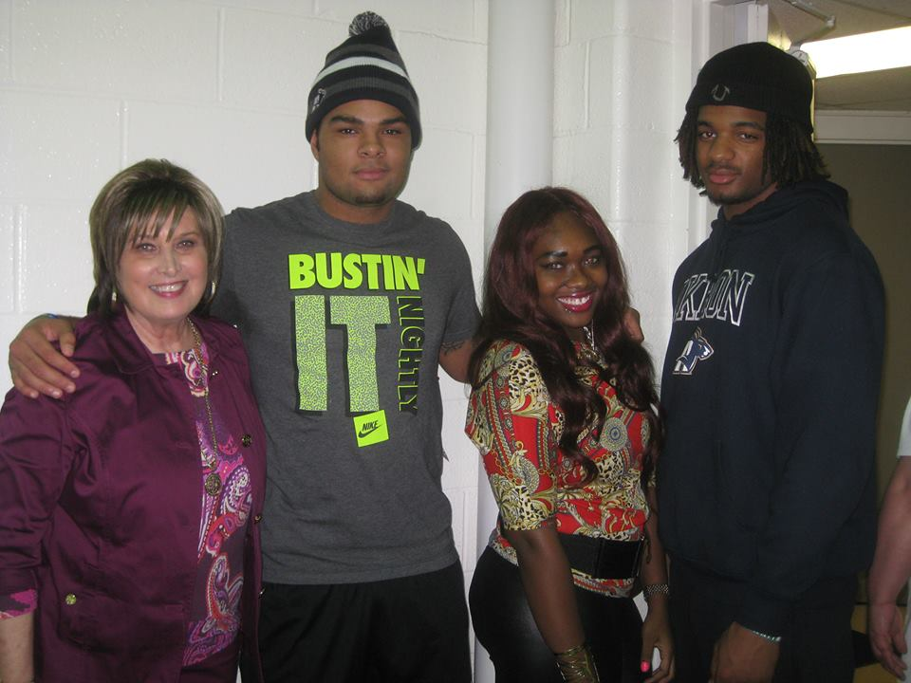
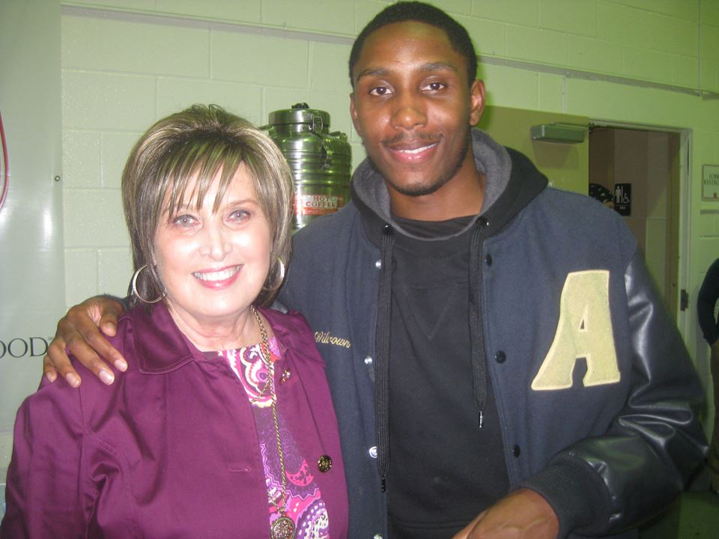
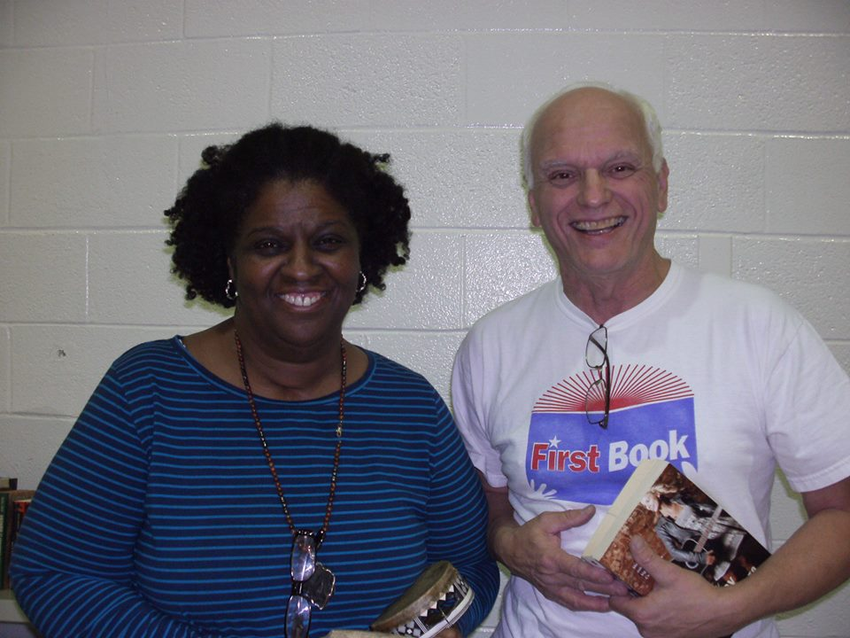
Project RISE, managed by Debra Manteghi, is a federally funded program through Ohio Department of Education. This program is a collaborative effort by Akron Public Schools, local shelters and the Akron community to provide supplemental educational services to children and youth experiencing homelessness. During the 2012-2013 school year, Project RISE Identified and served over 1,200 students who were experiencing homelessness. For more information on Project RISE and how you can help, please contact Debra Manteghi at 330-761-2969 or dmantegh@akron.k12.oh.us.
A Completed Cornucopia Project.
Debra Manteghi with Some of the University of Akron Volunteers.
A Volunteer from the University of Akron with Debra Manteghi.
Robin Echols Cooper, Storyteller, with Chuck Bell.

