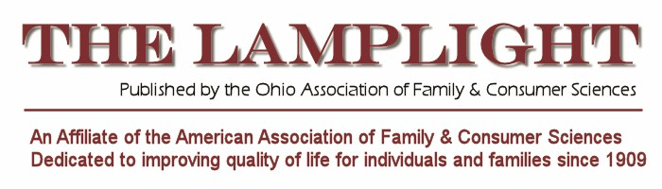
February/March 2013

Message from the President
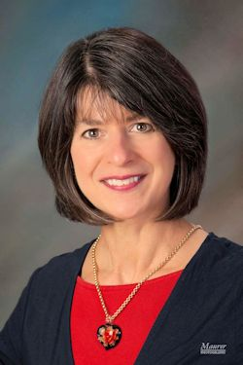
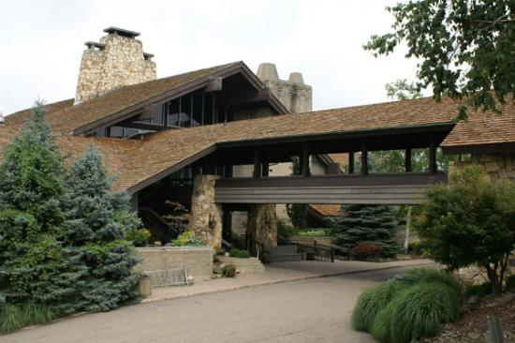
Next month is our biggest event of the year, our Annual Meeting (March 22 & 23).
Invite family and friends to join you at the beautiful Salt Fork Lodge. Kimberly Strode has worked tirelessly to plan a fun and informative meeting for all of us. Consider staying Saturday night as well, as the lodge will extend the same discounted room rate for attendees of the meeting. This would be a great way to enjoy an early spring get-away with family or friends. Check out the amenities of the lodge!

Your OAFCS board has worked hard as well – be sure to check committee reports on the website. WE are the association. Please consider joining the board or offering your services on a committee. We’re always looking for professionals to move the association forward.

A recent edition of the Sunday Cleveland Plain Dealer included an article on The Value of Professional Organizations. Three major points were made: 1) networking; 2) continuing education; 3) resume builder. You are already a member! Take advantage of the opportunity to be involved with professional activities outside of work, develop your leadership skills and network with other professionals to share experience and expertise at this year’s conference.

I look forward to seeing you in March!
Deborah Sullivan


To all Ohio FCS College Students

We Want to See You at the OAFCS Conference at Salt Fork
Submitted by Brooke Scheiderer, OAFCS Student Unit Communications Liaison
The 2013 Ohio Association of Family and Consumer Sciences annual meeting is right around the corner. The annual meeting is an opportunity to get to know other college students and professionals in Ohio. Networking and professional development are the key goals of the conference.

This year the conference theme is Embracing and Managing Change through Family and Consumer Sciences. The conference is March 22-23 at Salt Fork Lodge and Conference Center in Cambridge, Ohio.

The lodge is a great get-away and features indoor/outdoor pools, running/walking trails, a Jacuzzi, game room, fitness center, gift shop, lounge, full service restaurant, basketball, volleyball, tennis, golf, and water activities. This is an exciting location to meet for two days. See all the features here: http://www.saltforkstateparklodge.com/

We look forward to seeing all FCS college students in Ohio at Salt Fork Lodge, Cambridge OH. Be sure to register soon and make your lodge reservation. Go to OAFCS Website and register by March 1, 2013.
http://www.oafcs.org/oafcs-annual-meeting/

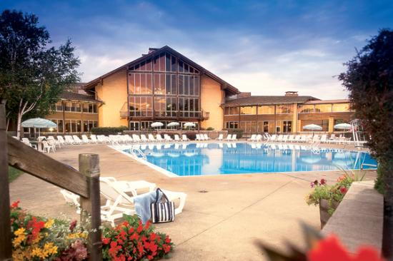

View at Salt Fork Lodge, Come join us at OAFCS
New Student Unit Election Leadership
The OAFCS College Student Unit annually elects new officers. During the business meeting elections for the 2013 OAFCS College Student Unit officers will be held. The Student Unit Business Meeting is March 22 at 2:15 PM.

New officers are being sought for each of the four positions. Please attend and nominate yourself or your FCS college student colleagues. Officers and all FCS college students are encouraged to attend AAFCS annual conference June 26-29, 2013 in Houston Texas. OAFCS provides financial support for two College Student Unit officers to attend.

All of the Student Unit officers from 2012 will be in attendance at the business meeting.
- Chair: Katie Jordan (kj119107@ohio.edu)
- Vice Chair: Megan Burney (mb375608@ohio.edu)
- Secretary: Emily Murray (emurray2@ashland.edu)
- Communication Liaison: Brooke Scheiderer (scheiderer.45@osu.edu)


The Student Unit Encourages All OAFCS Members to Support the NO KID HUNGRY Campaign!

The OAFCS Student Unit invites all OAFCS members to contribute the “No Kid Hungry, Every Kid Healthy” campaign.

The Student Unit will be collecting donations for “No Kid Hungry” during the OAFCS conference at Salt Fork, March 22, 23 2013. The first 50 people who donate will receive a “No Kid Hungry” pen or Frisbee.

Help the OAFCS College Student Unit make a difference! Checks may be written to “Share Our Strength-No Kid Hungry”.
No child should grow up hungry in America, but more than 16 million children in this country are at risk of hunger. That’s one in five children who struggle with getting enough nutritious food. These kids are sick more often and have a harder time concentrating and performing well in school. “No Kid Hungry” campaign is committed to ending childhood hunger in America.

Money raised for “No Kid Hungry, Every Kid Healthy” works to end childhood hunger by: helping to feed more kids during the summer when school lunches are not available, helping more kids start the day off on the right foot by expanding access to school breakfast, and helping afterschool and pre-school programs provide nutritious meals and snacks so kids have the nourishment they need to learn and grow.


The Green Fashin Designer Cntest

Do you have a GREEN thumb…when it comes to your clothes? Green fashions are not only Earth friendly, but innovative in the eyes of fashion all over the world!

We’d like YOU to show off your creative designs in a green way at this year’s Ohio Association of Family and Consumer Sciences Conference! If you have a unique idea for a green fashion, we want to show it off and recognize your talents!

All submissions will be sent to the annual OAFCS Conference in Cambridge, OH held March 22 & 23, 2013 and will be displayed and voted upon by attending audiences. The winning designers will receive prizes, along with recognition for their unique creations!
Categories:
Most Unique Design ~ Best Use of Materials ~ Spring 2013 On Trend ~ Honorable Mention

Submit your original design ideas with the Green Fashion Designer Submission Form to Emily at emurray2@ashland.edu by March 2 *All pieces must be complete by March 19.

Contact Emily (emurray2@ashland.edu) for more information!
Application Form on Line at OAFCS Website

Looking for Officers!

District B is looking for a new Treasurer and Secretary for the upcoming year (2013-14)
They can contact me if interested. Please contact Rachel.
Rachel Matejin
President
OAFCS-District B
330-907-8807
matejinr@yahoo.com

Interested in a free ticket to the Hispanic Cultural Evening?

This year we are offering a free ticket to the Hispanic Cultural Evening to anyone joining the IFHE-US Global Legacy Society by June 1, 2013. The IFHE-US Development Fund is a 501 (c) 3 not-for-profit organization. You can bequeath a fixed dollar amount or a percentage of your estate. Another option would be to list the IFHE-US Development Fund as a beneficiary of a retirement account or life insurance policy. Your support can make a difference for many years.

A brochure is available at: www.ifhe-us.org and click on link to Global Legacy Society or contact Sharon McManus for a copy. Go here on the OAFCS website to download the event form: http://www.oafcs.org/aafcs-annual-meeting/

Submit information by showing that you have listed the IFHE-US Development Fund in your estate plans. This information is kept confidential in a safe deposit box at Macatawa Bank, Holland, Michigan. We can list you as a member of the IFHE-US Global Legacy Society or you may remain anonymous.

For further information, contact Sharon McManus at (616) 546-3394 or svmcmanus@aol.com.
Submit necessary information to:
Sharon McManus, CFCS, Director
IFHE-US Development Fund
PO Box 2403
Holland, MI 49422-2403



