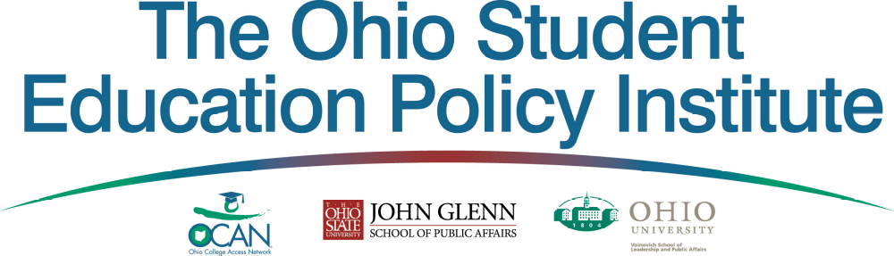

FIRST OHIO STUDENT EDUCATION POLICY INSTITUTE
February-April 2011

Between February and April of 2011, more than fifty college students from across the state will take part in the first annual Ohio Student Education Policy Institute to analyze, develop recommendations and debate the issues affecting their education and economic success. In the process, students will create policy recommendations and create an advocacy action plan to take their policy analyses directly to the policy makers of Ohio.

These students, selected through a competitive application process, will have the opportunity to hear directly from elected officials and education leaders about the challenges and opportunities that lie ahead. They will study and debate critically important policy issues such as improving high school curriculum rigor, financial aid and college accessibility, persistence to degree and college retention, as well as the economic opportunities available with the attainment of a postsecondary degree. More importantly, the students will draft and approve resolutions that they will take directly to members of the Ohio Legislature in Columbus.

Selected students will present approved resolutions to members of the Ohio Legislature in April 2011 in Columbus. All students who are selected to participate in the 1st OSEP Institute will be expected to attend the Ohio Student Education Policy Summit in downtown Columbus in April 10-12, 2011. There, students will advocate and promote college readiness, access, and success directly to elected officials and education leaders.

Every student selected to participate in the OSEP Institute (February-April, 2011) and the OSEP Summit (April 10-12, 2011) will have all their travel expenses, meals, and hotel accommodations covered. Each will also be eligible for special awards and honors presented for distinguished and notable contributions to the student conference.

Students participating in the OSEP Conference will also benefit from:
- debating with other college students on policy issues that impact them directly
- developing a network of friends and associates around the state
- gaining valuable leadership experience that will help in career preparation

Eligibility Requirements:
- Enrolled full- or part-time in a college or university in the state of Ohio
- Attendance at the Ohio Education Policy Student Institute Kick-Off meeting in Columbus, OH on February 18, 2011
- 15 hours of convening with university team prior to Ohio Education Policy Student Summit
- 8-10 independent research hours
- Attendance at the 2-day Ohio Education Policy Student Summit in Columbus, OH on April 10-12, 2011

If you are interested in participating in the OSEP Institute and OSEP Summit at the Capitol, please fill out the following application form.

Submit all application materials by email to whiter@ohiocan.org or by fax at (614)947-3501 by January 30, 2011.

Applicants will be selected and notified by February 10, 2011.
Participant Application

Ohio Student Education Policy Institute: February-April, 2011
Ohio Student Education Policy Summit: April 10-12, 2011

Name: ______________________________________________________________
University or College: ___________________________________________________________________
College Address: _______________________________________________________________________
Expected Graduation Year ______ Major: ______________________________
Cumulative GPA ______ Hometown: _______________________________
Previous College/University Attended (if any): _______________________________________________
Race/Ethnicity (optional): __________________________________________________________

- Are you the first person in your family to attend college? _____Yes _____No

- Have you participated in student leadership or philanthropic organizations?
_____Yes _____No
If Yes, What years? ____________________________________________
- If you did participate in student leadership or a philanthropic organization(s), did your experiences teach you anything about state government, policymaking, our educational system, or a related topic? Please explain.

_________________________________________________________________________________________________________________________________________________________________________________________________________________________________________________________________________________
__________________________________________________________________________________________

- Have you ever attended a student policy/debate or leadership conference before?

_______________________________________________________________________________________________________________________________________________________________________________________________________________________________________________________________________________
__________________________________________________________________________________________

- Are you currently working a full or part-time job in order to pay for your college education? If so, how many hours per week?

_______________________________________________________________________________________________________________________________________________________________________________________________________________________________________________________________________________
__________________________________________________________________________________________

- What are some of the extracurricular activities or clubs that you are currently involved in, including athletics?

______________________________________________________________________________________________________________________________________________________________________________________________________________________________________________________________________________
__________________________________________________________________________________________

- Looking back on your high school career, do you feel that you were adequately prepared for the demands of college-level coursework? If so, please explain what teachers, courses, or counselors were important in preparing you for college. If not, please explain what could have been done differently to prepare you better for the demands of college.

______________________________________________________________________________________________________________________________________________________________________________________________________________________________________________________________________________
__________________________________________________________________________________________
__________________________________________________________________________________________
__________________________________________________________________________________________

- Looking at your college experiences to date, what have been the most significant barriers to your success?

______________________________________________________________________________________________________________________________________________________________________________________________________________________________________________________________________________
__________________________________________________________________________________________
__________________________________________________________________________________________
__________________________________________________________________________________________

- What could your university or community college do differently to promote your success?

______________________________________________________________________________________________________________________________________________________________________________________________________________________________________________________________________________
__________________________________________________________________________________________

ESSAY: Based on your experiences and understanding of Ohio’s unique opportunities or challenges in education, please attach to this application a one-page essay outlining the ways in which you believe Ohio can improve college preparation, access, and success for first generation, low-income, or minority students-- from your experience, what would you change in the Ohio education system? How could the issue that you raised be improved upon?

Submit all application materials by email to whiter@ohiocan.org or by fax at (614) 947-3501 by January 30, 2011.

Applicants will be selected and notified by February 10, 2011.

