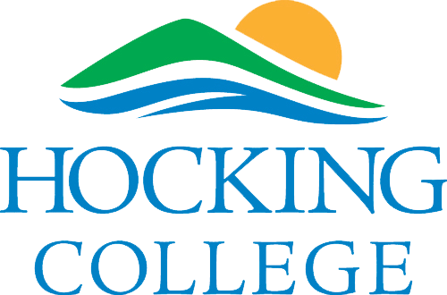

Welcome to GPS & GIS Class

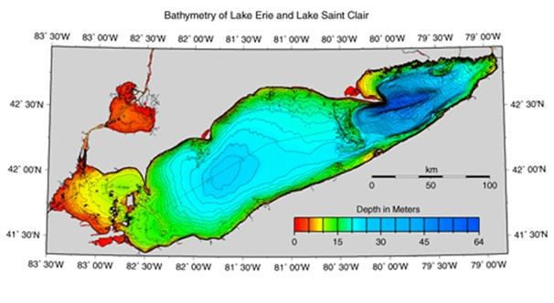

[Course description/overview]

Course Syllabus

Course Name: Introduction to GPS & GIS

Course ID: GEO-1104

Credit Hours: 3

Prerequisites: None

Approved by:

___________________________________________

Dean signature Date

Course Learning Objectives

In this course you will learn to:

Upon completion of this course, the learner is able to do the following:

1. Explain the theory of GPS operation.

2. Correctly configure and use GPS equipment and software in order to

navigate and record waypoints, preplan data capture, post-process

data and display corrected data.

3. Use different GPS set-ups to successfully collect data.

4. Prepare appropriate data dictionaries in Pathfinder Office 5.X.

5. Successfully use Trimble XM GPS for data collection (minimum Code phase).

6. Utilize Post-Processing method of differential correction to correct GPS data.

7. Successfully export GPS data for use in GIS.

8. Plot GPS position using Geographic Information System software.

9. Understand the difference between code and carrier phase.

10. Define Geographic Information Systems.

11. Create and edit spatial and attribute data.

12. Perform GIS queries and spatial joins using basic Geoprocessing tools.

13. Manipulate and analyze spatial data.

14. Create a Geodatabase and Map Topology

15. Georeference data.

16. Prepare spatial data for analysis and presentation in map and tabular form.

17. Prepare data for an ArcGIS project and present the results of geographic analysis.

18. Develop mastery of the Success Skills identified for this course.

This course also helps fulfill these program outcomes:

* Collect, manipulate and manage data using geospatial equipment, techniques, and methods;
* Utilize basic geographic information systems (GIS), global positioning systems (GPS), surveying and cartographic skills;
* Ensure quality of data and product meets professional and industry standards;
* Create effective visual, tabular, and analytical products i.e. maps, graphs, charts, statistics, databases, tables and models;
* Ability to think spatially and perform spatial analysis on geographically referenced data;
* Assist in development and implementation of a project plan while monitoring time constraints;
* Use verbal and written communication skills;
* Use interpersonal skills to collaborate with others, establish relationships, network, market, and advocate for projects and the profession;
* Develop professional skills and continue to update them; and,
* Exhibit versatility and the ability to change, problem solve and maintain balance.

This course relates to these [Success Skills](https://www.hocking.edu/assessment-academic-achievement-office#skills):

* **CE** - Communicates Effectively
* **PA** - Maintains Professional Skills and Attitudes
* **CT** - Demonstrates Learning Critical Thinking, and Problem Solving Skills
* **ET** - Maintains a Code of Ethics
* **HR** - Practices Human Relations Skills
* **MS** - Demonstrates Math Skills
* **GA** - Demonstrates Community, Cultural and Global Awareness
* **IT** - Implements Career-Appropriate Technology

Books/Materials you need

* All students are required to have a laptop or tablet meeting the specifications of the Hocking technical specs policy. Having a computer will ensure you can succeed by staying connected to your college email and having access to course components that are online.
* IT IS STRONGLY RECCOMMENDED THAT A WINDOWS COMPUTER BE USED FOR THIS COURSE. IF YOUR LAPTOP IS A AN APPLE BRAND YOU MAY BE ASKED TO USE THE COMPUTERS IN THE GIS/GPS LAB AT ACCESS AND COMPLETE COURSEWORK.

Required Text: Mastering ArcGIS (provided), 8th ed., Price, McGraw-Hill. (ISBN: 9-781259-929656)

Student Required Equipment:

▪ Materials to take notes - such as, #2 pencil with eraser, ink pen,

notebook, and storage media to back up course data – minimum 4GB USB

Flash Drive.

Student Recommended Equipment:

Materials for field notes - pencil with eraser, all-weather field notebook.

What to typically expect when you go to class

Topic 1. Theory of GPS Operation

Topic 2. Introduction to GIS Software/Hardware and Data

Topic 3. Inventory and Configuration of Equipment

Topic 4. Basic Data Models/Structures and Data Input/Creation

Topic 5. GPS Navigation and Recording Waypoints

Topic 6. Scale, Datums, Projections, and Coordinate Systems

Topic 7 Uploading/Downloading Files to PC

Topic 8. Mapping & Presenting GIS Data and Cartographic Elements

Topic 9. Attribute Data and Joining Attribute Tables

Topic 10. Building Data Dictionary Files

Topic 11. GIS Queries and Spatial Joins

Topic 12. Recording Point, Base and Rover Files

Topic 13. Building a Geodatabase

Topic 14. Post-Processing for Differential Correction

Topic 15. Data Digitizing/Editing & Quality

Topic 16. Plotting of GPS Data

Topic 17. Geoprocessing with ArcToolbox

Topic 18. Exporting and Mapping GPS Data into an ESRI Shapefile Format

Topic 19. Basic Editing

Topic 20. Data Collection in Different Collection Environments

Topic 21. Georeferencing GIS Data & Network Analyst

Topic 22. Populating GPS Attribute Data into GIS Attribute Data

Topic 23. Differential and Position Correction

Topic 24. Performing Basic Spatial Analysis on Data

Topic 25. Code Versus Carrier Data Collection

Topic 26. Raster Data and Analysis using Raster Calculator

Topic 27. GPS Project Planning & GIS Project Cycle

For asynchronous online sections, which means there are no scheduled meeting times: [Explain what students do differently in this case.]

Types of Assignments/Activities

|  |  |
| --- | --- |
| Participation | Participation is not simply attending class. In order to receive full participation you should be engaged in class, assist in any group activities, and not cause a distraction in the classroom. |
| Quizzes and Labs | Each week you will have a quiz and a lab assignment. These tutorials will help prepare you for creating maps for you final project and final exams. |
| Project | Your class projects must be completed prior to taking your final exam and should be related to your field of study. |
| Final Exam | Your final exam will be 30% of your grade and be comprised of a mapping making portion as well as a knowledge from the textbook. |
| Course/Instructor Evaluation | Near the end of the course, there will be survey available to evaluate aspects of the course and instructor. Your feedback is valued and will help drive improvements in the course design, delivery, and instruction. |

Course Grade

Grading Scale

Hocking College grading scale to be used for all courses.

93% - 100% = A 73% - 76% = C

90% - 92% = A- 70% - 72% = C-

87% - 89% = B+ 68% - 69% = D+

83% - 86% = B 66% - 67% = D

80% - 82% = B- 65% = D-

77% - 79% = C+ 0% - 64% = F

*Using all of the preceding factors, you should constantly be aware of your potential final grade in the course. You are welcome and encouraged to initiate discussion with your instructor regarding your progress or other aspects of this course.*

Blackboard

All Hocking College courses are delivered in conjunction with our Learning Management System [Blackboard](https://connect.hocking.edu/authenticationendpoint/login.do?commonAuthCallerPath=%2Fsamlsso&forceAuth=false&passiveAuth=false&tenantDomain=carbon.super&sessionDataKey=53026570-7591-4961-816b-f7dd4c9765e4&relyingParty=Blackboard&type=samlsso&sp=BBTest&isSaaSApp=false&authenticators=BasicAuthenticator:LOCAL). Students are expected to actively log into their Blackboard account and subsequent courses on a regular basis. You will find information about how to contact your professor, assignments, grades, and more for your courses in Blackboard.

Click the image to view a 2-minute introduction to Blackboard:

[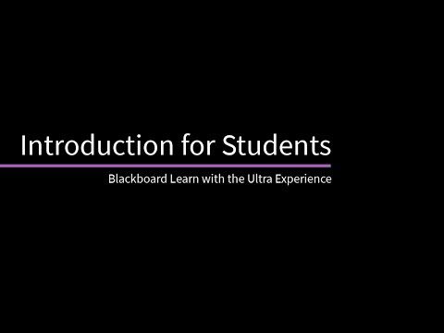](https://www.youtube.com/embed/IKjBxIe_138?feature=oembed)

You can access your courses in Blackboard in the Hocking College app OR by going to the Hocking College website at [www.hocking.edu](http://www.hocking.edu) and clicking the Blackboard link near the top.

Attendance Policy

In support of preparing Hocking College students for the world of work, the following policy has been developed to model work environments they will enter upon graduation.

**The expectation is that students attend all classes. In the event of illness or emergency, it may be necessary for a student to miss a class. To report an absence, a student must contact their faculty member in advance and make arrangements to complete all required coursework.**

**Policy**

**In an 8-week course, students have 1 Unexcused Absence**

**In a 16-week course, students have 2 Unexcused Absences**

**Unexcused absences greater than the above will result in being administratively DROPPED from the course(s).** Students administratively DROPPED from a course(s) will not be re-admitted. They will be required to repeat the course to complete the program and are responsible for all associated charges.

The College is not responsible for the student’s failure to follow the official withdraw policy. Students will be responsible for tuition and fees according to the refund policy.

Academic Success Center

The [Academic Success Center](https://www.hocking.edu/academic-support#about) (ASC) is located on the first floor of Davidson Hall. The ASC houses the Testing Center, Library, Accessibility Resource Office, and Tutoring services.

[The Testing Center](https://www.hocking.edu/testingcenter) – Location Davidson Hall Room 108. Testing Center hours are Monday – Friday, 8:00 am – 5:00 pm. Make-up tests are arranged with your instructor and can be taken on a walk-in basis. Standardized tests such as TEAS and ACE, SCANTRON and NOCTI are scheduled through the testing firm or coordinating agency and can be taken in the Hocking Testing Center. Please allow adequate time to complete an exam by the 5:00 pm closing time.

[Library services](https://www.hocking.edu/library) – The Hocking College Library is committed to the advancement of teaching and learning by providing resources and services that support the core values of the college and enriching the experience by creating a community of lifelong learners. The Hocking College Library is an OhioLINK member. All faculty, staff, and currently registered students can borrow books from the Library or from other OhioLINK member libraries through the OhioLINK Catalog, or on site at other OhioLINK libraries.

Library Hours: Autumn/Spring Semester: Summer Semester:

Monday – Thursday 7:30 am – 10:00 pm Monday – Friday 8:00 am – 5:00 pm

Friday 7:30 am – 5:00 pm

Saturday – Sunday 12:00 pm – 5:00 pm

[The Accessibility Resources Office](https://www.hocking.edu/academic-support#accessibility) – In accordance with the requirements of Title II of the Americans with Disabilities Act of 1990 and subsequent Amendments in 2008 (“ADA”), Hocking College will make reasonable modifications to its practices and will provide certain individualized services and accommodations as needed to assure nondiscrimination on the basis of disability. Students or applicants for admission who would like to request disability-related services and accommodations should contact the Director of Academic Support and Disability Services. The Accessibility Resources Office (Access Center) is located in Davidson Hall, Room 114. Accessibility Resources Office hours are Monday – Friday, 8:00 am – 5:00 pm.

Director of Academic Support and Disability Services – Erin Bowald

Contact Information: bowalde@hocking.edu

(740) 753-7103

[Tutoring](https://www.hocking.edu/academic-support#tutoring) – The Academic Success Center offers free academic assistance to all Hocking College students.From tutoring to reinforcing good study habits, they help students overcome difficulties they might have with coursework and collaborate with them in managing the challenges of academic life. Studies show that students who seek academic assistance tend to perform better in their classes and retain more information. Tutoring schedules and locations are listed on the college website here: [https://www.hocking.edu/academic-support#tutoring](https://www.hocking.edu/academic-support%23tutoring). Students are encouraged to make an appointment for tutoring, but walk-ins are welcome.

Health Resources

[Hawks Center for Well-being](https://www.hocking.edu/campus-health-wellness)

[Mental health support](https://www.hocking.edu/mental-health-resources)

Netiquette

Hocking College delivers many courses online, whether wholly or in a blended format. Online communication is expected to be professional and respectful, just as it is in a traditional classroom.

Accommodations Disabilities Notice

In conformance with the Americans with Disabilities Act of 1990, Hocking College will make reasonable accommodations to its practices to assure nondiscrimination on the basis of disability. The Access Center/Office of Disabilities Services in DVD 114 is dedicated to serving the various needs of individuals with documented disabilities and to promoting their full participation in college life.

Title IX Statement

As an instructor, I’m committed to supporting survivors of sexual misconduct, including sexual assault, sexual harassment, dating violence, domestic violence, and stalking. There are college policies that may require me to report disclosures about sexual misconduct to the Title IX coordinator whose role is to coordinate the Hocking College response to sexual misconduct.

Commitment to Diversity and Inclusion

Our mission is immeasurably enriched by the students, faculty and staff who bring diverse experiences and backgrounds to our campus. We believe that diversity comes in many flavors, not just those typically considered--race, religion, color, age, gender, national origin, sexual orientation, physical challenge, or marital status--but also in thought, political persuasion, physicality, and spirituality.

Hocking College is committed to fostering an inclusive environment where the individual differences among us are understood, respected, recognized as a source of strength, and valued as qualities that enrich the environment in which we work.

Hocking College believes that diversity is a matter of institutional integrity and plays an integral role in educational excellence. Students learn better in a diverse educational environment, and are better prepared to become active participants in our pluralistic global society.

Our institutional commitment to diversity is made visible through celebration, through opportunities for introspection, and through artistic expression. It is a commitment that never ends, an open and ongoing dedication to creating an environment within which all individuals feel safe, valued and welcomed.

Hocking College expects the members of our campus community to promote this vision as fully and conscientiously as possible.

Academic Grade Appeal Process

Academic grade appeals consist of complaints from students concerning final grades given. The Appeals Process is available only for final grades not for an individually graded assignment. When a student believes that his or her academic performance has been unfairly or improperly graded, the first recourse will be communication with the faculty member in an attempt to resolve the complaint. A student appeal of a final grade must be formally initiated within two weeks of the grade being posted. Students should understand that the burden of proof is theirs to demonstrate. Please visit the College web site for more appeal information. <http://www.hocking.edu/studentaffairs/academicappeal>

Policy Regarding Honesty

Honesty and integrity are major elements in professional behavior and are expected of each student. This is part of the Success Skill "Maintains a Code of Ethics." All work is assumed to be your own unless special permission is granted from the instructor or sources are appropriately cited. It is expected that you will be honest in all endeavors related to the completion of this course, just as you must be in all activities at work. The definition of academic misconduct that is provided in the Hocking College Student Guide applies to this course and all other courses that you are taking at the College. It is a Code I Offense:

Academic Misconduct refers to dishonesty in examination (cheating); presenting the ideas or writing of someone else's as one's own (plagiarism); knowingly furnishing false information to the college by forgery, alteration, or misuse of college documents, records or identification. Academic dishonesty includes but is not limited to:

1. Permitting another student to plagiarize or cheat from your work,
2. Submitting an academic exercise, written work, project, or computer program that has been prepared totally or in part by another,
3. Improperly acquiring knowledge of the contents of an exam,
4. Using unauthorized material during an exam, to include notes, information, calculators, or other electronic devices or programs during exams or for assignments from which they have been expressly or implicitly prohibited,
5. Submitting the same paper in two different courses without knowledge and consent of all faculty members involved,
6. Obtaining academic material through stealing or other unauthorized means,
7. Falsification of research findings and methodology.

Academic Misconduct is unacceptable behavior in all Hocking College courses. A student observed or found to be engaged in academic misconduct on a test or assignment in this course will receive will be held accountable as described by the academic school policy in addition to the Hocking College student code of conduct. A written report of the incident, signed by the instructor and the student, will be submitted to the Campus Judiciaries Office. The Office of Student Rights and Responsibilities and Judicial Affairs will conduct a judicial proceeding with the accused student, resulting in a finding of "In Violation" or "Not In Violation" of the Hocking College Code of Conduct. The outcome of the judicial process will not be used to modify or validate the specific consequence as decided by the individual faculty/program or academic unit, but may be used to determine future Judicial consequences, in demonstrating a pattern of behavior on the part of the student.

Further information pertaining to Academic Misconduct can be found by contacting the Office of Student Rights and Responsibilities and Judicial Affairs, JL 269, or by referring to the Student Code of Conduct found on the Hocking College website (www.hocking.edu).