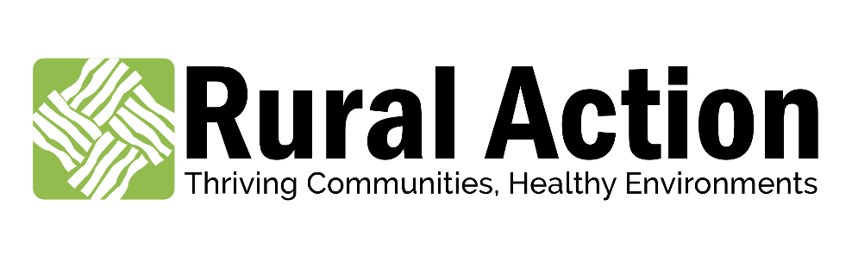

POSITION/JOB DESCRIPTION

Title: | Sustainable Forestry Program Director
Department: | Sustainable Forestry
Reports to: | Chief Program Officer
Supervises: | Sustainable Forestry Program Manager, national service member, and contractors as required.
FLSA Status: | Exempt
Hours of Work: | 40
Pay Range: | Starting at $45,000

Job Summary
The Sustainable Forestry Program Director is responsible for overall development, management, and day-to-day functioning of Rural Action’s Sustainable Forestry program and its projects. The Rural Action Sustainable Forestry program has an established and growing body of work including the cultivation and preservation of Non-Timber Forest Products (American ginseng, ramps, goldenseal, black cohosh, maple syrup, mushrooms, etc.), planting stock sales, peer-to-peer education for forest farmers in Appalachian Ohio and West Virginia on site-appropriate techniques, site visits for landowners, education and technical assistance (including rental of Rural Action-owned equipment) for land management and timber stand improvement, and more.

Key duties for this position include personnel management, oversight of grant deliverables, implementation of project activities to achieve those deliverables, and administrative support / reporting. The Director is also responsible for new project development, problem solving with team members, developing program strategies with the Chief Program Officer and Rural Action’s Leadership Team, managing partner relations and communications, and communicating decisions and needs to the CPO. The Director is expected to communicate directly with the CPO to problem solve and communicate program activities, successes, or roadblocks.

Duties and responsibilities include, but are not limited to the following areas:

Program Oversight and Personnel Supervision
- The Director is responsible for day-to-day supervision of each RA forestry staff person, forestry program AmeriCorps members, and independent contractors.
  - Undertake routine check-ins with staff and AmeriCorps members, and contractors;
  - Respond to daily requests/needs where possible;
  - Provide assistance on project implementation where time allows;
  - Communicate with the CPO on emerging issues or opportunities that involve staff, or refer staff to the CEO, Finance Director, or other management team member where needed.
- Recruit, manage, and complete all reporting and paperwork for National Service members working with the Forestry program;
- Ensure that each staff person and AmeriCorps member has a detailed workplan that they are capable of implementing;
- Establish any needed communications or information systems to facilitate supervision, reporting, monitoring, etc.

Program Development and Fundraising
- Implement semi-annual strategic planning sessions with forestry team and other staff or members for forestry program development;
- Work with the forestry team to identify and develop new projects, markets, and expand services in accordance with the organizational and program strategic plans;
- Support new idea formation through analysis and community and partner engagement;
- Understand RA’s Strategic Plan and develop projects that help achieve five-year goals in the Sustainable Forestry program;
- Work in a team setting to create a list of grant sources and a timeline for submissions and reporting;
- Perform other grant preparation and reporting activities including writing, research and data collection.

Marketing, Outreach, and Communciations
- Implement the forestry program’s communications plan in coordination with the Media & Communications team, including all materials required for print and online publications;
- Assist with the preparation of reports and presentation of data for any and all aspects of the program;
- Work with forestry team members, partners, and other programs to support and provide educational opportunities for producers and landowners;
- Ensure that all forestry program events (trainings, workshops, meetings) are produced with the highest quality for participants;
- Actively seek out new program partnerships that can result in enhanced programming and collaborations.

General Program Administration
- Communicate routinely with the CPO, CEO, and other RA staff on forestry program outcomes and activities;
- Attend external partner meetings and make presentations on Rural Action’s behalf;
- Schedule and lead routine Sustainable Forestry program team meetings;
- Update workplans for the program and all team members as required, and monitor workplan implementation;
- Prepare monthly Sustainable Forestry program reports for the CPO;
- Provide any financial information or budget reports when requested by the Finance Director;
- Work with the Development and Communications Team to grow Rural Action memberships through forestry and donor investment in Rural Action;
- Perform other duties as assigned.

Knowledge, Skills and Abilities
- Leadership skills to organize a team toward shared strategic goals, balanced with concrete grant deliverables;
- Strong interest and commitment to sustainable forestry;
- Working knowledge of forestry, and forestry issues relevant to Ohio and the Appalachian region, including: including: 1) Basic forest management and restoration practices, such as timber stand improvement (TSI), crop tree release (CTR), and invasive species control; 2) Small-scale wood products utilization and value added wood products marketing/manufacturing; 3) Non-timber forest products cultivation, processing, and markets;
- Strong project and people management skills;
- Excellent writing and phone communication skills;
- Proven ability to work with internal and external partners to accomplish projects, problem solve, and work through conflict;
- Ability to use Microsoft Excel / Google Sheets to develop planning documents and databases, including workplans;
- Experience developing and working under government and private grant funding, including proposal development and budgeting;
- Experience leading projects in a well-organized manner while being attentive to detail;
- Experience organizing public events and implementing communications/marketing plans to promote attendance;
- Shows consistent follow-through with minimal supervision.

Minimum Qualifications
- A Bachelor’s degree in a related field or related college experience;
- Three years’ experience working in a related field;
- At least one years’ experience managing staff, with strong preference for additional National Service management experience;
- Excellent communication skills, both verbal and written;
- Ability to work at a computer for long periods;
- Ability to work weekends and evenings as required;
- Ability to complete field work days on-site on private, state, and public forestland, at times in difficult-to-access locations;
- Ability to setup banners and displays at Rural Action events.

Preferred Qualifications
- Master’s Degree in Forestry or related environmental field;
- Demonstrated experience with grant-writing, grant management, and project management.

NOTE: The above noted job description is not intended to describe, in detail, the multitude of tasks that may be assigned but rather to give the associate a general sense of the responsibilities and expectations of his/her position. As the nature of business demands change so, too, may the essential functions of this position. Nothing in this job description restricts management’s right to assign or reassign duties and responsibilities to this job at any time.

Affirmative Action/Equal Opportunity
Rural Action is committed to the principles of equal employment opportunity and is committed to making employment decisions based on merit. We are committed to complying with any and all pertinent Federal, State and local laws providing equal employment opportunities, as well as all laws related to terms and conditions of employment.

This job description has been reviewed and approved by:

___________________________________________ _____________________________
Debbie Phillips, CEO Date

