*******OUTREACH NOTICE*******
WAYNE NATIONAL FOREST
Forestry Technician (Multi-Resource Crew), GS-0462-4/5
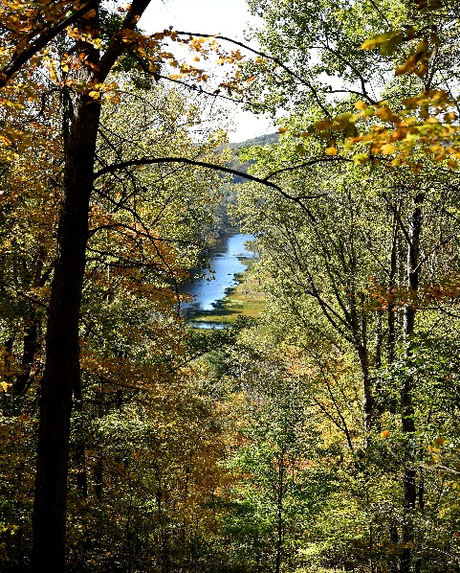
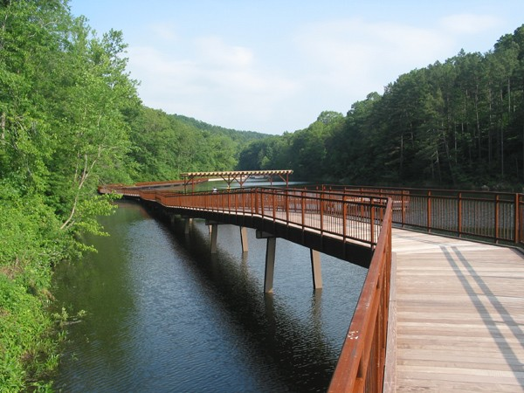
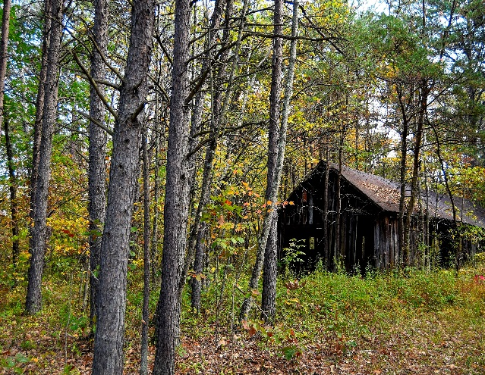

PERMANENT POSITION
Title, Series, and Grade: Forestry Technician (Multi-Resource Crew Member), GS-0462-4/5
Position: Multiple positions may be filled
Tour of Duty: Full-Time, Permanent
Duty Station: Wayne National Forest, Ironton Ranger District, Pedro, OH

The Ironton Ranger District of the Wayne National Forest is looking for an individual(s) who enjoys working outdoors doing a variety of different work across many different disciplines including timber, recreation, wildlife, botany, and fire. The position entails outdoor work in a variety of environmental conditions and hiking in rough and uneven terrain.

MAJOR DUTIES:

This position performs a variety of routine and frequently complex tasks involving techniques and practices relating to natural resources management programs, (i.e., timber and silviculture, recreation, wildlife, range, and fire and fuels management). Successful accomplishment of the following assignments supports field projects and program planning activities for the unit:

- Timber: Performs timber marking, cruising of forest products, planting, site preparation, and timber stand improvement projects to meet silviculture objectives and forest policy standards. Collects, summarizes and prepares requested timber reports and maps which provide information for planning and implementing forest management projects.

- Recreation: Assures recreation areas are maintained in accordance with standards and reports on condition of area. Makes group and individual contacts in providing forest recreation information and answering questions about recreation management on the unit. Provides specific information concerning camping or swimming and other area regulations such as fire, safety and sanitation. Notifies visitors of violations and potential violations.

- Wildlife: Makes wildlife and fish habitat surveys and implements coordination measure such as marking key areas. Performs independently, or as leader of a small project crew in construction or completing wildlife habitat improvement projects such as water developments, fish attractors, or clearing and planting site preparation areas for establishment of more desirable food or cover and other similar tasks. Participates in plant control or type conversion by flagging boundaries, operating equipment, carrying out kill studies, or reseeding.

- Vegetation: Participates in noxious plant control, seeding, or similar projects by flagging boundaries, operating equipment, and carrying out kill studies. Identifies, collects, stores, and prepares collected native plant seed for vegetation improvement projects. Identifies plants and noxious weeds and determines how they grow. Applies the proper chemicals to control noxious weeds. Uses botanical key to identify plants encountered during field trips or surveys of forest and range areas. Compiles and summarizes the vegetation types obtained from ground surveys including forest health monitoring. Layout of experimental plots by taking measurements and marking corners and boundaries.

- Fire and Fuels: Executes fuel treatment plans, slash hazard appraisals and hazard reduction plans. Records fuel treatment activity records for required reports and final project completion. Operates motor vehicles and equipment in support of fire suppression activities as capable and qualified.
Position Contact – Further Information:
For further information please contact Tim Slone, Ironton District Ranger at tim.slone@usda.gov or 740-534-6525.

About the Forest:
The Wayne National Forest is located in the rolling Appalachian foothills of southeastern Ohio. This small National Forest, in the heart of the heavily populated Midwest, covers almost a quarter million acres of Appalachian foothills. Public and private ownership is heavily interspersed within our boundaries. The Wayne is divided into three blocks administered by two Ranger Districts at Athens and Ironton. A field office is also located east of Marietta.
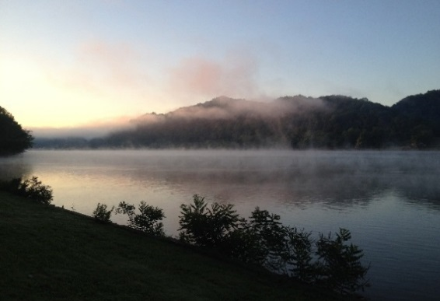
The Forest offers a variety of recreation opportunities, including camping, picnicking, fishing, hunting, nature viewing, canoeing, and much more. There are over 300 miles of Forest trails for hiking, all-terrain vehicle riding, mountain biking or horseback riding in season.

The Forest is located within an hour from Columbus, and a few hours from Akron, Cleveland, Dayton, Cincinnati, Lexington, Louisville, and Pittsburgh.
More information about the forest can be found on our websites:
www.fs.usda.gov/wayne
www.facebook.com/WayneNationalForest
www.twitter.com/WayneNationalFS

About the Ironton Ranger District and Community:
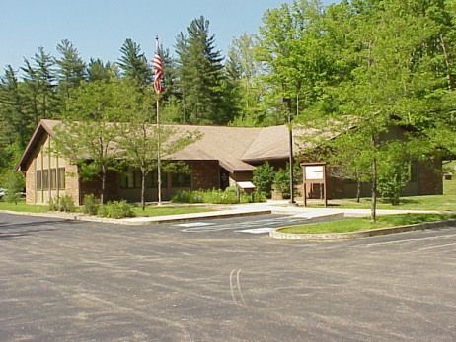
The Ironton Ranger District is the largest district on the forest with approximately 107,000 acres of Wayne National Forest. The popular Lake Vesuvius Recreation Area is located here. The rec area contains Lake Vesuvius a 143 acre lake, two campgrounds, picnic areas, group camping, fishing, boating, hiking and an archery trail. It is named for the historic Vesuvius Iron Furnace and is the Wayne National Forest's premier developed site. The rugged hills and cliff outcrops provide a scenic backdrop for this historical and beautiful area.

The Ironton District office falls within Lawrence County and is located just a few miles from Ironton, Ohio (county seat) along the Ohio River. Lawrence County is within the WV-KY-OH Metropolitan Statistical Area (MSA) and has a 2010 population of 287,202 people. Within the tri-state area there are many full service communities within driving distance to the office. The cost of living is low to average with the median home price of approximately $84,000. The rental market is good, with prices between $400 - $800.

Additional information can be found at:
http://www.lawrencecountyohio.org/ (Lawrence County Chamber of Commerce)
http://www.ironton-ohio.com/ (City of Ironton)
http://www.ashlandky.gov/ (City of Ashland, KY)
http://www.cityofhuntington.com/ (City of Huntington, WV)

The following positions will be open on www.usajobs.gov Apr. 6-12.
- Recent Graduates/Merit
  - GS-04/05 with conversion to GS-0462-06 Forestry Technicians. Multiple Positions being filled on the Wayne National Forest.

Review the job announcement carefully for required information to include in your application. Employment start dates vary.
The Forest Service is hosting webinars to help you through the application process. Join us and get answers to your questions.
Note: You may be prompted to download the free Microsoft Teams application.
- “Federal Resume Workshop” – Thursday, Mar. 25, 3-4 p.m. MDT, Microsoft Teams
- “Navigating USAJOBS” – Tuesday, Mar. 30, 3-4 p.m. MDT, Microsoft Teams
- “Eligibilities & Qualifications” – Thursday, Apr. 1, 3-4 p.m. MDT, Microsoft Teams
- “Tips for Job Seekers” – Tuesday, Apr. 8, 3-4 p.m. MDT, Microsoft Teams
Visit the Forest Service Jobs webpage, fs.usda.gov/fsjobs, to learn more about career opportunities, benefits, hiring events, and resources to help with the application process.
We look forward to working with you.

USDA is an equal opportunity provider, employer, and lender.

