Outreach Notice

Permanent Position

East Zone Fish Biologist/Hydrologist, GS-0482/1315-9/11

Mio Ranger District

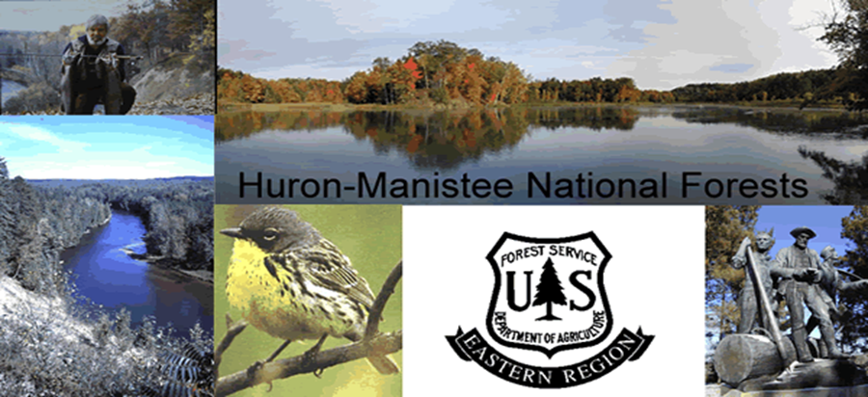

Huron-Manistee National Forests will soon be advertising for a Fish Biologist/Hydrologist, GS-0482/1315-9/11. This is a permanent appointment with a full-time tour of duty. The position will be located at the Mio Ranger District office in Mio, Michigan. The purpose of this Outreach Notice is to inform prospective applicants of this upcoming opportunity. To express interest in this position, visit the Forest Service Outreach Database, search for this position, and submit the online response no later than February 5, 2020.

This position is a shared resource for the Mio and Huron Shores Ranger Districts. Primary responsibilities for the position may include: developing plans, evaluating and implementing aquatic habitat and watershed restoration activities and projects; knowledge of fish habitat management, interrelationships of aquatic and terrestrial biota and ecological systems, hydrologic processes and riparian ecology, and watershed management principles and concepts. The candidate will be expected to provide program budgeting, project coordination and fulfill annual reporting to effectively manage the fisheries and watershed restoration programs.

Desirable skills or qualities include working in a team environment (participating on Interdisciplinary Teams and as primary Zone/District Staff), innovative problem solving, and ability to engage with partners to expand conservation, restoration and management opportunities. The HMNFs currently work in an interdisciplinary and integrated manner and this position will be a key member of our team.

The successful candidate will have the ability to communicate in writing and verbally with internal and external partners. An ability to work in a team environment is critical to success in the position. The position is expected to be able to handle long periods working at a desk, as well as enduring field work involving hiking moderate distances, in inclement weather, and on challenging terrain while carrying needed equipment and supplies.

Qualification Requirements:

Those who are interested must meet the qualification requirements for the GS-0482 or 1315 series. Administrative and Management Standards are identified in the Office of Personnel Management (OPM) Qualification Standards Handbook. The Handbook is available for review at any federal personnel office OR on the Internet at http://www.opm.gov/qualifications/Standards/group-stds/gs-admin.asp

About Mio and the Surrounding Communities:

The Mio Ranger District is in the northern portion of the Lower Peninsula of Michigan in Oscoda County. Mio has a population of 2,000 (approximately 8,500 in county) and is located 90 miles north of Saginaw, Michigan and midway on the Au Sable River. The cities of Grayling and West Branch are 35 minutes away. Other communities nearby in Oscoda County are McKinley, Comins, Fairview and Luzerne. There generally is a good selection of housing starting at $70,000; however, year-round rentals are somewhat scarce. Recreational activities in the area include fishing, hiking, swimming, camping, boating, canoeing, kayaking, tubing, hunting, motorcycle and ATV riding, snowmobiling and cross-country skiing. A nine-hole golf course is conveniently located five miles north of town and a 72-hole resort is only 20 miles distant.

For more information on the Mio area, please visit the Chamber of Commerce for Oscoda County at http://www.michigan.org/property/chamber-commerce-for-oscoda-county/

Fisheries and Hydrology on the Forest:

The Forests of Northern Michigan are rich in history. Glaciers shaped the landscape and formed many beautiful lakes and streams. There are 1,800 miles of stream and over 17,000 acres of lakes and impoundments found on these National Forests. These riverine and lake ecosystems provide habitat for diverse species of fish, invertebrates and other riparian-dependent species, including several threatened, endangered and sensitive species. They also support world class recreational fisheries that contribute greatly to the local economies. Visitor use in pursuit of fishing is high, be it for trout fishing or the fall and spring seasonal runs of salmon and steelhead.

Fisheries management is a collaborative landscape approach through watershed restoration partnerships. Partners include the Michigan Departments of Natural Resources (MDNR), Michigan Department of Environment, Great Lakes, and Energy (EGLE), Tribes, other federal agencies, local watershed councils, and other private conservation organizations.

Much of the work for stream ecosystems focuses on protecting riparian habitat (BMPs), reducing sediment delivery, re-connecting fragmented habitat (culverts), restoring structure (usually large wood), and enhancing fishing opportunities. Lake management activities within these watersheds emphasize the enhancement of fishing opportunities while protecting riparian resources.

In recent years approximately $1 million per year has been spent on the fisheries and watershed restoration program on the Huron-Manistee National Forests, with partners contributing almost 40% of this. The Forests have taken full advantage of funding opportunities such as the American Reinvestment and Recovery Act (ARRA) and currently, the Great Lakes Restoration Initiative (GLRI) programs.

Visit our Website at http://www.fs.fed.us/r9/hmnf/.
For more information, contact Andrea Ania, Forest Fish Biologist: 231-878-3801 or andrea.ania@usda.gov

Non-Discrimination Policy

The U.S. Department of Agriculture (USDA) prohibits discrimination against its customers, employees, and applicants for employment on the bases of race, color, national origin, age, disability, sex, gender identity, religion, reprisal, and where applicable, political beliefs, marital status, familial or parental status, sexual orientation, or all or part of an individual's income is derived from any public assistance program, or protected genetic information in employment or in any program or activity conducted or funded by the Department. (Not all prohibited bases will apply to all programs and/ or employment activities.)

To File an Employment Complaint

If you wish to file an employment complaint, you must contact your agency's EEO Counselor (click the hyperlink for list of EEO Counselors) within 45 days of the date of the alleged discriminatory act, event, or in the case of a personnel action. Additional information can be found online at http://www.ascr.usda.gov/complaint_filing_file.html.

To File a Program Complaint

If you wish to file a Civil Rights program complaint of discrimination, complete the USDA Program Discrimination Complaint Form, found online at http://www.ascr.usda.gov/complaint_filing_cust.html, or at any USDA office, or call (866) 632-9992 to request the form. You may also write a letter containing all of the information requested in the form. Send your completed complaint form or letter to us by mail at U.S. Department of Agriculture, Director, Office of Adjudication, 1400 Independence Avenue, S.W., Washington, D.C. 20250-9410, by fax (202) 690-7442 or email at program.intake@usda.gov.

Persons with Disabilities

Individuals who are deaf, hard of hearing or have speech disabilities and you wish to file either an EEO or program complaint please contact USDA through the Federal Relay Service at (800) 877-8339 or (800) 845-6136 (in Spanish).

Persons with disabilities who wish to file a program complaint, please see information above on how to contact us by mail directly or by email. If you require alternative means of communication for program information (e.g., Braille, large print, audiotape, etc.) please contact USDA's TARGET Center at (202) 720-2600 (voice and TDD).

OUTREACH INTEREST FORM.

Questions about the position and the Huron-Manistee National Forests Fisheries Program can be directed to Andrea Ania, Forest Fish Biologist: 231-878-3801 or andrea.ania@usda.gov

Fish Biologist/Hydrologist
GS-0482/1315-9/11
Duty Station: Mio, MI
Respond by: 02/05/2020.

Applicant Information

Name: |  |  |  |  |  | E-Mail Address:
Current Title, Series, Grade
Current Organization/Location:
Current Appointment: |  |  |  | Permanent Temporary Term Not Current Employee
If you are NOT a current permanent (career or career conditional) employee, are you eligible to be hired under any of the following authorities:
 | Reinstatement  Disabled Veteran with 30% Compensable Disability  Veteran’s Employment Opportunities Act of 1998  Other |  |  |  |  |  |  | Person With Disabilities  Former Peace Corps Volunteer  Demonstration Project (external  recruitment from the general public)  Land Management Workforce Flexibility Act (LMWFA)
THANK YOU FOR YOUR INTEREST IN OUR VACANCY.

