*******OUTREACH NOTICE*******
WAYNE NATIONAL FOREST
Forestry Technician (Multi-Resource Crew)
GS-0462-06/07
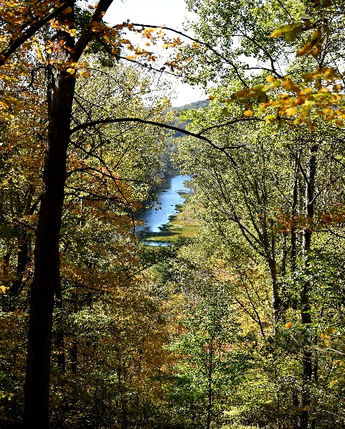
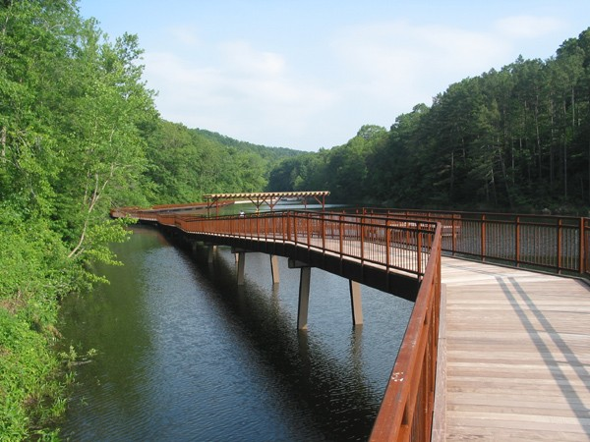
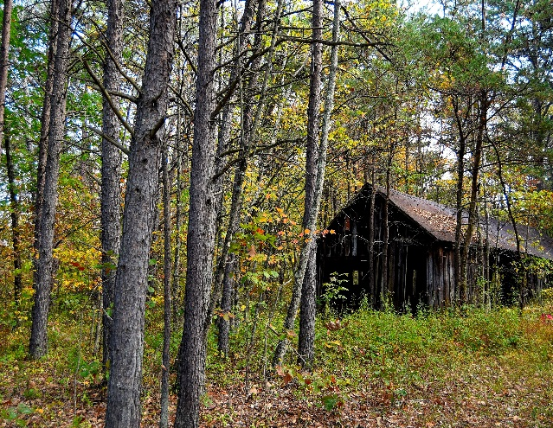

PERMANENT POSITION
Title, Series, and Grade: Forestry Technician (Multi-Resource Crew Leader), GS-0462-6/7
Position: One (1)
Tour of Duty: Full-Time, Permanent
Duty Station: Wayne National Forest, Ironton Ranger District, Pedro, OH

The Ironton Ranger District of the Wayne National Forest is looking for an individual who enjoys working outdoors doing a variety of different work across many different disciplines including timber, recreation, wildlife, botany, and fire. The position entails outdoor work in a variety of environmental conditions and hiking in rough and uneven terrain.

MAJOR DUTIES:

This position is located on a Forest Service unit and is assigned a variety of complex and recurring technical duties individually or as a crew member or team leader, in support of the unit’s various natural resource management program areas. This position performs a variety of routine and frequently complex tasks involving techniques and practices relating to natural resources management programs, (i.e., timber and silviculture, recreation, wildlife, range, and fire and fuels management). Successful accomplishment of the following assignments supports field projects and program planning activities for the unit:

- Timber: Performs timber marking, cruising of forest products, planting, site preparation, and timber stand improvement projects to meet silviculture objectives and forest policy standards. Collects, summarizes and prepares requested timber reports and maps which provide information for planning and implementing forest management projects.

- Recreation: Assures recreation areas are maintained in accordance with standards and reports on condition of area. Makes group and individual contacts in providing forest recreation information and answering questions about recreation management on the unit. Provides specific information concerning camping or swimming and other area regulations such as fire, safety and sanitation. Notifies visitors of violations and potential violations.

- Wildlife: Makes wildlife and fish habitat surveys and implements coordination measure such as marking key areas. Performs independently, or as leader of a small project crew in construction or completing wildlife habitat improvement projects such as water developments, fish attractors, or clearing and planting site preparation areas for establishment of more desirable food or cover and other similar tasks. Participates in plant control or type conversion by flagging boundaries, operating equipment, carrying out kill studies, or reseeding.

- Vegetation: Participates in noxious plant control, seeding, or similar projects by flagging boundaries, operating equipment, and carrying out kill studies. Identifies, collects, stores, and prepares collected native plant seed for vegetation improvement projects. Identifies plants and noxious weeds and determines how they grow. Applies the proper chemicals to control noxious weeds. Uses botanical key to identify plants encountered during field trips or surveys of forest and range areas. Compiles and summarizes the vegetation types obtained from ground surveys including forest health monitoring. Layout of experimental plots by taking measurements and marking corners and boundaries.

- Fire and Fuels: Executes fuel treatment plans, slash hazard appraisals and hazard reduction plans. Records fuel treatment activity records for required reports and final project completion. Operates motor vehicles and equipment in support of fire suppression activities as capable and qualified.

Position Contact – Further Information:

For further information please contact Tim Slone at timslone@fs.fed.us or 740-534-6525.

Outreach Response Database:

Responding to our outreach database provides us your contact information. To respond using the Outreach Database, please click the link below and respond. Thankyou.

Link: https://fsoutreach.gdcii.com?id=D5138F87F1E146389538B2476517DF91

About the Forest:
The Wayne National Forest, located in the hills of southeastern Ohio, encompasses approximately 244,000 acres across 12 counties. The Wayne is divided into three units (Athens, Marietta, and Ironton) administered by two Ranger Districts at Athens and Ironton. A field office is also located east of Marietta.

The Forest consists predominantly of oak/hickory and mixed hardwood forests with smaller amounts of pine in the unglaciated foothills of the Appalachian Mountains. Several smaller rivers and the much larger Ohio River are located within the Forest providing some of the best warm water fishing in the state. The Wayne National Forest was also recently rated as one of the top 10 public land hunting opportunities in the country and is known for producing large white-tailed bucks.
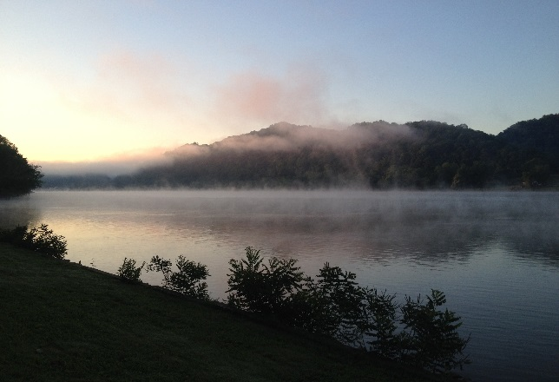
The Wayne gives visitors a chance to explore southeastern Ohio’s diverse landscape of hills, valleys, streams and rivers. Visitors are welcome to camp, hike, hunt and fish. With over 300 miles of trail for hiking, all-terrain vehicle (ATV) riding, mountain biking, and horseback riding, trail opportunities are wide-ranging. Additionally, the Wayne attracts visitors that range from medicinal root hunters and deer hunters to backpackers in an area where they can hike and camp on public land that is limited in Ohio.

The Forest boundaries surround a checkerboard pattern of ownership, with public and private ownership interspersed. As arguably one of the most complex landscapes to manage due to the urban to rural gradient, overlapping ownership issues, and diversity of public opinion, working on this Forest will provide one with a knowledge and skillset that will advance one’s career in natural resource management, as well as the support of a friendly, welcoming work environment.

More information about the forest can be found on our websites:
www.fs.usda.gov/wayne
www.facebook.com/WayneNationalForest
www.twitter.com/WayneNationalFS

About the Ironton Ranger District and Community:
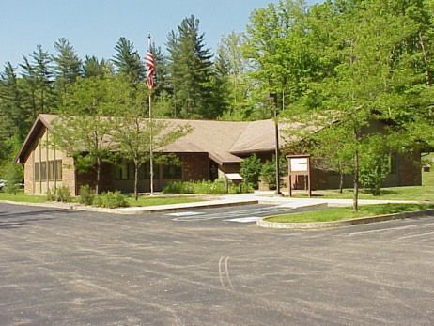
The Ironton Ranger District is the largest district on the forest with approximately 107,000 acres of Wayne National Forest. The popular Lake Vesuvius Recreation Area is located here. The rec area contains Lake Vesuvius a 143 acre lake, two campgrounds, picnic areas, group camping, fishing, boating, hiking and an archery trail. It is named for the historic Vesuvius Iron Furnace and is the Wayne National Forest's premier developed site. The rugged hills and cliff outcrops provide a scenic backdrop for this historical and beautiful area.

The Ironton District office falls within Lawrence County and is located just a few miles from Ironton, Ohio (county seat) along the Ohio River. Lawrence County is within the WV-KY-OH Metropolitan Statistical Area (MSA) and has a 2010 population of 287,202 people. Within the tri-state area there are many full service communities within driving distance to the office. The cost of living is low to average with the median home price of approximately $84,000. The rental market is good, with prices between $400 - $800.
Additional information can be found at:
http://www.lawrencecountyohio.org/ (Lawrence County Chamber of Commerce)
http://www.ironton-ohio.com/ (City of Ironton)
http://www.ashlandky.gov/ (City of Ashland, KY)
http://www.cityofhuntington.com/ (City of Huntington, WV)

