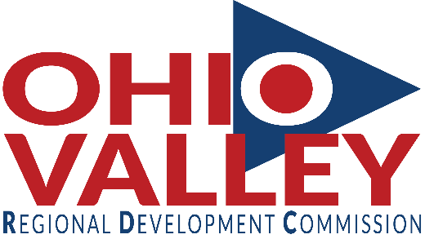

**Available Positions at OVRDC**

**Research/Planning Specialist**

Under the direction of the Planning/Development Director, the Research/Planning Specialist is primarily responsible for providing technical assistance and research with community/economic development, business development, transportation planning, as well as continually developing and maintaining the OVRDC Geographic Information System (GIS) and Global Positioning System (GPS) program.

Associate’s or Bachelor’s Degree in geography, social science, planning, public administration, or related field with at least one year of GIS or research experience preferred; or an equivalent combination of education and experience.  No special license and certification required.

Excellent benefit package including major medical, dental, and vision insurance and Ohio Public Employees Retirement System.  Annual salary range $30,000 and up.

[For more information and job description click here.](http://www.ovrdc.org/media/Research-Planning-Specialist-Job-Description-8-8-18.pdf)

Submit cover letter, resume, and three professional references to Research/Planning Specialist Position, Ohio Valley Regional Development Commission, 73 Progress Drive, Waverly, Ohio 45690-1196, or email to sclark@ovrdc.org.  All resumes must be received by **12:00 noon Friday, September 7, 2018**.

**M/F/H**

**“An Equal Opportunity Employer”**

73 Progress Drive

Waverly, OH 45690

740-947-2853

800-223-7491 (in Ohio)

www.ovrdc.org