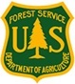
Shawnee National Forest
Trail Crew Member Summer Intern 2017
ABOUT THE POSITION:
The Shawnee National Forest’s trails program is seeking four summer volunteers or interns. Project work will be located forest wide. Participants will have opportunities to explore other program areas within the agency and to complete internship credits.
Applicants for this position should have experience or interest in learning the duties described below. This is a physically arduous job. The ideal applicant is someone interested in the outdoors, who is passionate about the stewardship of public lands and interested in a career in natural resource management.
Intern compensation includes free housing, a daily food allowance, official training/certifications, and career/life experience.
If interested or looking for more position details, please feel free to reach out to the listed point of contact.

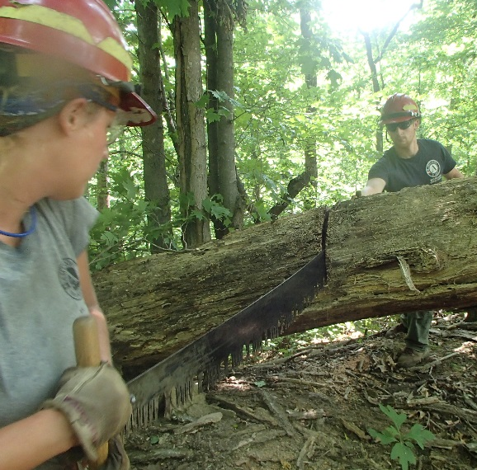
DUTIES:
Trail Crew members’ primary duty will be trails maintenance and construction in Wilderness. Use and maintenance of hand tools include axe, crosscut saw, rogue hoe, etc.
Further potential duties include:
- Assisting Resource Crew with wildlife and habitat management targets; timber marking, bat surveys, etc.
- Leading student crews and volunteers groups on day projects.
- Assisting educators in environmental education programs.
- Training on Wildland Fire Fighting.
- Assisting Biologists in removal of invasive plants.

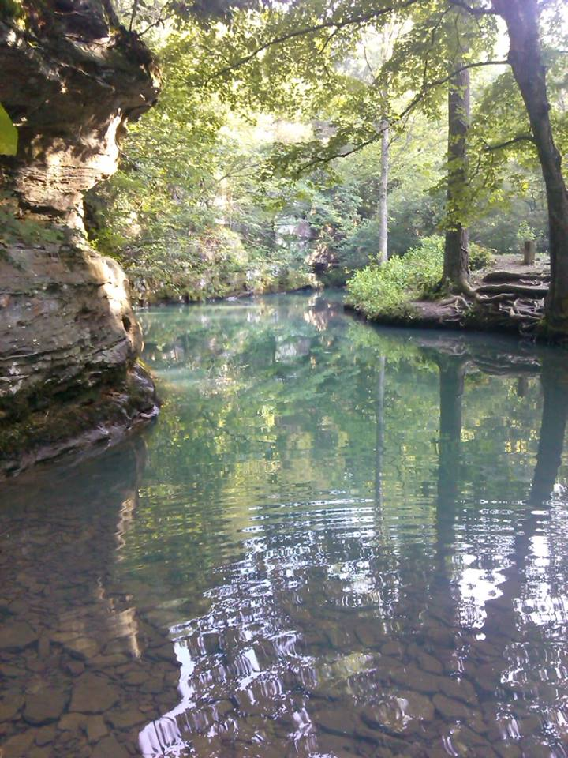
WHEN:
Approx. June 1st through Sept. 2017. Timeframe is negotiable!
WHERE:
Vienna, Illinois. Government housing is available.

CONTACT and APPLY:
Submit a resume and cover letter to:
Megan Martin at meganrmartin@fs.fed.us.
Please call or email with questions. (618) 833-8576.
Application deadline: April 02, 2017.

