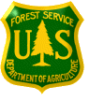
OUTREACH NOTICE

GIS Specialist
GS-0101/0401/1301-7/9
Salary Range: $39,179 – $62,297
USDA Forest Service
Southwestern Region
Santa Fe National Forest

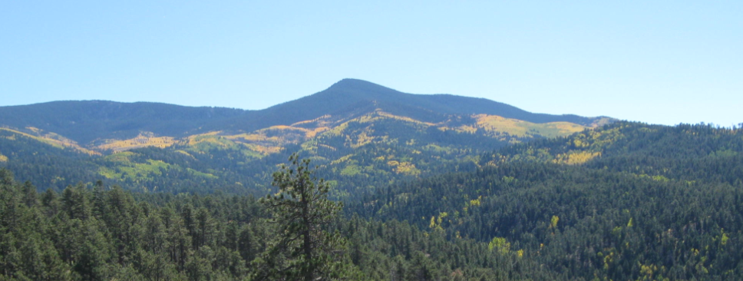

The Santa Fe National Forest will soon be advertising a vacancy for a GS-0101/0401/1301-7/9 GIS Specialist. The position is a permanent full-time appointment and is located at the Supervisor’s Office in Santa Fe, New Mexico. Please note: The purpose of this Outreach Notice is to inform interested applicants of the upcoming opportunity and evaluate their responses to help determine the appropriate recruitment method (e.g. series(s), target grade(s), service-wide/region-wide/government-wide, DEMO, Pathways) and area of consideration that will generate a diverse and highly qualified applicant pool for the position.

To express interest in this position, please complete the attached Outreach Response Form and return by October 24, 2014.

The Position
The primary purpose of this position is to support the automated spatial data needs and Geographic Information Systems (GIS) implementation on the Santa Fe National Forest. The incumbent assists with the maintenance of the Forest’s spatial and tabular natural and cultural resources databases and associated National Applications (including hydrology, vegetation, soils, wildlife, range, fire, roads, trails, and other resources and infrastructure). The incumbent works with resource specialists to update databases and ensures regional and national data standards are met, ensures accuracy of data, resolves errors, and updates metadata. The incumbent uses knowledge gained through formal education of the theories, principles, concepts, and methods of geography and related social sciences, biological sciences, or physical sciences to perform geospatial modeling and analysis procedures and synthesizes results for inclusion in environmental assessments. Coordinates input from managers, other resource specialists and interdisciplinary teams to understand the interrelationships of the resource and other data; determines type, amount and level of information required to perform analysis, and produces map products and reports required for the development and analysis of management alternatives to meet project needs. Incumbent applies geographic and cartographic principles in geospatial database construction and map compilation. The incumbent may conduct one-on-one or small group trainings in GIS and GPS technologies and regularly provides GIS help desk and trouble-shooting support for local GIS users.
A strong working knowledge of ESRI ArcGIS software is required including the use of editing, topology, and analysis tools. Experience with ArcSDE, Spatial Analyst, Model Builder, LiDAR, ArcPad, Garmin GPS, Pathfinder Office, Google Earth, ERDAS Imagine, ArcGIS Online, PL/SQL, Visual Basic Scripting, and Python is a plus. Projects the incumbent will be involved in include providing GIS support for Forest Management Plan Revision, the Southwest Jemez Mountains Collaborative Forest Landscape Restoration Program (CFLRP), and wildfire Burned Area Emergency Response (BAER) GIS support as needed.
We are looking for an enthusiastic and hard working person who is excited about learning and utilizing new and innovative geospatial technologies to support the Santa Fe National Forest’s GIS program.

For information about the position please contact:
Julie Luetzelschwab, GIS Coordinator, jluetzelschwab@fs.fed.us or call 505-438-5460

The Santa Fe National Forest
The Santa Fe National Forest in the Southwestern Region has 1.6 million acres of mountains, valleys and mesas, ranging from 5,000 to 13,000 feet high in northern New Mexico. Recreational and cultural experiences branch out in all directions, and you don't have to go far to find the ruins and petroglyphs from ancient Indian civilizations and incredible scenic features as you travel through colorful volcanic formations, deep river gorges, and beautiful pine, fir, spruce and aspen forests. The urban populations in Albuquerque, Santa Fe and other communities rely heavily on the Forest for recreational activities, including skiing and snowboarding, river rafting and boating, hiking, mountain biking, camping, fishing, and hunting. Rural residents often use the forest for family-oriented gatherings, cattle ranching, firewood cutting, and collecting pinyon nuts and herbs.

The Community
Santa Fe, the state capital of New Mexico, is located at 7000 ft. elevation in the Rio Grande valley between the Jemez and Sangre de Cristo mountains. The city's population is about 68,000. Santa Fe is 50 miles from Albuquerque, a metropolitan area of nearly 900,000. Santa Fe averages 280 days of sunshine a year with warm summer days in the mid 70s to 90s and cool nights in the 50s and 60s. Winters are relatively short and mild, with heavy snow accumulations primarily in the surrounding mountains. Average annual snowfall is about 22 inches and average annual total precipitation is about 14 inches.
The cultural influence, art, and architecture from the Native American pueblos and Spanish American villages of northern New Mexico are unique to this part of the nation and world. Santa Fe has a world-class art community, with over 150 art galleries. Special events in art, music, dance and theater occur frequently. The city offers high quality health care with a 265-bed hospital and a wide choice of doctors, specialists and alternative health care practitioners. The city has over 200 restaurants, 70 churches, 45 parks, 27 tennis courts, 16 movie theaters, 10 health clubs/spas, 8 museums, 5 libraries, 4 swimming pools, 2 golf courses, the Santa Fe Opera, Symphony, and Chamber Orchestra. The Santa Fe Ski Area is only a 30-minute drive from the plaza, and there are 4 other ski areas within 1.5 hours of Santa Fe. Public schools include a community college, 3 high schools, 3 junior highs and 20 elementary schools, as well as other academies, magnet schools, pre-K, and combined middle/high schools . Private schools include 4 colleges, 4 junior/senior high schools, 9 elementary schools, and 25 child care centers. Travel options include city and regional bus service, commuter rail, and commercial air from Santa Fe or Albuquerque.
The cost of living in Santa Fe is about 18% higher than the national average, however federal employees in Santa Fe receive the standard Rest of US locality pay. The median home price in the city is $350,000, and the average apartment rental is about $800/month. Government housing is not available in Santa Fe.

More affordable housing is located in the outlying areas and in Albuquerque and Rio Rancho (median home price is $234,000). If you choose to commute, you may be eligible for a transit subsidy through the Public Transportation Benefit Program if you utilize an approved form of mass transit. A number of Vanpools and the NM Rail Runner Express Train provide service from Albuquerque to Santa Fe with a Rail Runner stop just a 3 minute walk from the Supervisor’s Office.

Information about the Santa Fe National Forest can be obtained from the website (http://www.fs.usda.gov/santafe/). Santa Fe, New Mexico community information can be accessed at http://www.santafenm.gov/, http://www.santafechamber.com/, and http://www.sfps.info.

The position will be advertised through the USAJOBS website (http://www.usajobs.gov/).

OUTREACH RESPONSE FORM

If you are interested in this position, please complete this form and email it to Julie Luetzelschwab (jluetzelschwab@fs.fed.us). Forms may also be mailed to Julie Luetzelschwab, Santa Fe National Forest, 11 Forest Lane, Santa Fe, NM 87508 or FAX #505-438-5390. Please respond by October 24, 2014. You will automatically receive notice of the advertisement if you return the outreach form.

I am interested in the following position: GIS Specialist, GS-0101/0401/1301-7/9

Location: Region 3, Santa Fe National Forest, Santa Fe, NM

PERSONAL INFORMATION:

Name: |  | Date:

Address:

Email Address:

Phone:

Are you currently a Federal employee? | YES: |  | NO:

IF YES: Current Agency and location:

Current title/series/grade:

Current Type of Appointment: | Permanent |  | Term |  | Temporary |  | Reinstatement Eligble

If you are not a current permanent employee (career or career conditional), are you eligible for appointment under any of the following special authorities?
Person with Disabilities
Veterans Readjustment
Former Peace Corps Volunteer
Disabled Veteran with 30% Compensable Disability
Pathways Students and Recent Graduates https://www.usajobs.gov/StudentsAndGrads
Veterans Employment Opportunities Act of 1998
Other, please describe:
Applicants may use this space to identify special qualifications, interests, needs or provide other information (please indicate which series GS-0101 (Social Scientist), GS-0401 (Biological Scientist), or GS-1301 (Physical Scientist) best matches your education, experience, qualifications, and interests):

Thank you for your interest in our vacancy!


USDA Non-Discrimination Statement

"The U.S. Department of Agriculture (USDA) prohibits discrimination in all its programs and activities on the basis of race, color, national origin, age, disability, and where applicable, sex, marital status, familial status, parental status, religion, sexual orientation, genetic information, political beliefs, reprisal, or because all or part of an individual's income is derived from any public assistance program. (Not all prohibited bases apply to all programs.) Persons with disabilities who require alternative means for communication of program information (Braille, large print, audiotape, etc.) should contact USDA's TARGET Center at (202) 720-2600 (voice and TDD). To file a complaint of discrimination, write to USDA, Director, Office of Civil Rights, 1400 Independence Avenue, S.W., Washington, DC 20250-9410, or call (800) 795-3272 (voice) or (202) 720-6382 (TDD). USDA is an equal opportunity provider and employer."

