Vol. XXXIV, No. 8 www.ohio.edu/emeriti April, 2019
EMERITI NEWSLETTER
OHIO UNIVERSITY
April Program
April is National Poetry Month, ergo:
Three times a Pushcart nominee, Kari Gunther-Seymour’s chapbook Serving was chosen runner-up in the 2016 Yellow Chair Review Annual Chapbook Contest and nominated for a 2018 Ohioana Award. Her poems can be found in many fine journals, Rattle, Crab Orchard Review, CALYX, Still, Stirring, Main Street Rag, and on her website www.kariguntherseymourpoet.com. She is an instructor in OU’s E.W.Scripps School of Journalismand Poet Laureate for Athens.
Patricia Black taught English in Italy, was editor of Ohio University Publications, was a travel agent, and drove a bookmobile. Now she writes poems, gardens, and edits academic papers for international students. She is a member of the Athens Poetry Group, the online PentaPoets, the Evening Poets, and the Ohio Poetry Association. Her poems have appeared in the OPA’s Common Threads and its juried anthology Everything Stops and Listens. She has been a featured reader in Athens, Cincinnati, Columbus, Coshocton, Marion and Wooster. Her children’s book Twillaby Pond will come out in the fall.
EMERITI LUNCHEON
Notice: There will be no luncheon in June.
April 18, 2019, 11:30 a.m., The Ohio University Inn
MENU Things to Remember About the Luncheon
Mixed Green Salad 1. It costs $16. Exact change is appreciated.
Garlic Grilled Chicken 2. Notify SUE BOYD at suenboyd@gmail.com
Broccoli Casserole by April 11 if you will attend on April 18.
Glazed Carrots 3. If you “always attend” but can’t make it this month,
Rolls and Butter notify SUE BOYD at suenboyd@gmail.com. by
Assorted Desserts April 11.
Emeriti Distinguished Service Award
Do you know a member of our Emeriti Association who deserves recognition of her or his work for the association? If so, nominate that person for our Distinguished Service Award. Past awardees include past presidents, chairs of various committees, newsletter editors and exemplary workers in the Emeriti Park. Just send the name of your nominee, with a brief description as to why this person should be recognized, to Ed Baum at baum@ohio.edu or mail it to him at 20 Sunnyside Drive, Athens, Ohio 45701 no later than April 15. The award is presented at our May meeting.
============================================================================
Emeriti Board Members
President – George Weckman Volunteers – Jed Butcher
VP and Programs – Art Marinelli Archivist – Margaret Thomas
Secretary – Anne Braxton Emeriti Park – Richard Dean
Treasurer – Leslie Flemming Nominations – John Howell
Membership – Scott Malcom Website – Richard Post
Benefits – Karen and Richard Vedder Newsletter – Patricia Black
==========================================================================================
Message from the Emeriti President – George Weckma

I travel less in my senior years. I have “been there, done that.” But I know that others have bucket lists with many places to visit. This essay is not entirely a criticism of travelers but more a defense of my stability. There is much delight, education, and psychological benefit in travel, but there are negative aspects also.

Cruises are popular because you see different sites but don’t have to change hotels. However, the ships and the planes that get you to the port are not eco-friendly. Should global warming change our plans? Families are separated in today’s world and enjoying relatives is important, but how much or often, and at what cost? It is important to get away from usual routines periodically, but are vacations necessarily to destinations far away?

Walking is good for health. We might drive too much for our wellbeing. It’s also dangerous to drive; traffic kills more people than wars. Recent plane crashes remind us that air travel is tricky and computers are stupid.

Join me in enjoying Athens. If you are elsewhere, come visit us but not too often and stay a bit when you come. This is a nice place to live. Why go away?
=============================================================================

Day of Remembrance
On Wednesday, April 22, Ohio University will conduct a service commemorating all faculty, staff and students who have died in the past year. It will be held at 4:30 p.m. in the gazebo in Emeriti Park. President Nellis and other university notables will speak.
================================================================
OU Emeriti Nominations
The 2019-20 nominations process is not yet complete. The Emeriti Executive Committee is made up of 1) the officers, 2) the chairs of standing committees specified in the Emeriti Association Constitution adopted in 2014, 3) past presidents from the last two years, and 4) a University representative appointed by the University President to serve as liaison between the University and the Executive Committee. No one has yet agreed to serve as President, Vice-President or Benefits person. The Executive Committee nomination sheet currently looks like this:
President –
Vice President and Program Committee Chair -
Secretary – Margaret Thomas
Treasurer and Chair of Finance Committee – Leslie Flemming
Past presidents (for 2 years following their terms in office)– Alan Boyd and George Weckman
Membership and Services Chair – Scott and Marjorie Malcolm
Volunteer Services – Jed Butcher*
Emeriti Park – Richard Dean
Benefits –
Communication – Patricia Black
Nominations – John Howell
Webmaster – Richard Post
Archivist/Historian – Anne Braxton
University representative appointed by the University President – Victoria McFadden

Respectfully submitted,
John Howell
Email John (howell@ohio.edu) if you want to volunteer for an office or have a suggestion of someone he should contact.
=================================================================
Konneker Center
If you want to visit one of the offices formerly found in the Konneker Center, you’ll find them in Lindley Hall. Konneker is being remodeled on the inside and will be out of commission for months.

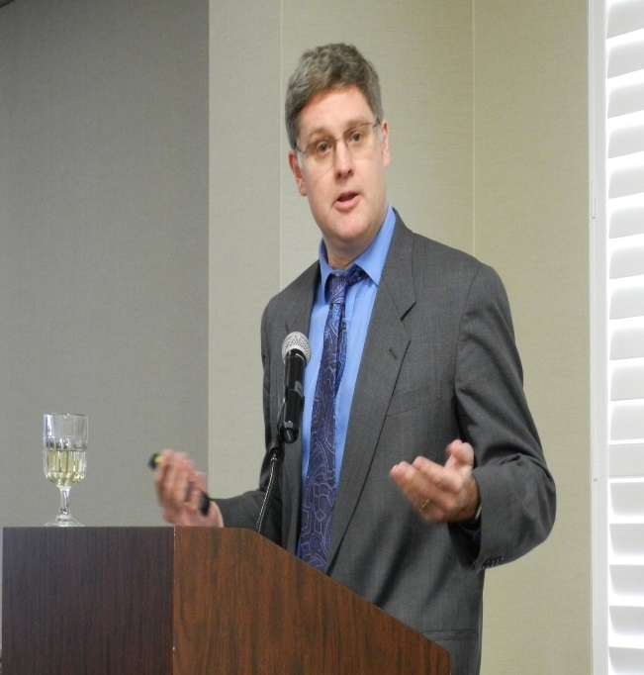
Dr. Brian Schoen gave a very enlightening talk about the role Ohio played during the Civil War. Politics were as wild and wooly back then an they are now, with candidates and officeholders throwing verbal brickbats at each other. As someone said, in effect, if we don’t learn from history, we are bound to repeat it.
============================================================================

A Brain Teaser
Did you find the anagrams? They were greet and egret.
Here’s something I’ve puzzled over: We can see the effect of heat waves rising from an object -- the things in the background look wavy. So why can’t we see the heatwaves themselves? And how do they cast shadows?
============================================================================
What I’ve Done Since I Retired You’ve read the various entries which have appeared under this heading. I encourage you to send me a write-up about YOU. Or send me the name and contact information for someone you would be interested in reading about. I’m at plhb222@hotmail.com.

OBITUARIES
Leep
Albert G. Leep died Feb. 26, 2019, in Athens. He received a B.S. from Indiana University, an M.S. from Indiana University, and a Ph.D. from Ball State University. Dr. Leep taught grade school in Winamac and West Lafayette, Indiana and was Principal at Burtsfield Elementary in West Lafayette, Indiana. He came to Ohio University’s Department of Education in 1965 as a Professor of Curriculum and Instruction. He chaired the Education Department for four years.
Albert was involved in the Teenage Teachers Aids program, the special student teacher program at The Plains Elementary School, developed and taught a program in gifted education, and guided the doctoral programs of over 50 students. Beyond the OU campus Dr. Leep taught at Sheffield University in England, as campus backup for seven years for the Botswana program, and led workshops in the Yucatan and Mexico. He was the 2006-2007 director of the Jennings Lecture.
Awards Professor Leep received include the 1984-85 President of Elementary Education and Nursery School Educators; 1994 Southeastern Ohio Gifted Program and 1999 Innovations in Teaching and Partnership Award. In 2000 he was inducted into the Gifted Education Hall of Fame. He co-chaired the 2005-2006 O'Bleness Volunteer Annual Giving Campaign and served 8,900 hours as a volunteer at O'Bleness Memorial Hospital. He enjoyed gardening and bridge.
Al is survived by his wife Peggy L. Rahe Leep; two sons, two grandchildren, a niece, and a nephew.No services are planned. Cremation has taken place. Memorial contributions may be made to OhioHealth O'Bleness Hospital, 55 Hospital Dr., Athens, OH 45701. A more complete obituary is available at www.jagersfuneralhome.com.

GREAN
Patricia (Pat) Anthony Grean died in Athens on Feb. 21, 2019. She attended Barnard College in New York City and graduated from Ohio University with a Bachelor in Fine Arts.
Pat was passionate about the arts, politics, and resisting racism. She was a founding member of Project Plant in Athens, volunteered with The Athens County Public Library, where she supported reading-aloud events for small children. She founded "Page," a monthly publication (1960-1965) of new poetry in Athens. For her long involvement with OU’s Trisolini Gallery she was awarded the Outstanding Contribution to the Crafts Award by the Ohio Designer Craftsman. A member of ACLU, she served as secretary to the statewide organization.
Pat taught Sunday school at the Episcopal Church, organized and helped prepare a weekly free lunch for OU international students and much more as part of her church community life.
Preceded in death by her husband Stanley and their son Nicholas, she is survived by three nieces. A memorial service and reception were held on March 10, followed by a private graveside service. In lieu of flowers, memorial contributions may be made to Project Plant, P.O. Box 5676, Athens, Ohio 45701. A more detailed obituary is available in the archives of The Athens Messenger.

