Vol. XXXIV, No. 7 www.ohio.edu/emeriti March, 2019
EMERITI NEWSLETTER
OHIO UNIVERSITY
March Speaker
Brian Schoen, associate professor of history, is director of the Masters of Social Sciences at OU. He completed his graduate work at the University of Virginia, then was the 2014-15 visiting Mary Ball Washington Professor at University College, Dublin. He teaches classes in early United States history, American South and Slavery, historical research and writing, and Capitalism and its Critics: An Intellectual History. He authored The Fragile Fabric of Union: Cotton, Federal Politics, and the Global Origins of the Civil War, which won the Southern Historical Association Bennett H. Wall book prize. He coedited The Old South’s Modern Worlds: Slavery, Region, and Nation in the Age of Progress and Between Sovereignty and Anarchy: The Politics of Violence in the American Revolutionary Era. He recently completed chapters for the Cambridge Histories of the American Civil War and American in the World. (See more information on p. 4 – Ohio’s Internal War.)
EMERITI LUNCHEON
Notice: There will be no luncheon in June.
March 21, 2019, 11:30 a.m., The Ohio University Inn
MENU Things to Remember About the Luncheon
Strawberry Salad 1. It costs $16. Exact change is appreciated.
Chicken Marsala 2. Notify SUE BOYD at suenboyd@gmail.com
Roasted Red Potatoes by March 14 if you will attend on March 21.
Asparagus 3. If you “always attend” but can’t make it this month,
Assorted Desserts notify SUE BOYD at suenboyd@gmail.com. by
March 14.
Speaking of Notifying Sue Boyd . . .
If you didn’t get a chance to check the official “always” list at the February Luncheon, you can check it at the March one.

Emeriti Distinguished Service Award
Do you know a member of our Emeriti Association who deserves recognition of her or his work for the association? If so, nominate that person for our Distinguished Service Award. Past awardees include past presidents, chairs of various committees, newsletter editors and exemplary workers in the Emeriti Park. Just send the name of your nominee, with a brief description as to why this person should be recognized, to Ed Baum at baum@ohio.edu or mail it to him at 20 Sunnyside Drive, Athens, Ohio 45701 no later than April 15. The award is presented at our May meeting.

Emeriti Board Members
President – George Weckman Volunteers – Jed Butcher
VP and Programs – Art Marinelli Archivist – Margaret Thomas
Secretary – Anne Braxton Emeriti Park – Richard Dean
Treasurer – Leslie Flemming Nominations – John Howell
Membership – Scott Malcom Website – Richard Post
Benefits – Karen and Richard Vedder Newsletter – Patricia Black

Message from the Emeriti President – George Weckman
This month I reach 80 years of life. As many others say when the years pass by, I never thought I’d last this long. Such sentiments are not silly, because we are on average living longer than previous generations. I knew only one grandparent; my father died in his fifties; I’ve read that the average lifespan eight decades ago was 60 years.
We can be happy that modern medicine has preserved so many of us for healthy, interesting old age. Sad, though, that so many seem to continue with radically reduced faculties, mental and/or physical.
Our association provides one of the ways in which we can enjoy and maintain these later years of life. Among the proven benefits of organizations like ours are time with friends, intellectual stimulation, and continuing contact with our profession.
Not everyone shares the delight I have in remaining close to our university. Some people have been quick to leave Athens and find new lives elsewhere. Among the reasons for that, however, is the lack of adequate retirement institutions and health care specialists. Maybe that will change but nothing major seems to be on the horizon.
While we’re here and while we can, let us benefit from our merited status, visit our park often, and participate in university activities. I think we are very lucky to be where we are.

Interruption in OU Email Service?
If you used to access your OU email through the Microsoft Office Outlook Program, things have changed. The University used to load Microsoft Office onto your personal computer but Microsoft now charges for Microsoft Office on an annual subscription basis, rather than a single download. OU will now download Microsoft Office onto your personal computer only if you are on the payroll.
Microsoft Office contains not only Outlook, but also Word, Excel, and Powerpoint, which many of us also use and to get it you will have to subscribe personally to Microsoft Office. This costs about $70 per year for use on a single machine, or $100 per year for use on up to six machines. To order the program, go to https://products.office.com/en-us/compare-all-microsoft-office-products?tab=1.
But there are alternatives. You can avoid Outlook and get your email by logging in through the University website and going to catmail. For word processing and spread sheets, LibreOffice and Apache Open Office are two free programs that work much like Microsoft Office. To see and download them go to LibreOffice at (https://www.libreoffice.org/) or to Apache Open Office at (https://www.openoffice.org/download/index.html).
Having said all this, I should point out that the Emeriti Association is asking OU to reconsider its policy which has cut Emeriti off from free access to Microsoft Office. So maybe this will be totally unnecessary, except on a temporary basis.
Accessing WiFi on the campus has also changed. Here is what you have to do. Complete the following steps for each laptop, phone, tablet or other device that you have connected to the OHIO University wi-fi: Download and install the Ohio University eduroam CAT tool. (https://www.ohio.edu/oit/internet-phones/internet/wi-fi/connect-wi-fi#eduroam) Open your device’s wi-fi or network settings, choose eduroam and ignore the OHIO University and OHIO University Guest wireless networks.
Actually, the easiest thing to do with any of this is just go to the computer desk at the BobCat Store, 1st floor of Baker Center, and ask for help. John Howell

Day of Remembrance
On Wednesday, April 22, Ohio University will conduct a service commemorating all faculty, staff and students who have died in the past year. It will be held at 4:30 p.m. in the gazebo in Emeriti Park. President Nellis and other university notables will speak.

Ohio’s Internal War

The US Civil War was not merely a “war between the states;” it was a war within the states. Brian Schoen’s talk will examine how Ohio navigated the shifting tides of war by showing how evolving understandings of executive power, recruitment, and the divisive subjects of emancipation, contraband, and black soldiering generated fierce political combat within the state. Highlights will include the arrest and election of a local draft opponent and a bloody race riot in Cincinnati, events revelatory of deeper rifts within the Buckeye state. Political leaders’ responses to these crises, the growth of so-called “Copperheads” and a truly bi-partisan effort that elected an OU alum as governor created problems in subsequent understandings of Ohioan’s relationship with emancipation, signaling the type of late-war developments crucial for Union victory. Brian Schoen

A Brain Teaser

Anna by the River
Early, at the edge of dawn,
Anna Graham walked the riverbank
to greet the coming day.
The tranquil riparian scene
held only silent trees,
a solitary egret,
and Anna, walking in the dawn.
Can you find the anagrams in this poem? There are two of them.

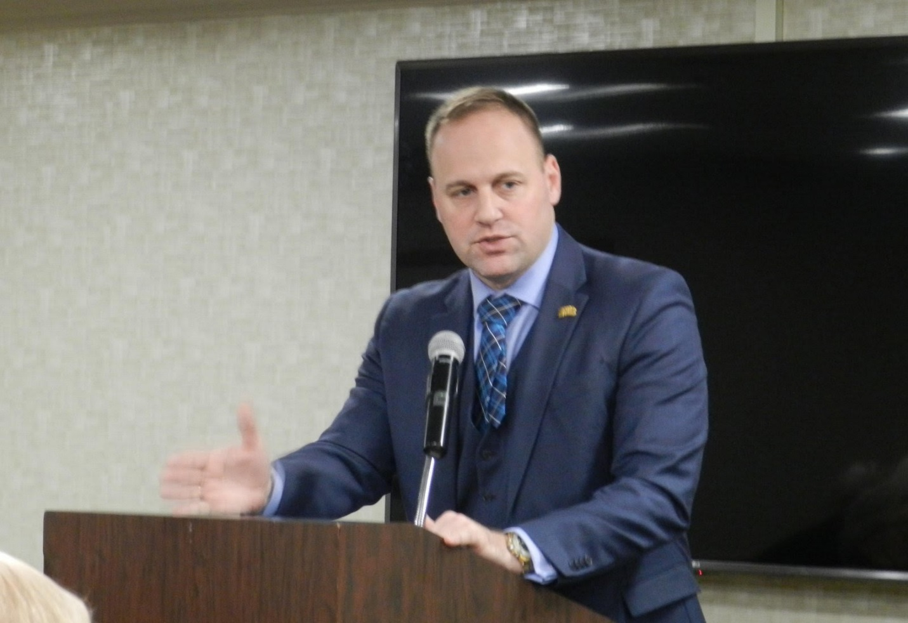

Emeriti who attended the February luncheon were pleased by the talk given by Nico Karagosian, the February speaker. Nico’s titles of Vice President of University Advancement and President and CEO of the Ohio University Foundation had led some of the more cynical in the audience to expect a strong appeal to their wallets. Instead, he gave an interesting and wide-ranging accounts of OU’s fund-raising throughout the country and the world. OU is doing well; as always, OU could do better.

