Vol. XXXIV, No. 6 www.ohio.edu/emeriti February, 2019
EMERITI NEWSLETTER
OHIO UNIVERSITY
February Speaker
Nico Karagosian, Vice President of University Advancement and President and CEO of the Ohio University Foundation, came to OU from the University of Cincinnati. His over 20 years of fundraising experience include the Goldie Hawn Foundation, the College of Arts and Sciences at the University of South Florida, and New College of Florida, among others. Nico earned his BA degree in English from Hobart College in New York State, an MS in Health Systems Administration and an MBA in Technology Management from the SUNY Institute of Technology. His Certified Fund Raising Executive (CFRE) designation was gained in 2009. His career began with a stint in the Office of Institutional Advancement at Hamilton College. He has been active with Pop Warner, Rotary International, the Association of Fundraising Professionals and The March of Dimes.
EMERITI LUNCHEON
February 21, 2019, 11:30 a.m., The Ohio University Inn
MENU Things to Remember About the Luncheon
Arugula Salad 1. It costs $16. Exact change is appreciated.
Meatloaf 2. Notify SUE BOYD at suenboyd@gmail.com
Southern Green Beans by February 14 if you will attend on February 21.
Fruit 3. If you “always attend” but can’t make it this month,
Assorted Desserts notify SUE BOYD at suenboyd@gmail.com.

Request for Information
The Emeriti Board is compiling a record of recipients of Distinguished Service Awards. If you received a Distinguished Service Award within the last 15 years, please notify Ed Baum at baum@ohio.edu. If you know someone who received a DSA, urge him or her to contact Ed (baum@ohio.edu).

Speaking of Notifying Sue Boyd . . .
Below is the “always list” from which she is working. If your name is on it, that means at some time in the past you told the Emeriti Association that you would always attend the luncheons (so you didn’t have to notify them every month). Sue adds these names to those of people who notify her each month and submits the total to The Inn. The Inn charges the association for that number of meals. This list is probably inaccurate (mine is not on it though I thought it was), so if you want to be added to or deleted from the “always list,” let Sue know. The association must pay for the number submitted.
Anita James Richard Post
Don Jordan Don Shamblin
Susan Loughridge Margaret Thomas
Marjorie Malcom George Weckman
Scott Malcom Elizabeth Westenbarger
Art Marinelli Bob Whealey
Kathy Marinelli Lois Whealey
John McCutcheon
Florence McGeoch
Danny Moates Speaker
Edie Post Guest

Emeriti Board Members
President – George Weckman Volunteers – Jed Butcher
VP and Programs – Art Marinelli Archivist – Margaret Thomas
Secretary – Anne Braxton Emeriti Park – Richard Dean
Treasurer – Leslie Flemming Nominations – John Howell
Membership – Scott Malcom Website – Richard Post
Benefits – Karen and Richard Vedder Newsletter – Patricia Black

Message from the Emeriti President

I worry too much. Worry is wasted energy, a friend tells me, but it is a major part of my personality. So I fret about our organization, wondering what I and our board need to do to run things smoothly, continue our fine tradition, and preserve our existence into the future.

One worry is the relative lack of participation by recent retirees. I do not have statistics so this may be a delusion. It cannot be good, however, that I recognize most people at our luncheons. They are people from my generation at OU and I retired a decade ago. If you know more recent emeriti, please encourage them to join us on third Thursdays.

Another worry is the need for more activity by the association. In the past we have sponsored overseas teaching programs, informative sessions, and various social events. You will hear soon about the possibility of us providing scholarships for some students. If you have suggestions for worthwhile things we should do, let me or any of the board members know.

We do much on computers these days and many of us appreciate our continued connection with the university services. But there are worries about changes in this area that affect us, like the elimination of “ohiou” from email addresses. “Ohio.edu” still works.

No sense worrying about later generations but we do wonder what future retirees will get from the state retirement systems. So many new people opt out of them, thinking perhaps that they will not stay in Ohio very long. Too much of that will weaken what has given us wonderful defined benefit retirement incomes.

Please help me, other emeriti, and all elderly folk as we try to keep up with a changing world. I’ll try to worry less.

Day of Remembrance
On Wednesday, April 22, Ohio University will conduct a service commemorating all faculty, staff and students who have died in the past year. It will be held at 4:30p.m. in the gazebo in Emeriti Park. President Nellis and other university notables will speak.

Center for Clinical Practice, Patton College of Education
Three very enthusiastic people informed us about the hands-on programs in the Patton College of Education. The familiar “student teaching” has gone more than a step beyond as OU students function on a more or less equal footing with the classroom teachers, so when the student graduates he or she goes into the new career with genuine experience to offer.

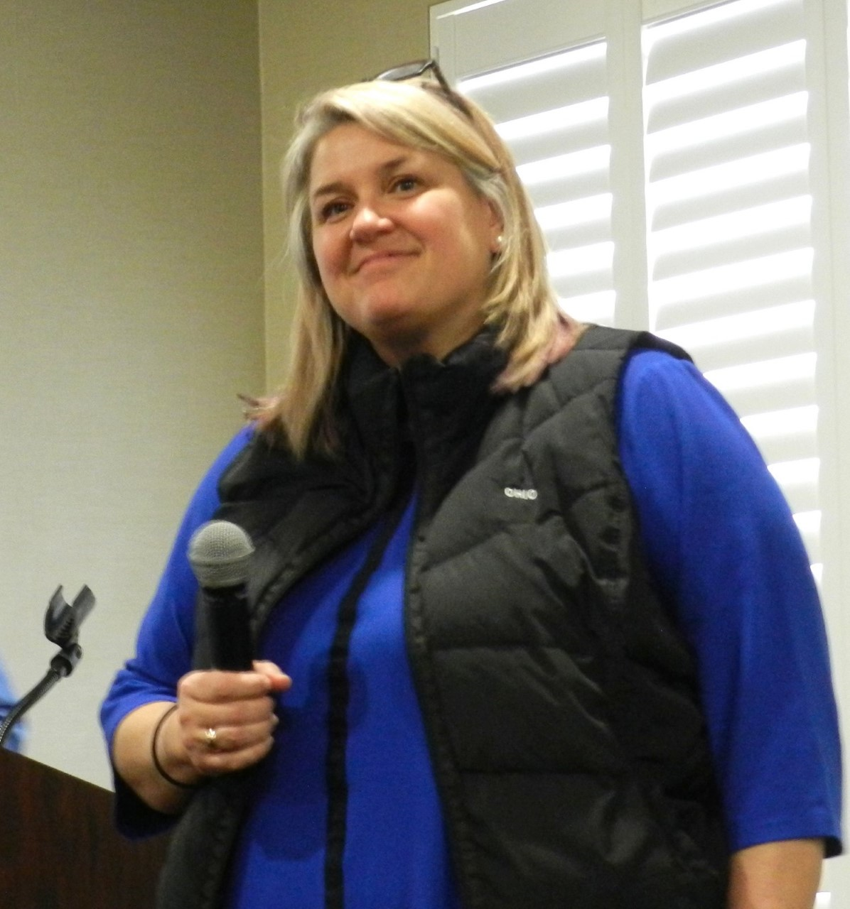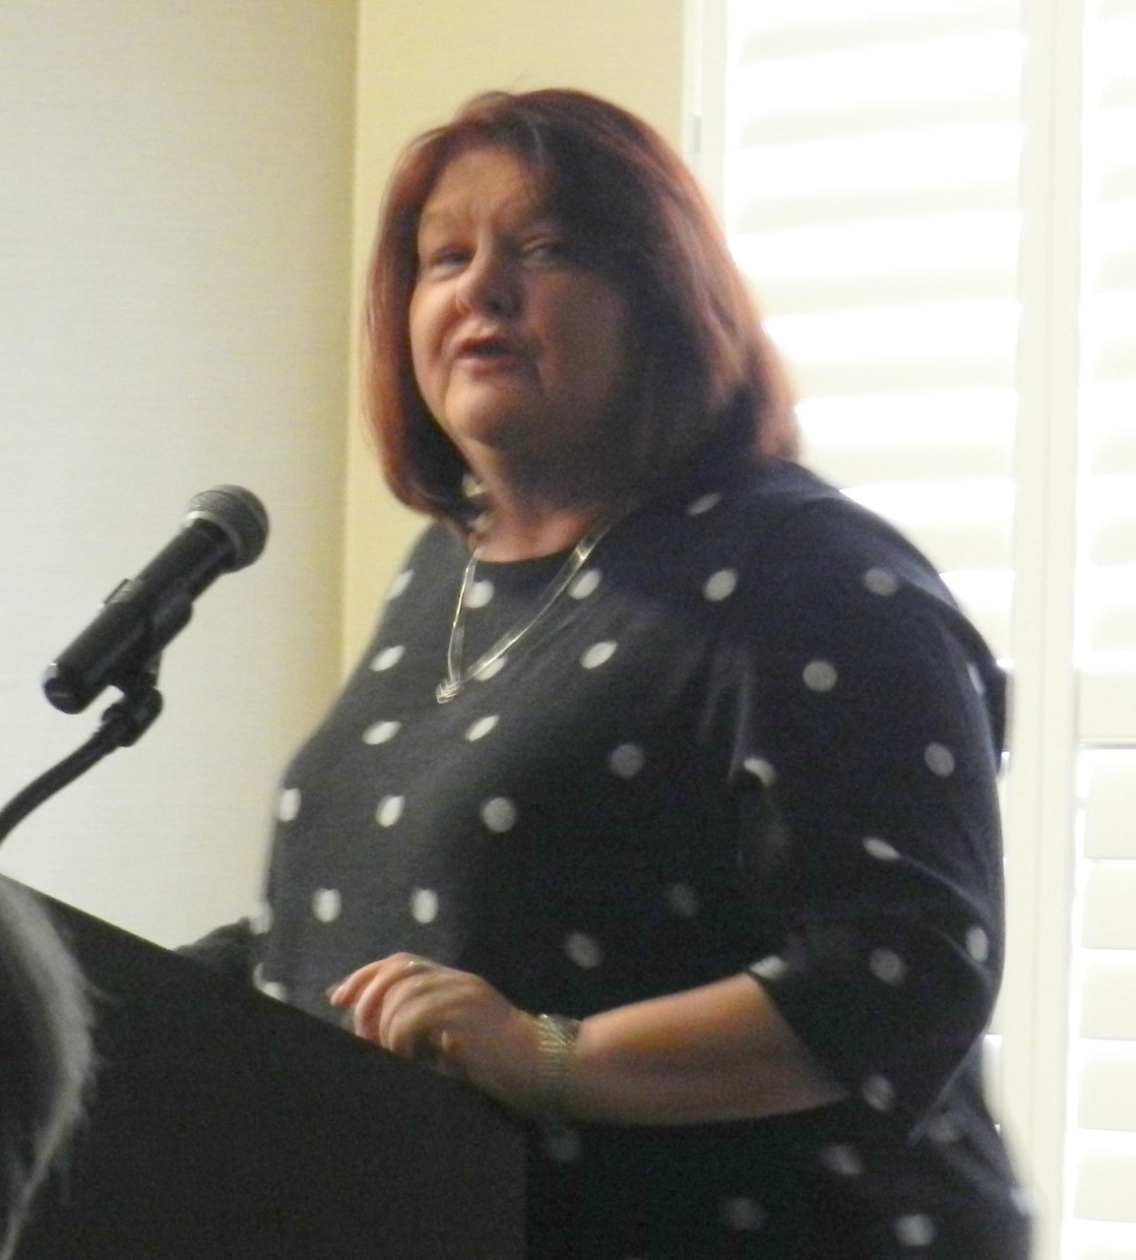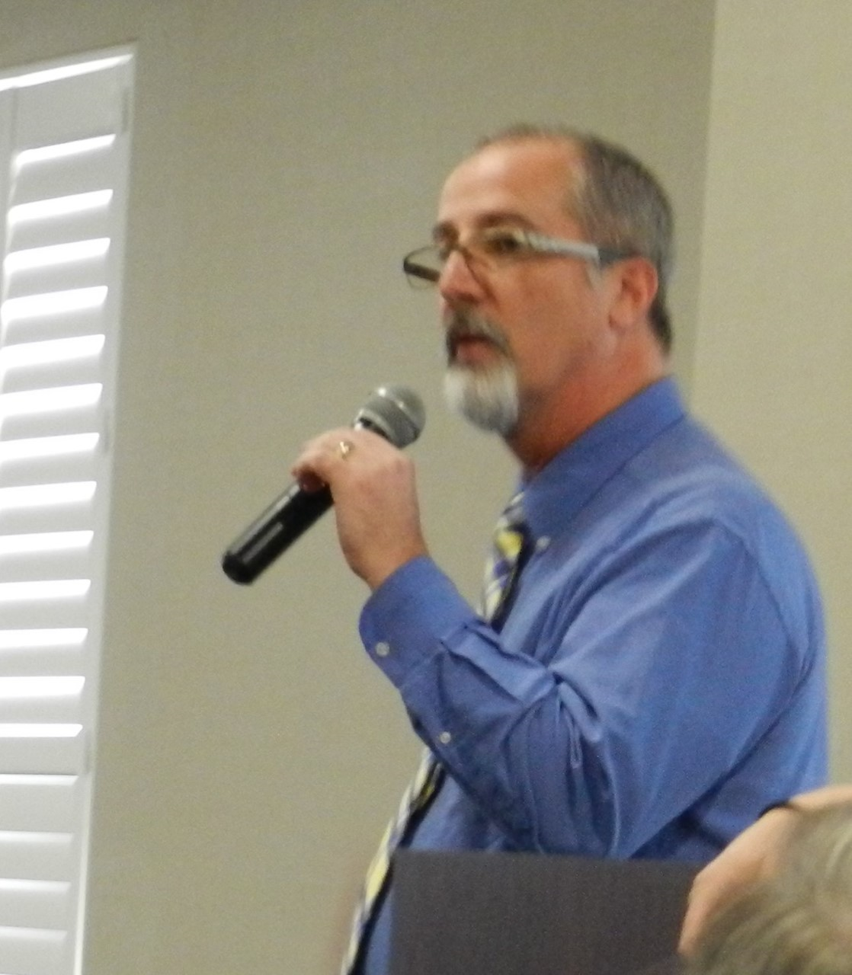
Left to right: Marcy Keifer Kennedy (Director), Liz Hoisington, Chris Kennedy
Photos by Richard Post.

Topics of interest
I want this newsletter to cover topics of interest to you readers so please let me know what those topics might be. I’ve thought of writing (with pictures) about the new buildings on campus, to let the out-of-Athens people see how the campus is evolving. Someone suggested I write about the academic programs. Someone else thought jokes and brain teasers would be welcome. There was even a suggestion that I eliminate the menu, since it is irrelevant to the out-of-towners and the in-towners don’t remember it. Email me at PLHB222@hotmail.com (Put Emeriti Newsletter on the subject line.) or write to me at Patricia Black, 8505 Rock Riffle Road, Athens, Ohio, and I’ll see what I can do to accommodate you.

OBITUARIES
GOLOS
Ellery Bernard Golos died January 12, 2019. Ellery enlisted in the Navy Air Force at age 17 and served in WWII. He earned a master's degree in both mathematics and philosophy. He was a math professor for at Ohio University for 40 years. In 1970, he submitted a proposal that became the Honors Tutorial College where he served as dean until 1977. Ellery was named honorary alumnus of Ohio University in 1983 and the Ellery Golos Lecture Series was created in 2012 in his honor. In mid-life he began painting and was encouraged by well-known Athens artist Murray Stern. Some of Ellery’s more than 100 paintings can be found in family and friends’ homes across the country. He is survived by daughters Pam Golos, and Debbie Golos Schmitz; and many cousins, nieces, and nephews. A private memorial service will be held in Minnesota on Sunday, January 20.
Memorial contributions may be made in Ellery’s name to The Ohio University Foundation, designated for either the Ellery Golos Lecture Fund or for the Honors Tutorial College Endowed Scholarship Fund, and mailed to P.O. Box 869, Athens, OH 45701, or online at www.ohio.edu/give. A more detailed obituary is available in the Archives of The Athens Messenger
A more detailed obituary is available in the Archives of The Athens Messenger.

MOLEA
Nellie J. Molea died January 13, 2019 at her home.in Columbus.
She was the widow of Dr. John S. Molea, D.O. She is survived by sons Marcus and David and numerous nieces and nephews.
Nellie attended Syracuse University and received a B.S. in microbiology.
She had a commitment to the osteopathic profession and served the Auxiliary to the Osteopathic Association in Ohio and New York. In Athens, she worked for the Athens Cancer Society, helped set up the Athens Area Hospice and the Hemoccult colon cancer screening program. She served as Secretary of the Board of the Dairy Barn Cultural Center and received the Holy Cow Award in 1995. She was president of the Friends of the Kennedy Museum and of the Tuesday Club.
A memorial service will be held on Saturday, March 30, 2019, at Rutherford-Corbin Funeral Home, 515 High St., Worthington at 3 p.m. In lieu of flowers, contributions may be made to OhioHealth Hospice, 800 McConnell Drive, Columbus, Ohio 43214. Condolences to www.rutherfordfuneralhome.com.
A more detailed obituary is available in the Archives of The Athens Messenger.

