Vol. XXXIV, No. 5 www.ohio.edu/emeriti January, 2019
EMERITI NEWSLETTER
OHIO UNIVERSITY
January Speaker
From the 1990s to the present, the central purpose of the OHIO Center for Clinical Practice in Education in The Gladys W. and David H. Patton College of Education has been to foster and support outreach activities that connect the college with local P-12 school partners.
The very core and mission of all programming between The Patton College and our local schools is to improve P-12 student learning. Mutually beneficial relationships between the college and our local schools are committed to high and equitable student achievement, to effective instructional practice, and to support of student learning. By all partners working together to create new and innovative programming, it is possible to positively impact P-12 learning and teacher preparation.
Marcy Keifer Kennedy is the director of the OHIO Center for Clinical Practice in Education. She oversees the operations of 12 active Professional Development School (PDS) partnerships, each with a unique structure and organization. She is a past president of the National Association for Professional Development Schools, a co-leader of the Ohio Clinical Alliance, and a member of the American Association for Colleges of Teacher Education’s Clinical Practice Commission.

EMERITI LUNCHEON
January 17, 2019, 11:30 a.m., The Ohio University Inn
JANUARY MENU Things to Remember About the Luncheon
Chopped Salad 1. It costs $16. Exact change is appreciated.
Beef Stroganoff with Buttered Noodles 2. NOTE CHANGE: Tom Franz is ill. Notify SUE BOYD
Vegetarian Entree at suenboyd@gmail.com by January 10 if you
Brussels Sprouts will attend on January 17.
Roasted Redskin Potatoes 3. If you’re signed up as “always attends” but can’t
Assorted Desserts make it this month, notify SUE BOYD at
suenboyd@gmail.com by January 10

Emeriti Board Members
President – George Weckman Volunteers – Jed Butcher
VP and Programs – Art Marinelli Archivist – Margaret Thomas
Secretary – Anne Braxton Emeriti Park – Richard Dean
Treasurer – Leslie Flemming Nominations – John Howell
Membership – Scott Malcom Website – Richard Post
Benefits – Karen and Richard Vedder Newsletter – Patricia Black

Message from the Emeriti President
They say deflation is bad for the economy, so modest inflation all the time is good, not that we enjoy it or want it. Retirees are often on fixed incomes without any cost of living adjustments, but still prices creep upwards.
In our contract with the Ohio University Inn for the coming 2019 calendar year the per meal price for our lunch buffets will be $16. The contract also requires a minimum of 50 diners each time. This may affect your participation.
First, you must let us know which lunches you will attend, or cancel one if you are on our “always” list. Otherwise we will guarantee a larger number and have to pay for them all (unless they are fewer than 50 when we will pay for that number anyway).
Second, it is always helpful to our member who collects the lunch money if you have exact change. The $16 increase will be a little more cumbersome.
We enjoy the Inn for its food, parking, and cooperation. There is no local place with convenient parking that is big enough for us. I am grateful for the staff’s understanding of our organization and its dynamics. I hope a little more cost will not deter you from enjoying our meetings.

The board is examining our meeting schedule to see whether it needs to change with the semester calendar of the university. Should we skip the June meeting and start our monthly sessions in August? Should we plan for nine meetings a year instead of ten? Should we publish our newsletter every other month or quarterly?
Let me or another board member know your thoughts about these changes. Ours is a delightful association; and we must make sure it continues to be so.

Bring Your Friends!
Following up on the Emeriti president’s thoughts about friendship, are some of your friends missing from the Emeriti roster? Wouldn’t you enjoy having lunch with them once a month, on the third Thursday? Speak to Scott Malcom to nominate said friends for membership – that’s the necessary first step. Well, the first first step is for your friends to retire, but after that … As a teaser, preview, call it what you will, bring one or more along to lunch next time. Just be sure to let Sue Boyd know so she can arrange for an extra plate or two.

Request for Information
The Emeriti Board is compiling a record of recipients of Distinguished Service Awards. If you received a Distinguished Service Award within the last fifteen years, please notify Ed Baum at baum@ohio.edu. If you know someone who received a DSA, urge him or her to contact Ed.

Memory Lane
I found this in my email inbox the other day and wanted to share it. I did not compile it, though I did do some minor editing. It was sent to me by a friend who had received it from a friend of his. That friend had received it from his sister and I was unable to learn who should get the credit. I hope you enjoy it as I did. And I bet you’ll ask why one or more of your pet phrases were not included. And I want to let you know that Mergatroyd was spelled this way in the email I received. The email spell checker DOES recognize Murgatroyd.
Mergatroyd!
Do you remember that word? Would you believe that the email spell checker did not recognize the word Mergatroyd?
Heavens to Mergatroyd!
The other day a not-so-elderly lady (I say 75) said something to her grandson about driving a jalopy and he looked at her quizzically and said, “What the heck’s a Jalopy?” He had never heard the word Jalopy!! She knew she was old . . . but not that old. Well, I hope you are Hunky Dory after you read this and chuckle.
About a month ago I illuminated some old expressions that have become obsolete because of the inexorable march of technology. These phrases included, “Don’t touch that dial,” “carbon copy,” “You sound like a broken record,” and “Hung out to dry.”
Back in the olden days we had plenty of “moxie.” We’d put on our best “bib and tucker” to “straighten up and fly right.” Heavens to Betsy! Gee whillikers! Jumpin’ Jehoshaphat! Holey moley! We were “in like Flynn” and “living the life of Riley” and even a regular guy couldn’t accuse us of being a knucklehead, a nincompoop or a pill. Not for all the tea in China! Back in the olden days life used to be swell but when’s the last time anything was swell? Swell has gone the way of beehives, pageboys and the D.A.; of spats, knickers, fedoras, poodle skirts, saddle shoes, and pedal pushers. . . AND DON’T FORGET . . . saddle stitched pants. Oh, my aching back! Kilroy was here but he isn’t anymore.
We wake up from what surely has been just a short nap and before we can say, “Well I’ll be a monkey’s uncle” or “This is a fine kettle of fish” we discover that the words we grew up with, words that seemed as omnipresent as oxygen, have vanished with scarcely a notice from our tongues and our pens and our keyboards.
Poof go the words of our youth. We blink and they’re gone. Where have all those great phrases gone? “Let’s go to the beach on Saturday.” Long gone: Pshaw. The milkman did it! Hey! It’s your nickel. Don’t forget to pull the chain. Knee high to a grasshopper. Well, fiddlesticks! Going like sixty. I’ll see you in the funny papers. Don’t take any wooden nickels. Wake up and smell the roses.

What a Festive Time!
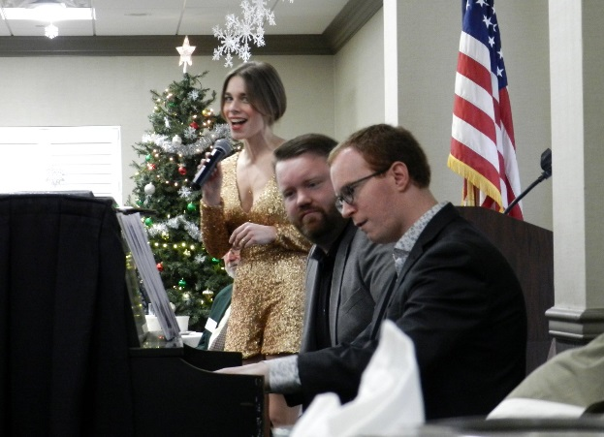

Rather than a speaker at the December luncheon we had three faculty members from the School of Music. From left to right above, Melissa Brobeck, Kelly W. Burns, and Daniel Mullins offered a delightful selection of holiday songs. In an interesting rendition of the controversial “Baby, It’s Cold Outside” Kelly and Melissa switched the genders in the song. It put a whole new slant on the message.
(Photo by Richard Post)

