**Columbus Open House**

**Friday, August 2nd, 2024 – 3:00 – 6:00 PM (EST)**

**Join our Software Engineer Program In-Person Open House for the Columbus Technology Center! This event is being provided to students interested in working in Columbus, OH.**

**During our interactive session, you’ll meet some of our senior tech leaders and technologists to see firsthand how our culture supports and develops a career in technology at JPMorgan Chase. Come and meet me and have the opportunity to network with our technologists from various lines of businesses. Through the open house, you’ll gain value career advice and guidance on effective personal branding. You’ll also learn about our firm and opportunities in our Software Engineer & Tech Connect Programs and the application process.**

[**CLICK HERE**](https://jpmc.recsolu.com/app/collect/event/E-e7yQ1JWru4wgWrkxR-jw) **to register your interest to participate or scan the QR Code below:**

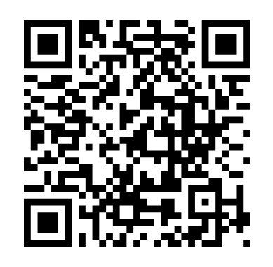

**Registration Deadline: Friday, July 12th, 2024**

**Location**:**In Person -  Columbus, OH

***\*\*****Due to space constraints, students selected to attend will receive a separate confirmation with additional details and logistics at least two weeks prior to the event date.  Travel reimbursement will not be provided to and from this event.\*\**

[](https://www.youtube.com/user/jpmorgan)[](https://instagram.com/jpmorgan)[](https://www.twitter.com/jpmorgan)[](https://www.linkedin.com/company/j-p-morgan)[](https://www.facebook.com/jpmorgan)