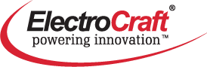

ElectroCraft is excited to be visiting campus at the ARC Atrium on Thursday, November 2nd from 1 pm – 3:30 pm. We are in search of talented engineering students who have interest in internships related to Product Design Engineering, Industrial Engineering, Manufacturing Engineering, and Quality Engineering during the winter, spring, and summer terms. Resumes will be accepted.

Company Description:
ElectroCraft, Inc. specializes in dependable, application-engineered specialty fractional-horsepower motor and motion products.

ElectroCraft Ohio has been a manufacturing mainstay in Gallipolis, OH for close to 50 years and is a primary location for product engineering for the entire company.

Gallipolis, OH ElectroCraft Manufacturing facility

