Andersen Windows
Information Session
Tuesday, September 26th at 5pm
Baker Center 230

Positions available in the following areas:

Mechanical Engineering
Technical Operations Management
Management
Business Management
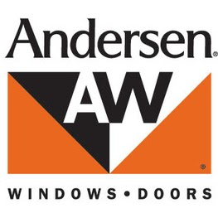
https://www.andersenwindows.com/

