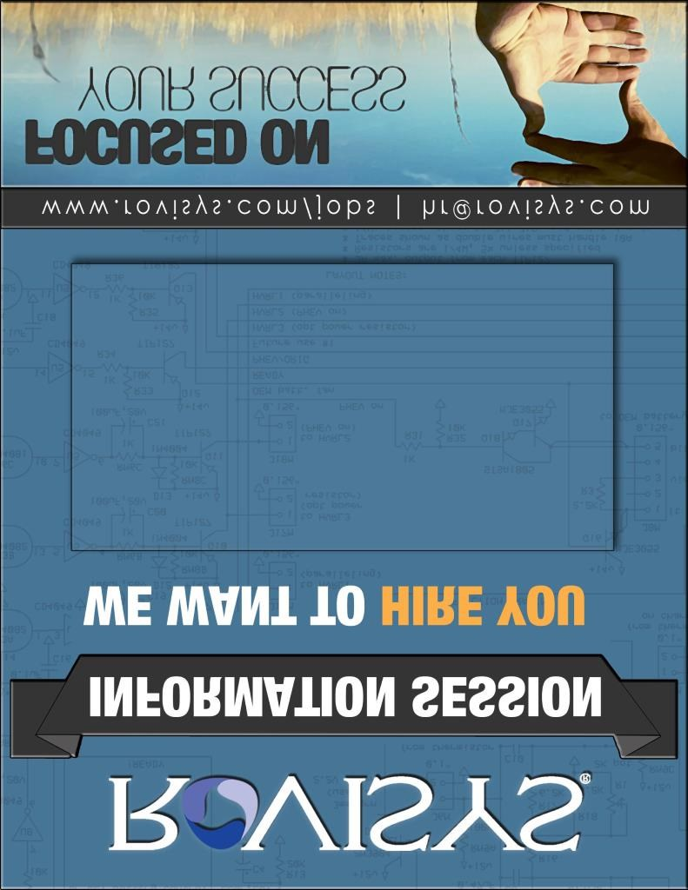

www.rovisys.com/careers careers@rovisys.com

**Where: Stocker 103**

**When: Tuesday, September 12th at 6:00pm**

**Why: Learn about RoviSys, set your career expectations, get some great advice on developing a winning resume and learn how to interview like a pro!**

**Bonus: Pizza, Pop (and great advice) Provided**

***BONUS*: Pizza, Pop (and good advice) Provided**