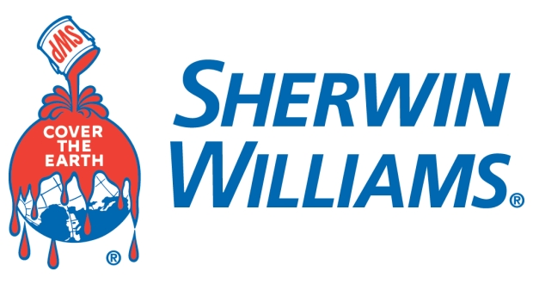

Sherwin Williams Meet and Greet
Tuesday, March 21st
10am – 2pm
ARC Atrium

Sherwin Williams is recruiting for their IT Application Training Program (SWAT). While the recruiter will be from their IT Department, the company also hires various engineering majors for other positions. If you would like to learn about other engineering positions at Sherwin Williams, the IT Recruiter can provide you with additional information and pass along your resume to the appropriate department with the company.

