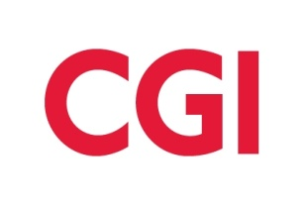
Satisfying clients
by helping them
win and grow

Information Session

http://www.cgi.com/

When: Thursday February 16 5:30pm-6:30pm
Where: ARC 212
CGI is hiring for Entry Level Software Developers, System Analysts, and Business Analysts across the US.
Meet our CGI Members and gauge your interest in our organization!
This session is designed to provide in-depth information about CGI and offer insight into our company’s culture and core values. CGI Members who work on local projects in San Diego will be available to answer questions and provide firsthand knowledge of life on a CGI project.
We look forward to meeting you!
Pizza and Refreshments will be provided!!!!!!!!!!

** The name “CGI” is the French acronym for “Conseillers en gestion et informatique,” (information systems and management consultants).

