Volunteers Needed for Research Study
Multicultural Counseling: Recentering the Voices of Students of Color Counselors-in-Training

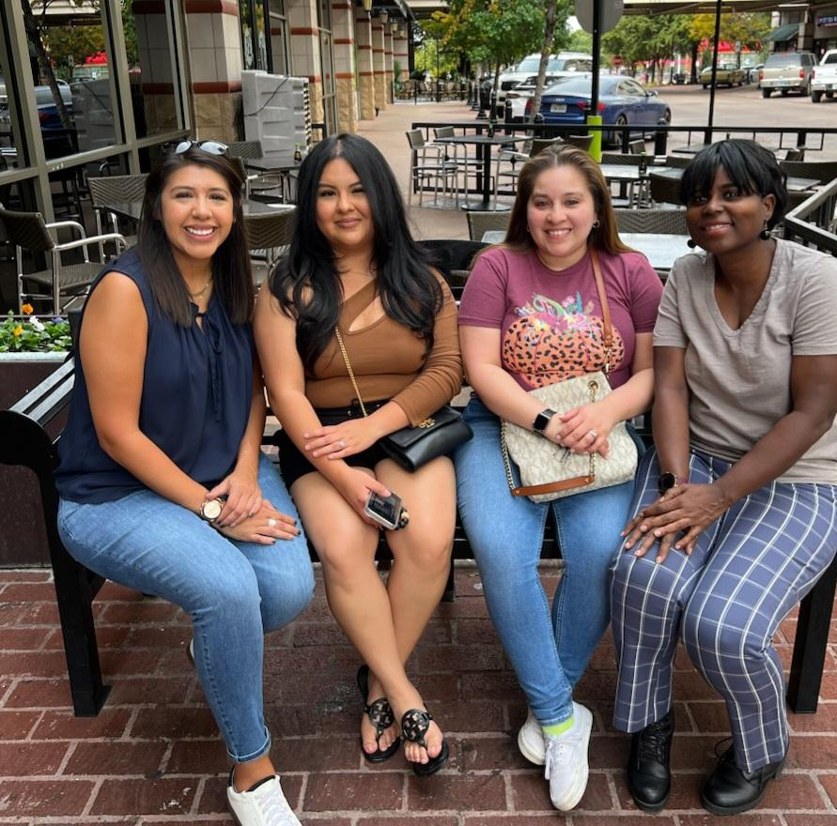

The College of Education/Counselor and Counseling Education is conducting research to find out the experience of counselors of color counselors-in-training’s experiences of working with diverse clients.

The criteria for participants are as follows: 1) identify as a person of color, 2) enrolled in a CACREP accredited master’s-level counseling program, 3) have completed at least one multicultural course, 4) are enrolled in Internship I or Internship II, 5) have worked with a former White client, 6) are currently working with at least one White client, attends an institution that offers free counseling services to its students, 8) are 18 years of age or older, 9) attends an institution that offers free counseling services to their students.

You will be asked to participate in a fifteen-to-thirty-minute screening, two interviews that may last up to ninety minutes, and answer journal prompts. Participation will take place via Zoom. There is a risk that participants could incur minor distress or discomfort due to interview questions focused on race, culture, and social justice issues.

Participants will receive a $50.00 Amazon gift certificate after the completion of the second interview.

Please call 903-288-4774 or
email r.frater@tcu.edu with any questions
IRB # 2023-370

Texas Christian University
TCU does not discriminate based upon any protected status. Please see
http://www.tcu.edu/notice-of-nondiscrimination.asp

