Department of Counseling and Educational Psychology Texas A&M Corpus Christi
PARTICIPANTS NEEDED FOR RESEARCH IN COUNSELING IMPOSTORS
We are looking for volunteers to take part in a study “Development and Validation of Counseling Impostor Scale (CIS)” fully funded by the Association for Assessment and Research in Counseling (AARC).
As a participant in this study, you would be asked to:
- Take a brief anonymous survey, including items containing your demographic information, screening questions, self-reporting experience with impostor characteristics and burn-out.
- Your participation would take 16-20 minutes to complete the one-time survey.
- Your participation is voluntary. You will receive a 7-dollar amazon electronic gift card after you complete the survey. The gift card will be given to you between the time you complete the survey and the end of May 2023.

To qualify for this study, you must be:
- counselor-in-training enrolling in counseling practicum/internship courses from either a CACREP or non-CACREP accredited program, or
- counselor having at least a bachelor’s degree (in any majors) and maybe holding appropriate practice credentials (e.g., NCC, LMHC, LMHC-Associate, LPC, LPC-Associate, LMFT, LMFT-Associate, LPC-S, Certified School Counselors, LCDC, LCDCI, etc.)

To participate in this research study, please click here: https://tamucc.co1.qualtrics.com/jfe/form/SV_0kdI56g9ZvWktgi
or scan here. 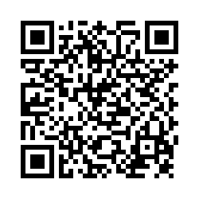
For more information about this study please email: Lien Nguyen, at lnguyen14@islander.tamucc.edu, or Dr. Joshua Watson at Joshua.watson@tamucc.edu, Department of Counseling and Educational Psychology, Texas A&M University-Corpus Christi
Permission to use this online listserv for research recruitment purposes has been granted by ________on ______(date)

