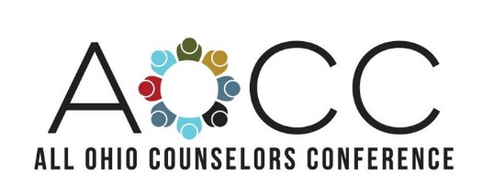
October 28-30, 2020 ● Hyatt Regency ● Columbus, Ohio

CALL FOR GRADUATE STUDENT POSTER SESSIONS
Poster Presentation Submission Deadline June, 13, 2020

The OCA expects to attract over 1,500 licensed and future counselors from across Ohio including academic leaders, private practitioners, and student delegates. Graduate student poster session presentations will be held on Wednesday, October 28th from 5:30-7:00pm during our Welcome Reception.

Graduate Poster Session Proposal Criteria
- Poster Presentation Title
- Presenter Name(s), School, Contact Info
- Faculty Advisor Name
- Provide 2-3 Learning Objectives or Goals of your presentation
- 100-word Description of Poster Session Focus
- Justification that your presentation will benefit other Graduate Students & Counselors from Ohio attending this Conference
- List 2-3 research citations relevant to the topic
- A description of your qualifications for presenting on your topic
- Please include a copy of your CV or Resume
- OCA membership is required to present at the conference
- Posters must be on foam core or similar backing
- All accepted presenters must be registered attendees for the AOCC Conference by Oct. 1st, 2019

What content area will be addressed?
Human Growth & Development Counseling Techniques
Counseling Theory Diagnosis
Group Dynamics Family Systems
Special Populations Intervention & Prevention
Professional Ethics Research & Evaluation
Supervision & Counselor Development Assessment
Lifestyle & Career Development Sociological/Cultural Foundations
Psychopathology & Abnormal Behavior

More conference information and rates can be found here:
https://www.ohiocounseling.org/aocc-2018

Submit your proposal via Qualtrics using the link below:
https://ysucspel.az1.qualtrics.com/jfe/form/SV_37Svi2MohgzHpuB

