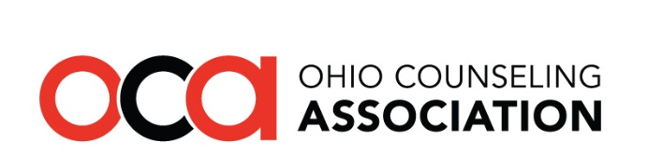
3227 Mountview Road ● Columbus OH 43221 ● 614.395.3341 ● www.OhioCounseling.org

Legislative Advocacy Day
Tuesday March 19th 2019 ● Riffe Center, Columbus OH

AGENDA

9:00 a.m. Registration, Coffee, Cocoa, Water, Soda, Snacks

9:30 a.m. Welcome
Sean Gorby – OCA Government Relations Chair
WillaMarie Jackson – OSCA Government Relations

10:00 a.m. Lori Criss – Director, Ohio Department of Mental Health and Addiction Services
Geoff Collver - The Ohio Council of Behavioral Health & Family Services Providers

11:00 a.m. Amanda Sines - Effective Advocacy

11:30 a.m. Legislative Appointments Begin

11:30 a.m. Alisha Nelson – Director – Recovery Ohio

12:00 p.m. Lunch Buffet (available until 2pm)

12:30 p.m. CSWMFT Board Update
Brian Carnahan, Executive Director of CSWMFT Board
Bill Hegarty, Deputy Director/Investigations

1:30 p.m. Representative Robert Cupp

2:15 p.m. Closing

This program content has been approved for four CE hours via OCSWMFT provider #RCS031407. Be sure to sign in and complete the session survey at the end of the day. You will receive a CE certificate via email post-event.

