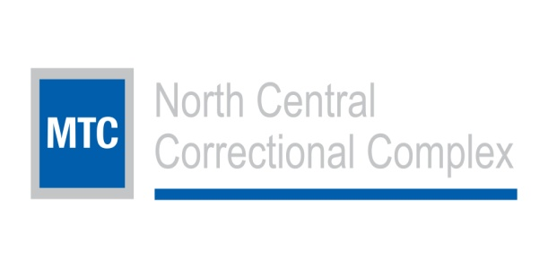
JOB POSTING ANNOUNCEMENT #21104
Position: Licensed Independent Social Worker/LPCC | Department: Medical
Open Date:4/6/2018 | Close Date: open
JOB SUMMARY

LICENSED INDEPENDENT SOCIAL WORKER (LISW) or LICENSED PROFESSIONAL CLINICAL COUNSELOR (LPCC)
Management and Training Corporation (MTC) Medical is looking for an energetic, dedicated and passionate clinician (LISW or LPCC) to join the mental health team at North Central Correctional Complex in Marion, Ohio. A correctional setting provides an opportunity to create a social impact in the lives of our clients, a rich clinical environment supported by a multidisciplinary team of professionals and challenging, rewarding work. At MTC Medical, clinicians are supported in their professional development, given flexibility to meet the needs of clients, and encouraged to develop new skills. Join our team and help us change lives!
Essential functions of the position include:
1. Develop and implement treatment and therapeutic programs for assigned inmates.
2. Assume independent clinical responsibility for all inmates including the application of crisis intervention techniques to include suicide prevention, recognizing abnormal behavior, and taking appropriate action to prevent or diffuse potentially disruptive situations.
3. Conduct diagnostic evaluations for inmates to determine needs, establish goals and develop plans; make referrals to community professionals to ensure continuity of care upon release.
4. Provide direct casework services, individual and group counseling to inmates.
5. Prepare progress reports; provide recommendations regarding discharge plans; make case presentations; and assist administrative and medical staff in development of statistical reports on assigned inmates.
6. Maintain and monitor confidentiality of inmates and their files; audit files to determine that all services provided meet policy requirements; review status of inmates to determine that all treatment and therapeutic programs are appropriate to their needs.
7. Attend scheduled staff meetings; promote communication and the proper flow of relevant information between administration, staff and inmates.
8. Attend seminars, workshops, conferences, as required, including licensure requirements.
9. Maintain current cardiopulmonary resuscitation (CPR) certification.
10. Perform other duties as assigned within his/her capabilities as determined by management.
11. Promote the development of positive social skills through modeling appropriate behaviors and intervening when inappropriate behaviors are observed.
12. Maintain accountability of inmates and property; adhere to safety practices.
Reports administratively to the health care administrator and clinically to the psychologist. Responsible for planning and implementing professional and ethical mental health services, within practice guidelines of the licensing body. Coordinates and directs the activities of LSW in provision of mental health services to inmates in compliance with MTC Medical and Ohio Department of Rehabilitation and Correction (ODRC) directives.
Master’s degree in social work, counseling or related field required from an accredited educational institution and current licensure in the state of Ohio as a Licensed Independent Social Worker or Licensed Professional Clinical Counselor. Three (3) years prior work experience required. Valid driver's license in the state of Ohio with an acceptable driving record required, unless waived by management. Must attain and maintain appropriate facility security clearance.
Post Hire Qualifications and Training Requirements:
Must successfully complete annual in-service training requirements.
MTC Medical is an Equal Opportunity Employer.

