child Abuse Prevention Month
  - Seminar with Athens County Children’s Services
Be a better Bystander  Report suspected abuse  Learn about the report process | 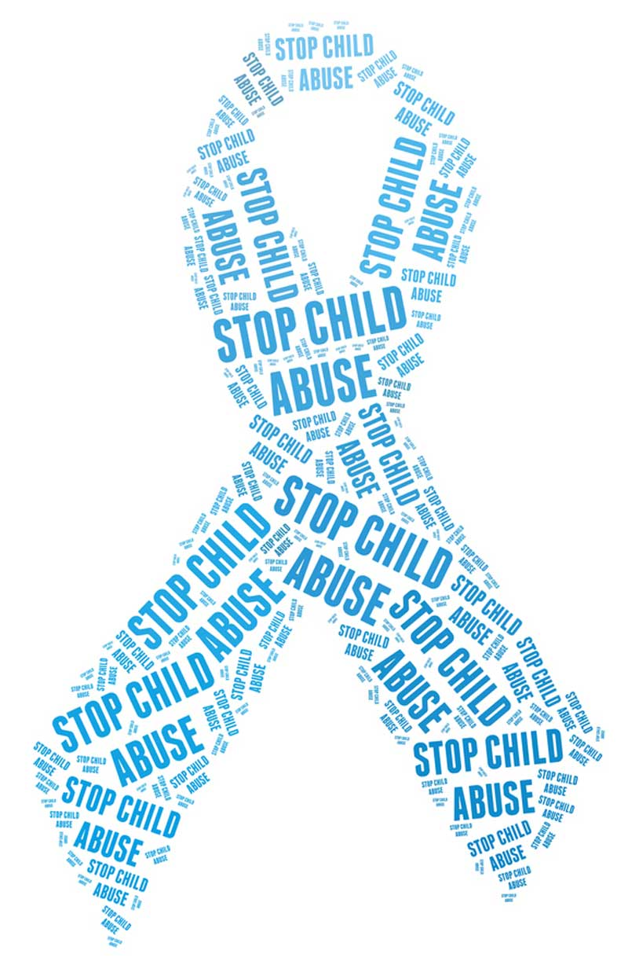

Event Time:
Thursday, April 19th at 5:30pm
In Baker 231

Hosted by COMS 4800

Questions? Please contact Megan at mm940412@ohio.edu

