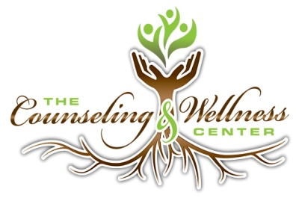

02/22/2018

Dear Counseling Graduates,

Our private group practice is seeking to add a few excellent therapists to serve the therapeutic needs of persons in the Mid-Ohio Valley. We have a location in Belpre, OH and across the river in Parkersburg, WV. We have the ability to supervise candidates as they become licensed in either state. We are requesting a letter of recommendation from either your advisor, program director or a professor.

Here is our website address for your review, https://www.counselingandwellnesscenter.com
If interested in applying, please send your resume and reference letter to the email or address listed below. Thank you in advance, for your interest in The Counseling and Wellness Center.

Sincerely,
LeAnn Bates, MEd., LPC, LPCC-S
on behalf of:
Stephen Givens and Mike Moore, Owner/Directors
Counseling and Wellness Center
936 Market St
Parkersburg, WV 26101
bjccwc@juno.com

