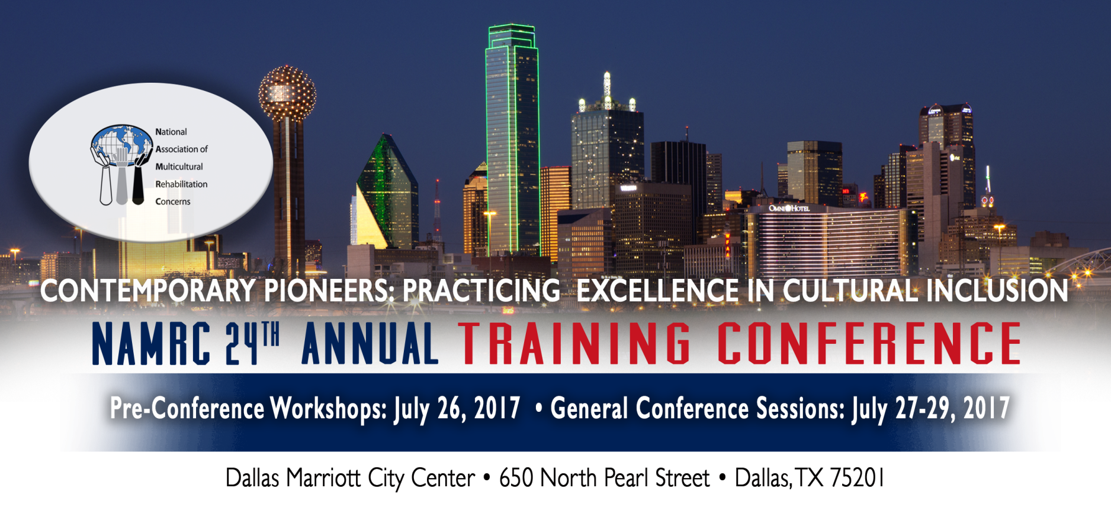
CALL FOR STUDENT POSTER PRESENTATIONS

The National Association of Multicultural Rehabilitation Concerns invite students to participate in the Annual NAMRC Conference. A student poster gallery will be featured during the conference.

Students who are interested in presenting research, service models, and/or best practices in the field of rehabilitation are encouraged to submit a poster. We are hoping that the poster presentations will serve as an effective forum for the exchange of information and a means to communicate new ideas, research, and programs.

Posters will be presented collectively in a 1.5 hour session. Students are especially encouraged to present posters of ongoing research studies, dissertations, and thesis research.

If you are submitting for a concurrent session, please email your proposal to: http://namrc.org/2017-conference/. If you are a student who only wants to submit a student poster presentation, please email your poster proposal to this email address: namrc.studentrep@gmail.com.

Submissions of this proposal is an acknowledgment and agreement to the following:
- Be available to present the poster on the date indicated by the preconference scheduling
- Cannot charge a separate fee for attending your session
- Pay the registration fee
- Make presentation materials and activities accessible to participants with disabilities

To provide proper consideration, proposals must be submitted by Friday, April 28, 2017.

Additional questions can be asked through: namrc.studentrep@gmail.com
Additional information can be found through: http://www.namrc.org
2017 NAMRC Student Poster Presentation Form
Email submission form as attachment by Friday, April 28, 2017 to: namrc.studentrep@gmail.com

Email subject line: 2017 NAMRC Poster – Lead Presenter’s Name

Proposal Format: Please fill out all requested information.

1. Title - (80 characters, including punctuation marks and spaces)
2. Abstract - (Length of content description should not exceed 150 words):
3. Track - Choose one of the following:
- Professionals/Rehabilitation Services
- Rehabilitation Education
- Student Development
- Best Practices in Rehabilitation
4. Learning Objectives - (brief description of measurable goals):
5. Lead Presenter & Co-Presenters Contact Information:
- Name of Lead Presenter (credentials: CRC, LPC, etc):
- Email (all contact from NAMRC will use this):
- Phone:
- School / Status (Undergrad, Master’s, Ph.D. student/candidate):
- Name of Co-Presenter (credentials: CRC, LPC, etc):
- School / Status (Undergrad, Master’s, Ph.D. student/candidate):
    - Name of Co-Presenter (credentials: CRC, LPC, etc):
    - School / Status (Undergrad, Master’s, Ph.D. student/candidate):
6. Would you like information about sharing a room with another student? Yes or No
7. Conference Program Guide Summary:
(50 words or less to describe your poster to be printed in the conference program):

