Come join Alpha Kappa Psi Professional Business Fraternity’s

Ballin’ for Booty Basketball Tournament

Alpha Kappa Psi is hosting a 3 v 3 basketball tournament to show our support for our bother, Brian “Booty” Neville. Starting from winter break of this year, Booty had several hospital and doctor visits that ended in a report of two tumors. The report showed that he had signs of grade three brain tumors that appear to be cancerous. He will be starting chemotherapy and radiation soon. Basketball is something that is important to Booty’s everyday life, so our organization wanted to raise money and awareness for him through this tournament. We are asking your help to play some basketball for Brian.

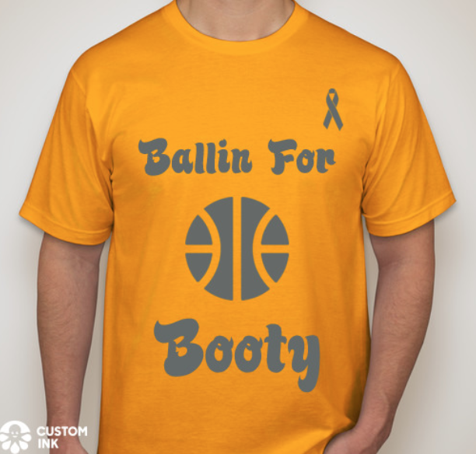

When: Sunday, April 29
Time: Noon – 4:00pm
Who: Teams of 3 – Can be co-ed
Price: $12/person, comes with a free shirt! You can also pick the color of your shirt! The ink will be all gray

For more information on the basketball tournament, feel free to contact Lauren Martin at lm739314@ohio.edu.

