Step 1: Go to website and click on your picture to go to your profile page.
(https://www.apoonline.org/deltagamma/memberhome.php?)
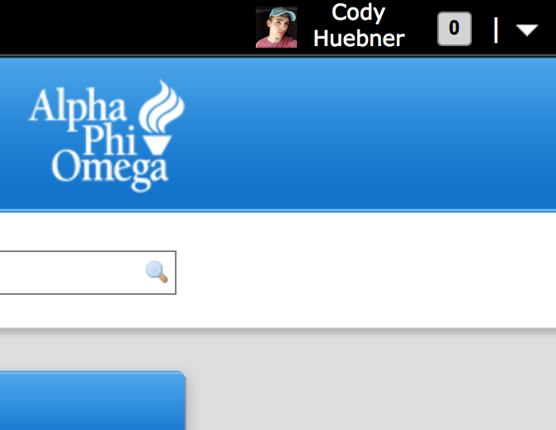

Step 2: Click on the family tab under your picture, and click “edit family” in the top right corner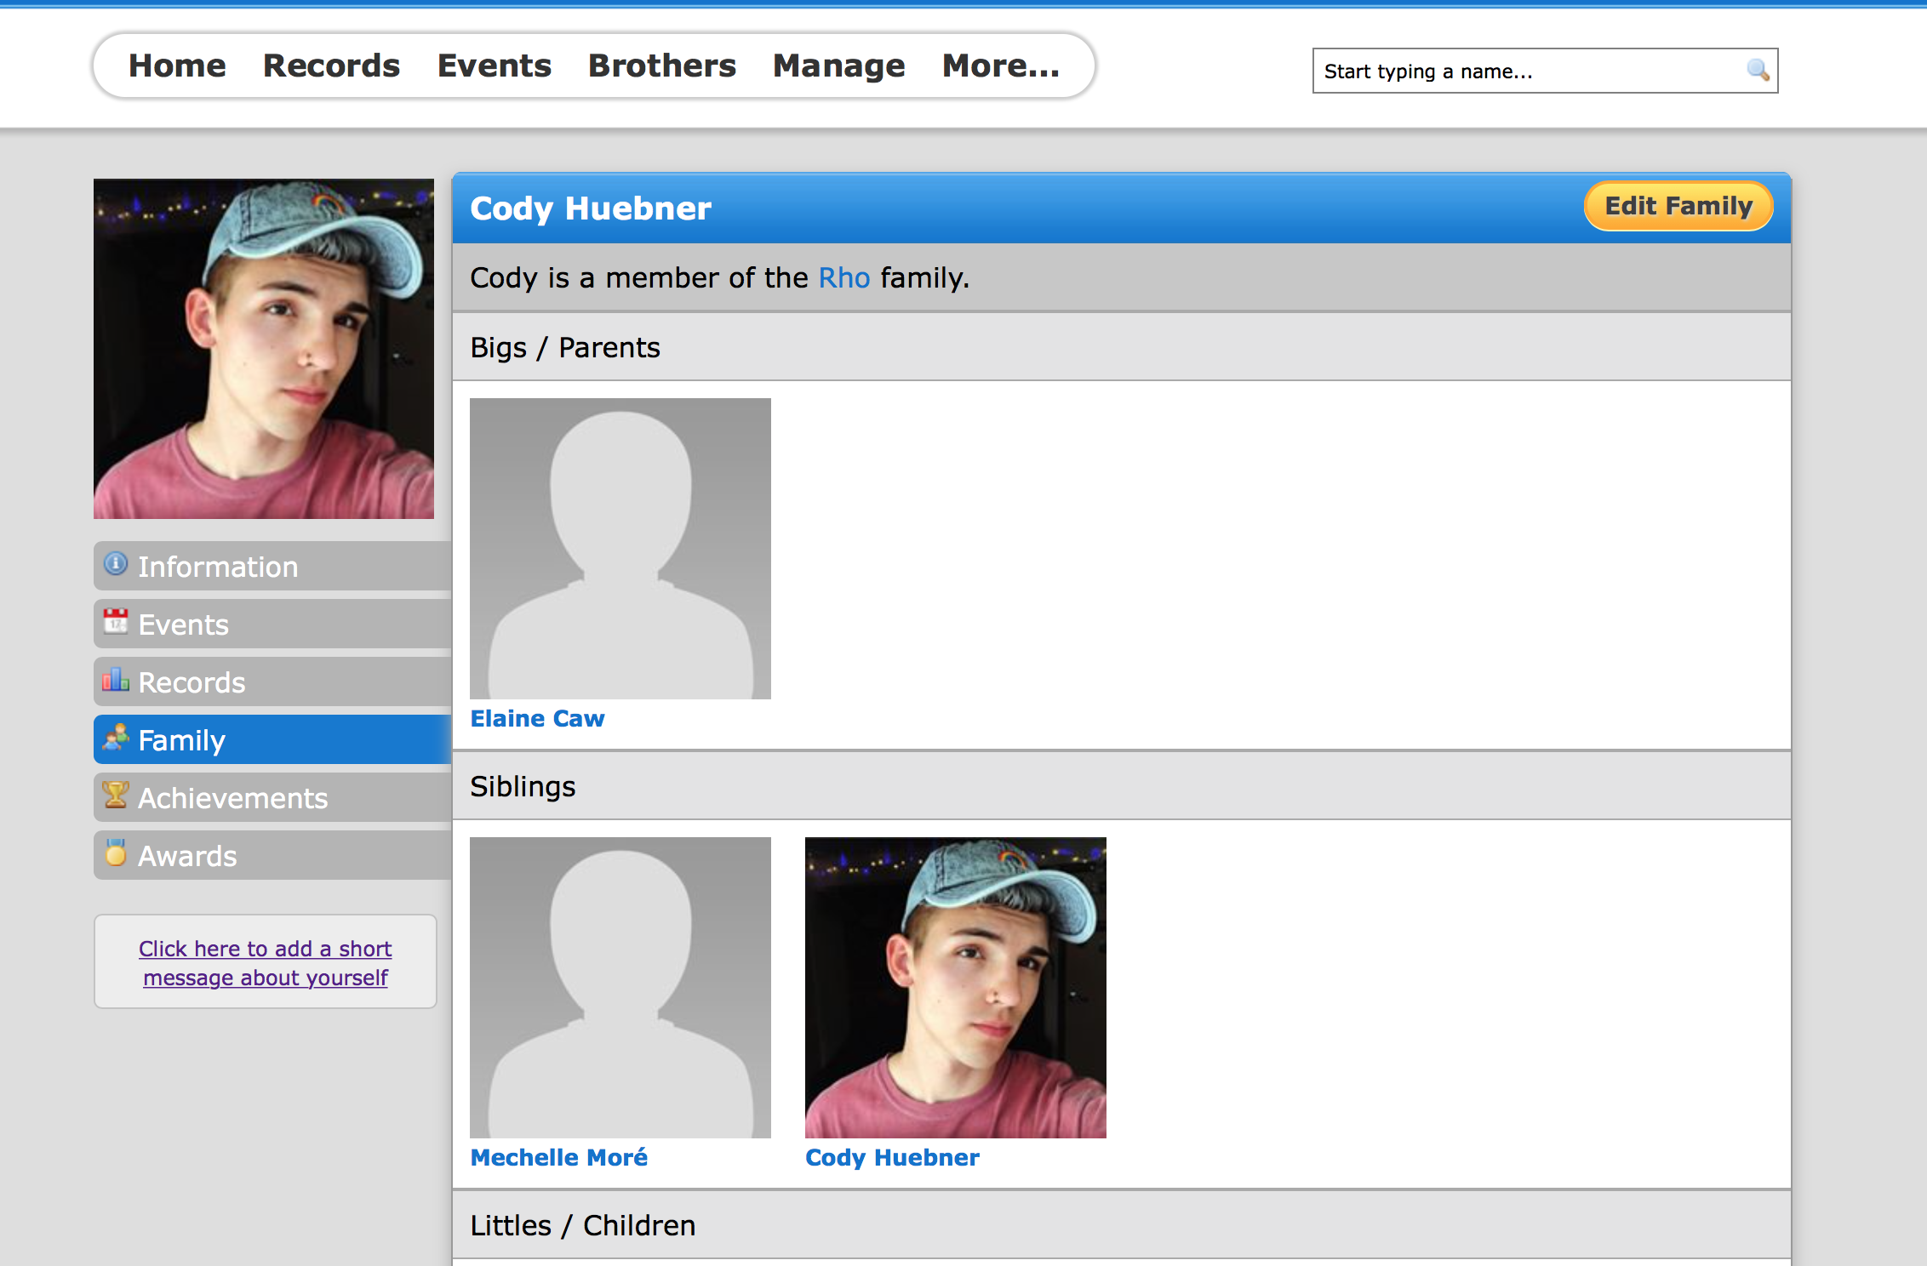

Step 3: Search for the bro/family you want to add and click add/update, respectively! 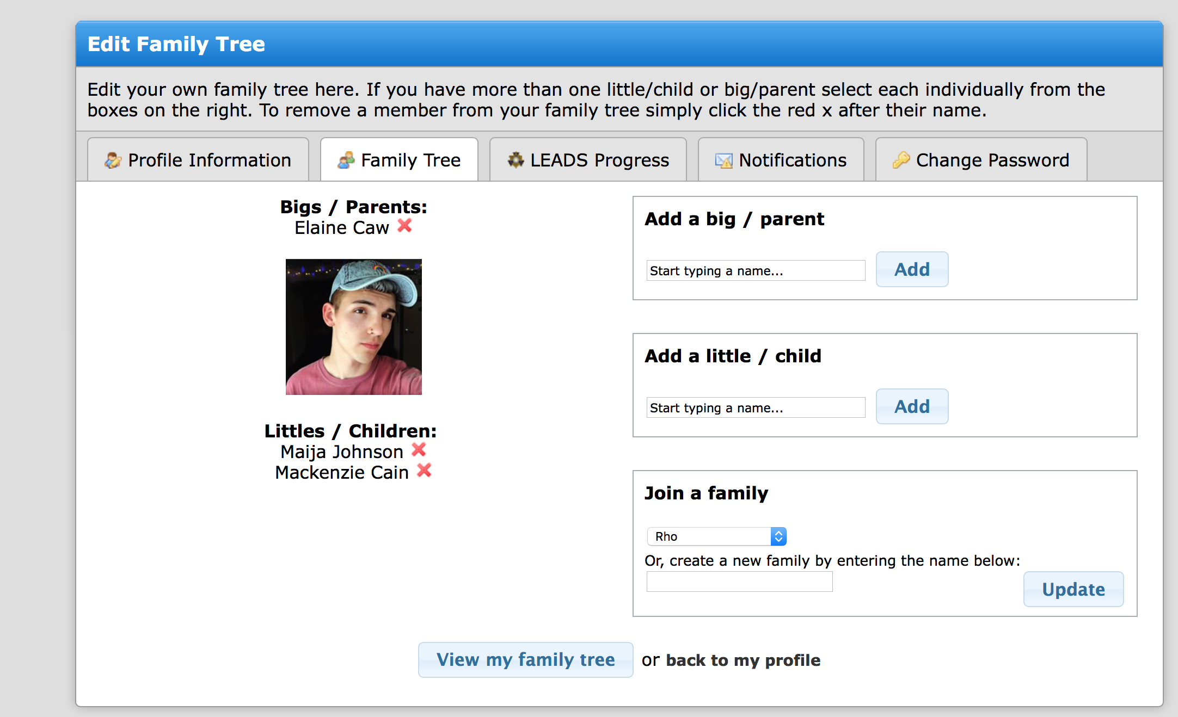

Step 4: Celebrate because you did good today and helped your favorite ombuddies

