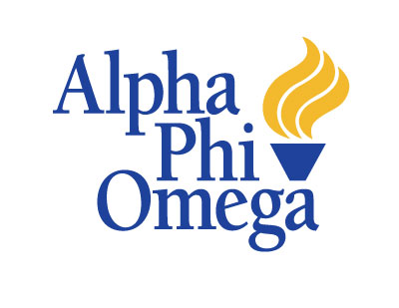
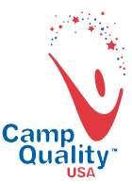
Presents:
The 4th Annual
Ava Nichols’ Faculty Pageant
Benefitting:

A Special Thanks To:
Athena Grand
Chipotle
College Bookstore
KFC
Randi Strittmather
Uptown Dog T-Shirts
The First United Methodist Church

Saturday February 16, 2013
Templeton-Blackburn Memorial Auditorium
1 pm
In Loving Memory….
Ava was four when she was diagnosed with an inoperable, malignant brain tumor located brain stem. She began treatment at St. Judes Hospital in 2010. Despite some small regression in the tumor’s size at the end of treatment in May 2010, the family found that in January of 2011, the tumor had slightly grown. After a hard, harrowing fight, Ava sadly lost her battle on March 13, 2012. She was six-years-old.
Ava will always be remembered in the hearts of many as a child full of life. She loved Taylor Swift, Justin Beiber, playing with babies and watching her favorite movies: Old Yeller, Titanic, and The Little Rascals.

Although she’s left this life behind, she continues to inspire people in their endeavors to help others.

She is survived by her loving and supportive parents, Traci and David Nichols, and her new brother, Aceynn.

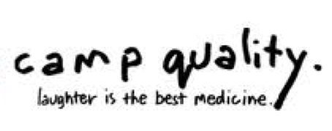
Today’s Performance
Welcome
Rachel Levine and Ciara Strittmather
Introduction of Emcees
Allison Barwacz
Valerie Hudak
Natalie Zelich
Introduction of Participants
Dr. Julie Suhr…………….……...….Dept. of Psychology
Dr. Bill Rawlins……………………..Dept. of Communication
Dr. Liz Blair…….............................Dept. of Marketing
G.A. Jessica Furgerson…………..…Dept. of Communication
Dr. Eddith Dashiell……………...….Dept. of Journalism
Rabbi Danielle Leshaw……………..Hillel, Executive Director
Formal Wear
Introduction of Judges
Kerri Franks…………………….Camp Quality-Ohio, Director
Jacob “Buddah” Hagman…...…Alpha Phi Omega, Advisor
Rylee Cavins………………...….Camp Quality Camper
What is Alpha Phi Omega?
Talents
What is Camp Quality?
Question and Answer
Remembering Ava
Closing Remarks
Coronation

Alpha Phi Omega is a co-ed, national service fraternity that aims to develop leadership, to promote friendship, and to provide service to humanity. Alpha Phi Omega is the single most represented intercollegiate service organization in the United States. At Ohio University, the Delta Gamma Chapter of Alpha Phi Omega partakes in a variety of service projects including: Relay for Life, 5k’s for various organizations, Give Kids the World Village, New Orleans service trips, ATCO, The Good Earth Farm, FIRST Lego League, and Camp Quality. Event Coordinators, Ciara Strittmather and Rachel Levine, would like to make a special thanks to the Alpha Phi Omega-Delta Gamma chapter for all their support and for making this an annual event!

Camp Quality is a non-profit organization that serves children with cancer and their families by providing a summer camping experience, year-round programs, and support, at no cost. Camp Quality promotes hope and inspiration while helping children foster life skills and develop their full potential.

